The Role of Sentiment in the Economy: 1920 to 1934

Ali Kabiri, Harold James, John Landon-Lane,David Tuckett, and Rickard Nyman[1]*

*Abstract*

*This paper investigates sentiment in the US economy from 1920 to 1934 using digitized articles from the Wall St Journal. We derive a monthly sentiment index and use a ten variable vector error correction model to identify sentiment shocks that are orthogonal to fundamentals. We show the timing and strength of these shocks and their resultant effects on the economy using historical decompositions. Intermittent impacts of up to fifteen percent on Industrial Production, ten percent on the S&P 500 and Bank loans and, thirty-seven basis points for the Credit risk spread, suggest a large role for sentiment.*

JEL; D89, E32, E70, N1, N3

Keywords; Great Depression, General Theory, Algorithmic Text Analysis, Behavioural Economics

# Introduction

Understanding what delivered the shock of the Great Depression has become what Ben Bernanke memorably called the “holy grail” of macroeconomics: but we know from medieval stories that the knights almost never succeed in their quest.[2] Although the US economy was dynamic at the beginning of the twentieth century, the NBER also measures ten recessions from 1899-1933. From 1920-34 credit and sentiment played a prominent role in the expansion and subsequent crisis in the US economy according to many historical accounts.[3] This paper examines whether these credit and business cycles can be explained partly in terms of sentiment, or market psychology.

By the summer of 1932, the US stock market had fallen by ninety percent from its 1929 peak, amidst the most severe depression in US history. Economists Benjamin Graham and David Dodd lamented the exuberance of the 1920s and the undervaluation of the US stock market in the market trough in 1932.[4] Irving Fisher in 1932 cited “pessimism” as one of the factors prolonging the slump: “Everybody's opinion is largely guided by the opinion of everybody else, even the people with the coolest heads will at least ‘fear the fears of other men’ and contribute to the panic of which such fears are a part.”[5] New ideas about the role of human psychology in the economy were given greater credence following the publication of Keynes’ *The General Theory of Employment, Interest and Money*. The role of expectations that Keynes’ new theory set out has been widely accepted. The role he attached to “animal spirits” (i.e. the role of human emotion in human cognition) has remained more controversial. He wrote of how “the uncontrollable and disobedient psychology of the business world” determined the marginal efficiency of capital. [6]

A disaggregation of sentiment shows a particular importance of sentiment in the period before the Great Depression; during the Great Depression, the identification exercise makes it hard to separate negative sentiment from the negative real economic performance. There may be a spiral in which economic news generate more negative sentiment which leads then to worse economic performance and so on, but the causal mechanism in that process – unlike in the pre-1929 era – cannot be clearly identified.

Sentiment looks for signals, and some part – rather larger than the real extent of the ties of the US to the world – derived from the interpretation of developments elsewhere. Edward V. Decker, president of the Northwestern National Bank Minneapolis, explained how ‘we are learning more to work together, farmers, bankers, businessmen, railroad men, and we propose to march forward with a united front, believing and expecting that we will have our share of the world's prosperity during the next few years.’[7] On the other hand, events elsewhere had the capacity to shake Americans’ confidence and security.

One such channel of sentiment and views about future prospects was especially important in the US in the 1920s. Before 1914, or the US entry into the First World War in 1917, the US economy looked rather cut off from world events. Now there were financial and political linkages in the form of war debts and reparations. Although because of its size the US was not an open economy, the perception of links to the wider world played a disproportionate role at particular turning points: the end of the post-war deflation in 1921, the emergence of prosperity in 1926 and of uncertainty in 1929 and 1930.

New research analysing news article data and a lexicon approach to search for words with positive and negative emotional content (the technical term is ‘valence’) has been shown to be useful in understanding financial outcomes.[8] Others use the analysis of news media or other digital sources to derive information about expectations and economic behaviour.[9] Recently, these innovative approaches have evolved to include very large long-run datasets of digitized news media examining the predictability of stock market volatility and stock prices and the impact of uncertainty induced by government policy.[10]

Specific historical applications of news article analysis have also emerged. One strand use news media data to examine inflation expectationsand others use uncertainty indexes derived from news media to examine the role of economic, government policy and political uncertainty on economic outcomes, in the interwar period.[11] Increased uncertainty has in the past been an explanation for the transmission mechanism between the stock market collapse and a reduction of orders and of demand that started the descent into the Great Depression.[12] New research focusing on emotions specifically uses a diverse range of text sources to understand emotions, sentiment, and wellbeing that cover the interwar period.[13]

The volatile credit and business cycles of 1920-34 provides the ideal setting to test for the role of sentiment using these new techniques and novel datasets on the basis of modern empirical research, as well as of the several prominent contemporary accounts of the period that emphasise behavioural effects. Evidence of sentiment-based mispricing of financial assets has been found by examining closed-end fund premia, while others suggest that an overvaluation of the stock market of a significant size occurred from 1927-9. [14]  Shiller illustrates over and under valuation in the late 1920s and early 1930s US stock market. [15] We investigate the impact of sentiment on major components of the macro economy to better understand them in a dynamic setting and are the first paper we are aware of to use this specific approach in a comprehensive dynamic macroeconomic model.

We hypothesise that newspaper articles of the time contain both information related to the state of emotions or confidence of economic agents and factual information about or related to the fundamentals of the economy. In our model, the emotion or ‘sentiment’ component can have independent effects on the economy that are unrelated directly to the fundamentals that they describe and we control for expectations of future fundamentals through several mechanisms.[16] Our aim is to illustrate two key points: First, what these sentiment shocks look like when expectations and fundamentals are accounted for and second: the scale, timing, and locus of related impacts on the economy.

To investigate our hypothesis, we utilize a computer algorithm to conduct large-scale text analysis of digitized newspaper articles, that measures the emotional word content in economic and financial narratives from approximately 1,000 sentiment-containing items per month in The Wall Street Journal (WSJ) from 1920-1934. We use our algorithm, which counts sentiment-indicating or, ‘emotionally loaded’ words to produce an index for WSJ from 1920-1934. Our index measures the balance between two emotion groups that are broadly analogous to excitement (approach) and anxiety (avoidance) in text data, using a lexicon of approximately 150 words for each category utilizing ordinary English words, associated with these two major groups. We calculate the difference between word counts from each word group normalized by the total word count per month to derive our index at a monthly frequency. We label this the business-sentiment index. We produce a general news-sentiment index using digitized articles from the *New York Times* (NYT) in the same way as the WSJ. The WSJ was a smaller (but still substantial) circulation paper, focused on business and finance news, and a key source of information to people involved in stock transactions, while the NYT is a much broader news source. The WSJ had a circulation of 18,750 in 1920, which grew to about 50,000 by the summer of 1929: an expansion which itself is an indication of the extent to which stock market engagement had become popularized in the great boom of the 1920s.[17]

Having constructed our indexes, we assemble a database of the macro economy from 1920-1934 at a monthly frequency. To perform the empirical investigation, we utilize a 10 variable vector error correction (VECM) model to identify a business-sentiment shock that is orthogonal to a large number of important variables. These variables include output, the stock market, prices, interest rates, and variables to control for inflation expectations and business credit distress. The model also uses a NYT based general news-sentiment index to filter out general news shocks.

We are subsequently able to analyse and interpret episodes where structural shocks to our VEC model are at their most intense and refer back to the actual news articles driving these effects. We do this by scoring each article individually for its net level of positive or negative business-sentiment words. We then perform historical decompositions utilising this model to illustrate clearly the impact of these structural shocks on all of the macroeconomic and financial variables. This method allows us to compare the actual with the counterfactual path of the economy without the impact of business-sentiment shocks.

The results show our business-sentiment index has robust and economically meaningful effects on the real economy. We illustrate the timing and intensity of these effects for Industrial production, the S&P 500 stock market index, bank loans, prices, interest rates, credit risk spreads, and term spreads. The impacts are large, reaching up to fifteen percent of the initial value for industrial production and ten percent for the S&P 500 and bank loans in specific time periods. Analysis of the business-sentiment levels in the specific news articles that create the structural shocks and their subsequent impacts on the economy, illustrate the potential sources of the shocks.

We proceed as follows. Section 2 describes the WSJ article data and macroeconomic data, and the method for constructing the business-sentiment index. Section 3 sets out the econometric method and reports the results of the empirical investigation of the effect of business-sentiment on the economy. In Section 4 we use historical decompositions of sub-periods to investigate the impact of business-sentiment on the economy while in Section 6 we report our summary and conclusions.

# Construction of a Business-sentiment Index

The analysis is based on the ProQuest digital archive of the WSJ, which in its entirety consists of 1.07 million individual digitised news items published between 1920 and 1934, converted to an XML format that is machine-readable. We also collect news items from the NYT from 1920 to 1934. We focus only on the period 1920-1934 using the NYT and WSJ due to data availability for the macro economy. We filter both databases by removing non-relevant items such as theatre reviews, legal notices, classified advertisements and display advertisements leaving a total of 738,275 digitized items in our analysis. This is an average of 4400 digitized items per month, of which there is an average of 945 digitized items that contain at least one word from our sentiment lexicon. The items that contains at least one word from our sentiment lexicon account for a monthly average of 46 percent of the total number of words contained in the dataset. See the online appendix for a more detailed discussion of the data.

We measure business-sentiment as a summary statistic of words in news articles related to the two emotion groups. The selection of the word lists differ from existing lexicons. Examples of existing lexicons include Loughran and McDonald (LM), and the Harvard-IV and Lasswell dictionaries.[18] These provide alternative indexes of sentiment based on positive or negative valence however, none have word lists specifically for excitement (approach) or anxiety (avoidance). Our sentiment index is based on Conviction Narrative Theory (CNT)[19]. CNT is a theory about decisions taken under radical uncertainty. It posits that the mental substrate underlying such decisions is a narrative – a summary representation of relevant causal, temporal, analogical, and normative information available to the decision maker – that is selected to support action although its outcome is ex ante uncertain because it evokes either approach or avoidance feeling.[20]

The word-lists were carefully constructed by expert judgement to capture approach and avoidance emotions – originally conceived as excitement and anxiety, in the very specific sense as to whether the outcome was likely to be more or less conviction about action. A recent paper highlights the key differences between LM and our index using the Binder features of the words.[21] The area where our lexicon differs from that of LM across 65 Binder features are the emotion groups linked to ‘cognition’, ‘drive’, ‘arousal’, ‘fearful’ and ‘surprise’. The index we produce reflects the emotions leading to action or avoidance in the beliefs about firms, consumers, investors, and the overall economy that are contained in the news.

For each of the two groups, we use a word list, or lexicon that consists of about 150 words.[22] The word lists we use were first developed using expert judgement from a team consisting of a social anthropologist, a sociologist, a psychoanalyst and a clinical psychologist.[23] We use a ‘bag of words’ technique and tokenize the articles to be able to match the words in each lexicon with the words in each article. [24] We do not treat the data for ‘Negation’ as correlations between negated and non-negated sentiment time series in earlier work developing the method was 0.999, so were not seen as necessary. We do not automatically stem the words in the lexicon as the stemmed words were considered by the experts when constructing the lexicon. ‘Stemming’ in this case has the danger of being too broad, capturing stems of words we do not want. In the excerpts from articles given below, we italicize the words from the lexicon: the reader will notice that it is a restrictive list and many terms with a powerful emotive effect (for instance abundant, faithless, nothing, pessimist or optimist, progress, prosperity or prosperous, speculative, weak) are not on the lexicon list.

For the summary statistic of a collection of texts, we count the frequency of excitement/ approach words () and anxiety/avoidance words () and then scale these numbers by the total number of words per period (). To arrive at a single statistic, we subtract the avoidance statistic from the approach statistic as in [1]. Data are collected at daily frequency but collated at the monthly frequency to ensure a higher signal to noise ratio. The formula for the construction of business-sentiment is

 [1]

During the period of 1920 –1934, there is some variation in the number of words published in a month (see online appendix). On average, there are 945 digitized items containing sentiment per month and these items account for an average of 46 percent of all words analysed. One issue that may lessen the accuracy of our algorithm in capturing business-sentiment is that the modern lexicon we use may not match the language typically used in this period. This issue is partially negated as we use two counterbalancing lists of words, which should be equally affected by any such bias. Furthermore, Manela and Moreira demonstrate that modern lexicons can be successfully used to measure ‘news implied volatility- NVIX’ back to 1889.[25]

**Figure 1:** **Index of Business-sentiment for the Wall Street Journal (1920 – 1934)**



* The series depicted is constructed using [1] and reflects the difference between approach and avoidance words in articles appearing in the WSJ. The series is calculated at a monthly frequency. The shaded regions are NBER recession dates.

Figure 1 reports the sentiment series obtained from the WSJ from 1920 to 1933 constructed using [1]. Some notable points in US history are clearly visible in Figure 1 and consistent with historical accounts of these periods. A major slide from 1929 through to 1934, at the deepest point of the Great Depression. It is striking that in the 1920s, two relatively mild NBER recessions (those beginning in May 1923 and October 1926) are both accompanied by large negative spikes in business-sentiment. With the Great Depression, after August 1929, business-sentiment follows the economy on its downward path.

As a robustness check of the WSJ data as compared to other financial and business news sources of this period, we use the Commercial and Financial Chronicle - a popular weekly financial news source based in New York. These news article data are gathered from the Federal Reserve Bank of St Louis - FRED database. The correlation between the business-sentiment indexes from the CFC and WSJ from 1907-1934 is 0.74 indicating that the WSJ business-sentiment index captures consistent information on the economy and financial markets that is not specific to the WSJ. Another alternative news source is the sentiment index of Garcia, who uses a different lexicon to construct a sentiment index based on two columns that were regularly published in the NYT. Our sentiment index has a correlation of 0.57 with that of Garcia, which is not surprising since the columns that are followed focus on financial markets rather than business and finance.[26]

The WSJ is one source of financial information that agents used during this period. The WSJ had an estimated 7,000 readers in 1902, climbing to 50,000 by the end of the 1920s. It can be seen as a good source of information for financial market and business professionals, rather than a general readership.[27] An alternative source of information that agents read during this period was the NYT. The NYT, however, reports on events other than business and the financial markets, whereas the WSJ is a more specialized publication. Using [1], we construct a business-sentiment series based on articles from the NYT in addition to the business-sentiment series constructed from the WSJ. A priori, there is no expectation that the two business-sentiment series would contain the same information and in our analyses, reported below, we include both series. The business-sentiment series constructed from both the WSJ and the NYT are reported in Figure 2. It is clear from inspection of the figure that the information obtained from the WSJ is different from the information obtained from the NYT. In particular, the business-sentiment obtained from the WSJ, declines at a faster rate than the NYT from 1928 to 1932.

It should be noted that there are several other approaches to measure business-sentiment. A notable approach is that of Loughran and McDonald (LM).[28] This index has been used widely as a benchmark and as a way of measuring business-sentiment in financial news text analysis, most recently in Calomiris and Mamysky.[29] This lexicon comprises 2355 negative and 354 positive words and is more tailored to financial reports. As a robustness check, we also construct a business-sentiment series using the lexicon of words from Loughran and McDonald (LM).

**Figure 2: Comparison of Business-sentiment constructed from WSJ and NYT.**

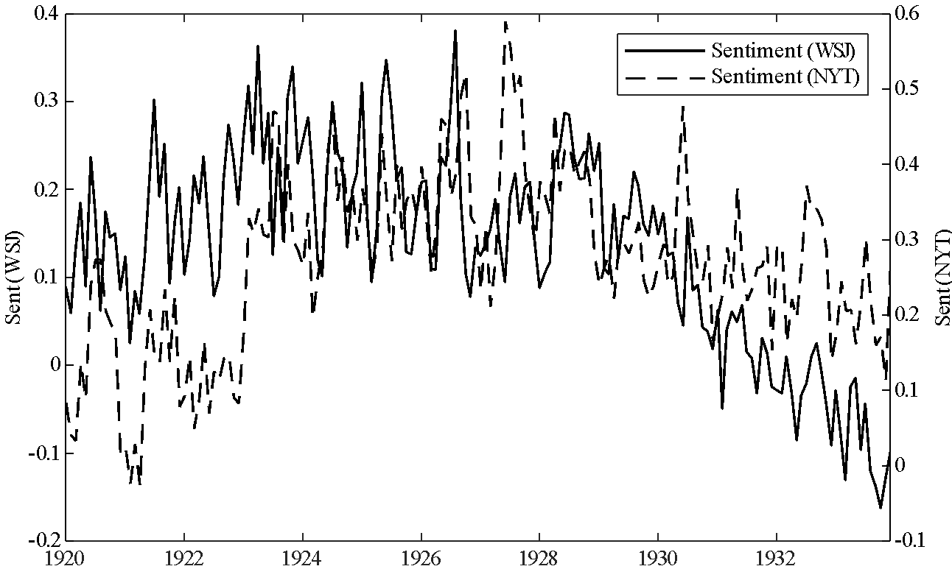

* The solid line represents the sentiment series obtained from the WSJ and the dashed line represents the sentiment series obtained from the NYT. The left hand axis is the scale for the WSJ sentiment series and the right hand axis contains the scale for the NYT sentiment series. The sentiment series is constructed using [1].

**Figure 3: Comparison of Business-sentiment from WSJ with Alternative Loughran and McDonald Series**

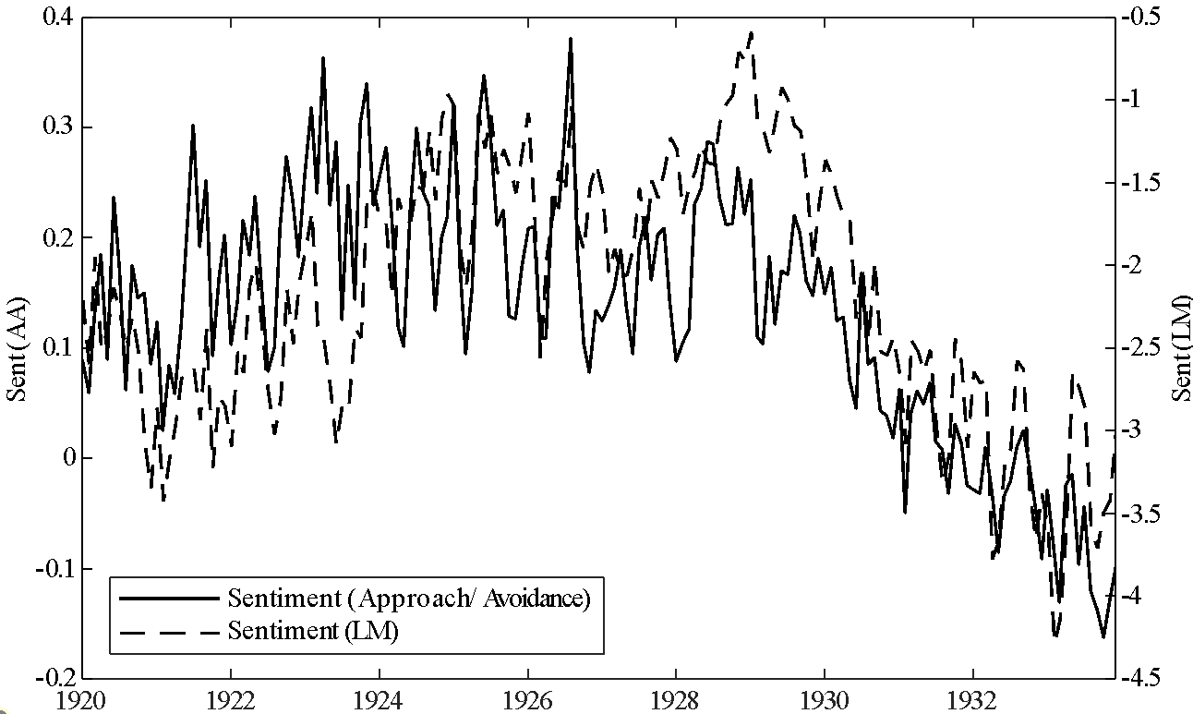

* The solid line represents the sentiment series obtained from the WSJ using the approach and avoidance lexicon while the dashed line represents the sentiment series obtained from the WSJ using the lexicon of Loughran and McDonald.

Figure 3 depicts the business-sentiment series that we construct using the approach/avoidance lexicon and the business-sentiment series constructed using the lexicon of words from LM. While the two series depicted show similar patterns, there are some noticeable differences. One noticeable difference is that the underlying trend in the business-sentiment that we construct turns negative earlier in 1928 than the underlying trend in the business-sentiment series constructed using the lexicon of words from LM. The differences in the two series show that the WSJ derived sentiment series moves before the NYT derived sentiment series. Note that the NYT derived series is derived from all articles in the NYT and not just business and finance related articles. Our conjecture is that sentiment in non-business related news moves after sentiment in business and finance news.

One thing to note is that the limitation of text based approaches is that there is no way to determine the cause of the sentiment of the writer. We can only observe the topic of the article and not the cause of the underlying emotion. A writer’s language can betray their emotion but not the root cause of their emotion. Thus, it is difficult to know what caused the turning point in the observed emotion from reading the articles alone. Analysis of the topics of articles during the period in which the sentiment series turn does not yield strong insights as to what caused the change in the trend of emotion.

# Identification of the Impact of Business-sentiment on the Economy

In order to determine the impact of business-sentiment on the real economy a vector error correction model is estimated that contains the following variables: the (natural) logarithm of industrial production (IP), the logarithm of the Standard and Poor’s 500 stock market index (SP), the logarithm of the secured bank loans (LOANS), the logarithm of the price level (CPI), the nominal interest rate (), the term spread (- the ten year rate minus the three month rate), the credit risk spread (), a measure of economic policy uncertainty (EPU), and our measures of business-sentiment (SNYT and SWSJ). [30] The interest rates are the three month time-loan rates at New York banks and the credit risk spread is the spread between Moody’s seasoned Baa corporate bond yield less the long-term (over 10 years) Treasury composite yield. This credit risk spread is “an indicator of the strength of lender preferences for safe, liquid assets (and hence of the difficulty of borrowers in obtaining funds) …”[31] Time series for these data are depicted in Figure A1 in the online Appendix together with the constructed business-sentiment data from the WSJ and the NYT.

Industrial production is included in the model to incorporate the real side of the economy into the model. We include industrial production rather than GDP/GNP as industrial production is available at a monthly frequency while GDP/GNP is only available at a quarterly frequency at best. During this period, the service component of the US economy was not as large as it is today. We believe the benefit of estimating the model at the monthly frequency outweighs the loss of the information caused by using industrial production over GDP/GNP.

Bank loans are also used in the model. Alternative specifications used M1 and M2. The results we obtained from these alternative specifications were qualitatively similar to the results presented here. Bank loans make up a large part of deposits and so the bank loans series contains similar information to M1 and M2. More importantly, the inclusion of bank loans allows us to model a channel for why business-sentiment affects output. Our hypothesis is that business-sentiment affects, at the margin, decisions to take out loans, which then impacts investment and finally output. As there is no reliable investment data for this period, we included bank loans instead.

There are two sources of news that we use. Our aim is to investigate the business-sentiment content of news from the WSJ as this news is focused on business, finance, and the economy. We include the information gathered from the NYT as well to control for general news, as this paper had a larger circulation during this time. Circulation in December 1928, for instance, was 429,537. [32]

The shock to business-sentiment is identified using an orthogonalized decomposition of the variance-covariance matrix obtained by estimating a vector error correction model (VECM). Note that we also estimated a vector autoregression (VAR) model in “levels” as a robustness check. The results from the VAR were qualitatively similar to the results from our preferred VEC specification.

The business-sentiment series constructed from the WSJ is ordered last in our model. This has a number of implications to the interpretation of the shocks that are identified. First, the business-sentiment shock is orthogonal to all other shocks in the model. That is, the business-sentiment shock is orthogonal to the shock to output, shock to the stock market, shock to bank loans, shock to the price level, shock to the short-term interest rate, shocks to the term and credit risk spreads, shock to economic policy uncertainty, and the shock to the sentiment obtained from the NYT. There is no structural interpretation to these shocks, but it is reasonable to expect that these shocks include aggregate demand and aggregate supply shocks, along with credit market and monetary shocks.

As the business-sentiment variable is ordered last, the identified business-sentiment shock does not have an immediate impact on any of the variables in the econometric model. It is possible however that the business-sentiment that is measured is contaminated by “news.” By ordering business-sentiment last, we are allowing the “news” contamination in measured sentiment to be filtered away leaving pure sentiment. Our reasoning is twofold: first, news about the economy is internalized in stock and credit markets. The business-sentiment shock that is identified is orthogonal to shocks to stock and credit markets. Second, the business-sentiment shock only affects the other variables in the system with a delay. Thus we are identifying shocks to the slow moving (or long-run component) of business-sentiment and not the short-run component. Our identification is that the long-run component of business-sentiment is not contaminated by non-business news.

It should also be noted that the approach of using written text to identify sentiment cannot identify the original cause of the sentiment. There is no guarantee that the topic written about in the article is the cause of the underlying sentiment being betrayed by the author’s use of approach or avoidance words.

The data used in our analysis all contain a unit root and the Johansen test for cointegration yields evidence of four cointegrating vectors. Information criteria suggest that the VECM should be estimated with one lag.[33] The VECM was estimated with the variables ordered as listed above. Orthogonalized shocks are identified using a Cholesky decomposition of the residual variance-covariance matrix. Given the ordering, the business-sentiment shock obtained from the WSJ is interpreted as a “pure” business-sentiment shock after controlling for shocks to industrial production, the S&P 500 stock market index, bank loans, price level (CPI), interest rates (3 month), the term spread, the risk-spread, economic policy uncertainty, and general news.

The VECM was estimated using likelihood methods. The full results are available in an online appendix that is available upon request. The estimates show a stable long-run relationship between the time series with the business-sentiment series obtained from the WSJ have a positive and significant long-run relationship with industrial production, the S&P 500 stock index, and bank loans. The identified business-sentiment shock is depicted in Figure 4. The grey areas in the figure represent the NBER recession dates for this period.

**Figure 4: Identified Business-Sentiment Shock**

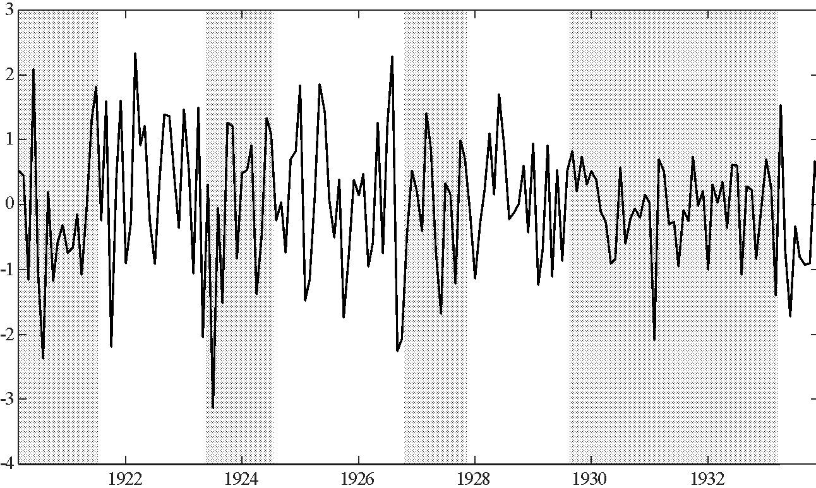

* The solid line represents the identified (orthogonalized) business-sentiment shock obtained from ordering the WSJ sentiment series last in a ten variable vector error correction model. The shaded regions represent NBER recessions.

Table 1 reports the forecast error variance decomposition (FEVD) for each variable to a one standard deviation shock to business-sentiment. The results show that the identified business-sentiment shock accounts for up to sixteen percent of the forecast error variance for industrial production over the medium to long term (20 months), of up to two and a half percent of the forecast error variance for the S&P 500 stock index, of up to twelve percent of the forecast error variance of bank loans, and up to three and a half percent of the forecast error variance of the credit risk spread.

**Table 1: Forecast Error Variance Decomposition of a Shock to Business** **Sentiment**

|  |  |  |  |  |  |  |  |  |  |  |
| --- | --- | --- | --- | --- | --- | --- | --- | --- | --- | --- |
| Period | *ip* | *sp500* | *loans* | *p* |  |  |  | *EPU* |  |  |
| 1 | 0.00 | 0.00 | 0.00 | 0.00 | 0.00 | 0.00 | 0.00 | 0.00 | 0.00 | 78.42 |
| 2 | 1.85 | 0.17 | 0.46 | 0.01 | 0.02 | 0.02 | 0.17 | 1.17 | 0.13 | 72.98 |
| 3 | 4.67 | 0.51 | 3.92 | 0.03 | 0.02 | 0.02 | 1.19 | 1.09 | 0.92 | 67.80 |
| 4 | 7.54 | 1.12 | 7.47 | 0.08 | 0.02 | 0.02 | 2.58 | 1.45 | 2.22 | 63.91 |
| 5 | 10.00 | 1.76 | 10.07 | 0.19 | 0.02 | 0.01 | 3.38 | 1.75 | 3.21 | 61.04 |
| 10 | 15.43 | 2.35 | 12.68 | 0.82 | 0.01 | 0.01 | 2.63 | 1.63 | 4.91 | 53.80 |
| 15 | 16.31 | 2.36 | 11.73 | 1.08 | 0.03 | 0.01 | 2.01 | 1.81 | 5.40 | 49.92 |
| 20 | 16.49 | 2.32 | 10.92 | 1.19 | 0.06 | 0.02 | 1.63 | 1.86 | 5.42 | 47.15 |
| Notes: Numbers reported are in percentages. Lowercase variables are in logarithms. | | | | | | | | | | |

Figure 5 reports the response of each variable to the business-sentiment shock identified from the VECM. The confidence intervals are constructed using the method of Hall with 1000 bootstrap replications.[34] The business-sentiment shock has a positive and significant impact on industrial production, on the S&P 500 stock index, on bank loans, on the credit risk spread, and on the business-sentiment series obtained from the NYT. The business-sentiment shock has a significant and negative impact on the credit risk spread and economic policy uncertainty.

The online appendix contains the full set of impulse response functions but the evidence is that the identified business-sentiment shock does have an impact on important real variables with a delay between 3 and 8 months. This is consistent with the forecast error variance decompositions reported in Table 1.

**Figure 5: Impulse Response Functions for Business-Sentiment Shock**

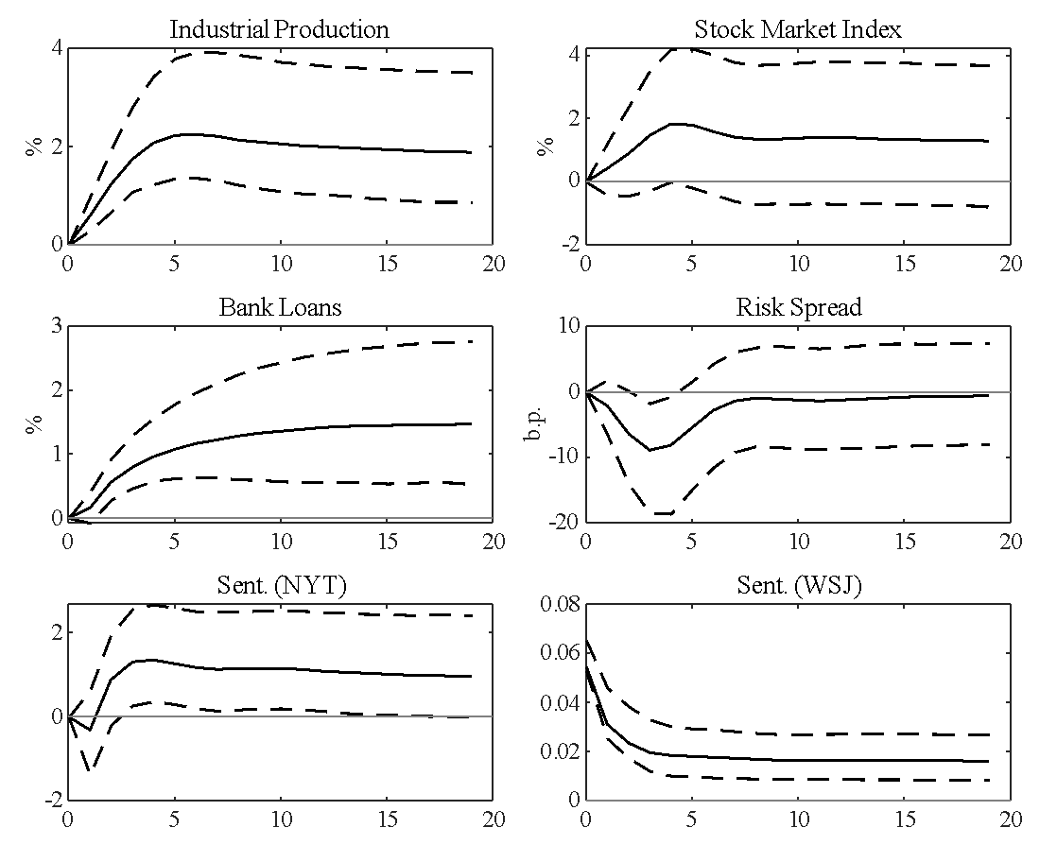

* The solid lines represent the mean impulse response of the selected variables to a one standard deviation shock to the business-sentiment shock. The business sentiment shock was obtained from ordering the WSJ sentiment series last in a ten variable vector error correction model. The dashed lines represent a 95% bootstrapped confidence interval using 1000 bootstrap replications using the method of Hall.

We have shown that the identified business-sentiment shock affects output, the stock market, business loans, and the credit risk spread. The inference is that business-sentiment affects the economy through the credit channel. That is, a positive shock to business-sentiment increases business loans and lowers the credit risk spread, a key measure of the price Baa-rated firms pay for raising capital through the bond market.

Note that the emphasis of this analysis is the identification of the component of shocks to business-sentiment that is orthogonal to a large number of fundamental shocks. These shocks are then used in historical decompositions for different sub-periods of our sample. It is important then that the identified shocks have a consistent interpretation across the whole sample. The forecast error variance decomposition and impulse response functions are not the main priority of the analysis. Alternative approaches to estimating the impulse response function, such as the method of local projections, were not considered, as this approach does not yield an innovation to sentiment with a consistent interpretation across the sample.

Before analysing our results for some important periods of our sample, we note that we performed a number of robustness tests of our specification. We first exchanged the order that the two sentiment series appeared in the model. The results were unchanged suggesting that the sentiment series obtained from the NYT contains different information to the business-sentiment series obtained from the WSJ.

The next robustness checks were to replace the sentiment series obtained from the NYT with alternative sentiment series obtained from the WSJ using the different lexicons of Loughran and McDonald and alternative NYT-based series from Garcia. Our results again did not change suggesting that the lexicon of approach/avoidance words used does have different information content than the standard lexicons used in the literature.

# Historical Decompositions of Important Periods in our Sample

The FEVD and the impulse response functions, reported in Figure 5, report the average impact of a “pure” business-sentiment shock on each series in the model. In this section, we drill down into specific periods to see the impact of the business-sentiment shock using historical decompositions. The historical decompositions report the counterfactual experiment of what would have happened had the business-sentiment shock not occurred. That is, the business-sentiment shock is set to zero for all dates in the sub-period and a counterfactual series is created using the estimated model. The periods that we chose are either periods where there are large one-off shocks to business-sentiment or periods where there are runs of shocks of one sign. The historical decomposition therefore allows us to report the accumulated impact of the business-sentiment shocks.

In what follows, we look in more detail at some periods in our sample and comment on what might have driven business-sentiment during these periods. In particular, how much optimism, and how much worry, were generated by observations of domestic developments. In addition, how far did articles reflect a concern that foreign developments, financial instability, worries about government debt levels, but also labor militancy, might spill over into the US? The online appendix reports historical decompositions for all variables and for a larger set of sub-periods. Here we report the historical decomposition for important variables and for periods in which there were some large impacts.

During the early 1920’s there was a sharp recession in the United States. The first period that we investigate using historical decompositions is the period from July 1920 to May 1921. During this period, there was a run of moderately large negative business-sentiment shocks, as seen in Figure 4.

Figure 6 depicts the historical decomposition for this period. The solid line in each tile is the actual data for this subperiod and the dashed line is the counterfactual series under the assumption that the business-sentiment shocks are set to zero from July 1920 to May 1921. In order to compare industrial production, the stock market index, and bank loans, each variable is normalized to be 100 at the start of the period. For the credit risk spread, the historical decompositions are reported in deviations from the initial value, in basis points.

It is quite clear from the figure that the impact of the run of moderately large business-sentiment shocks in late 1920 to early 1921 had a significant impact on some of the variables of our system. Measured business-sentiment, obtained from the WSJ, would have been roughly four times higher had business-sentiment only been driven by the other shocks in the system. The impact of this lower business-sentiment was to lower industrial production, lower the stock market, lower bank loans, and increase the credit risk spread.

**Figure 6: Historical decomposition for July 1920 to May 1921**

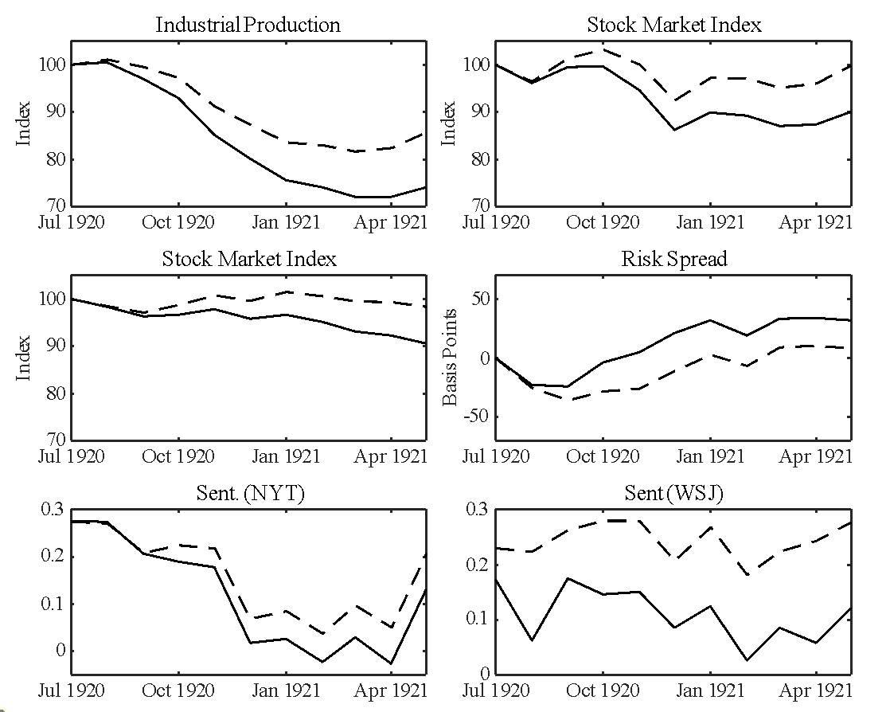

*Industrial production, the stock market, bank loans, and prices are normalized to equal 100 for the first date of each subperiod. The credit risk spread is measured in deviations (in basis points) from the value at the first date of each subperiod. The solid line is the actual data while the dashed line is the counterfactual series with the business-sentiment shock removed.

As can be seen by the dashed line, had it not been for the run of negative business-sentiment shocks, industrial production would have been fifteen percent higher than it actually was. That is the accumulated impact of the run of negative business-sentiment during this period was to lower industrial output by about fifteen percent. The impact on the stock market was eleven percent and the impact on bank loans was about eight percent. The credit risk spread was about twenty-five basis points higher.

During this period, the run of negative business-sentiment shocks has a significant impact on industrial production and the stock market. The credit channel is the obvious explanation for this as we see that bank loans decrease due to the negative business-sentiment and it was also more expensive for Baa-rated firms to raise capital in the bond market.

The articles that score high on “avoidance” dealt with domestic conditions in the US, but also with the impact of foreign political uncertainties, especially the western military push of the Soviet armies, and the uncertainty about Germany and reparations. In July 1920, the highest rating article in “avoidance” terms reported on the complaint of Comptroller of the Currency John Skelton Williams about the ‘excessive and burdensome interest rates, running up to 10, 12, and 15 percent and higher’ charged by New York banks.[35] Other articles dealt with transportation difficulties, and coal shortages, with discussions that the wartime control of coal might be required to combat bottlenecks in the supply of bituminous coal and anthracite.[36] In August 1920, a substantial number of articles were concerned with the slow pace of downward wage adjustments and consequent threats to profitability.[37] While consumer prices were falling during this period, railway wages were not. There was deep concern that the Interstate Commerce Commission was not allowing railroads to increase their shipping prices, which was affecting profits. This meant that railroads were not investing in increased capacity leading to problems with capacity constraints within the system.

The next period in the early 1920’s is from June 1921 to March 1922. This reflects the expansion of output after the end of the recession in 1921. This is also a period of predominantly large positive shocks to business-sentiment. A characteristic article is the upbeat reflection of Charles M. Schwab, the steel magnate and former director-general of the wartime Emergency Fleet Corporation: ‘Out of the decisions which are made within the few months there may arise the *greatest* prosperity the world has ever known ….it is impossible for me to be anything but an optimist. To me the world is so full of opportunity and *promise* and *confidence*, that I cannot look forward to anything but a future full of *brilliance* and abundance.’[38]

The historical decomposition for this sub-period can be found in Figure 7. This period is a mirror image of the previous sub-period in that the run of predominantly positive business-sentiment shocks have significant and positive impact on industrial production, the stock market, bank loans, and the credit risk spread. Industrial production is higher by seven percent than the counterfactual industrial production series, the stock market is five percent higher, bank loans are four percent higher, and the credit risk spread is twenty-eight basis point lower in October 1921. Again, this points to business-sentiment affecting the economy though the credit channel.

**Figure 7: Historical Decomposition for June 1921 to March 1922.\***

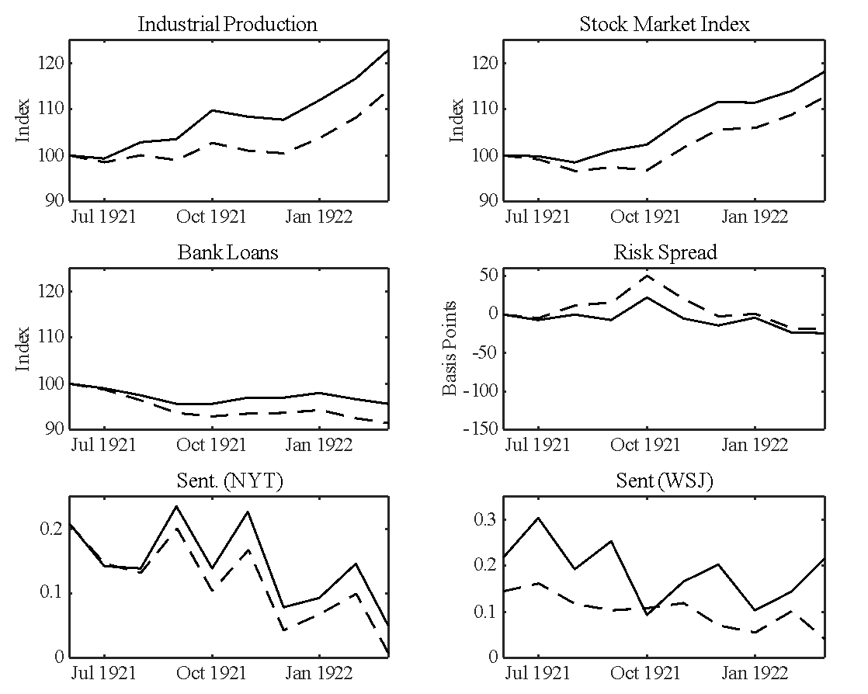

* Industrial production, the stock market, bank loans, and prices are normalized to equal 100 for the first date of each subperiod. The credit risk spread is measured in deviations (in basis points) from the value at the first date of each subperiod. The solid line is the actual data while the dashed line is the counterfactual series with the business-sentiment shock removed.

The next period that we investigate is the period from May to November of 1923. In May, July, and September there are large negative shocks to business-sentiment, with the July 1923 shock being the largest shock over the whole sample as seen from Figure 4. This is also the start of an official recession. Figure 8 depicts the historical decomposition for this period. The accumulated impact of these large negative business-sentiment shocks are that industrial production is twelve percent lower than the counterfactual series, the stock market index is nine percent lower, market index, bank loans are six percent lower, and the credit risk spread is thirty-seven basis points higher. The

**Figure 8: Historical Decomposition for May 1923 to November 1923.\***

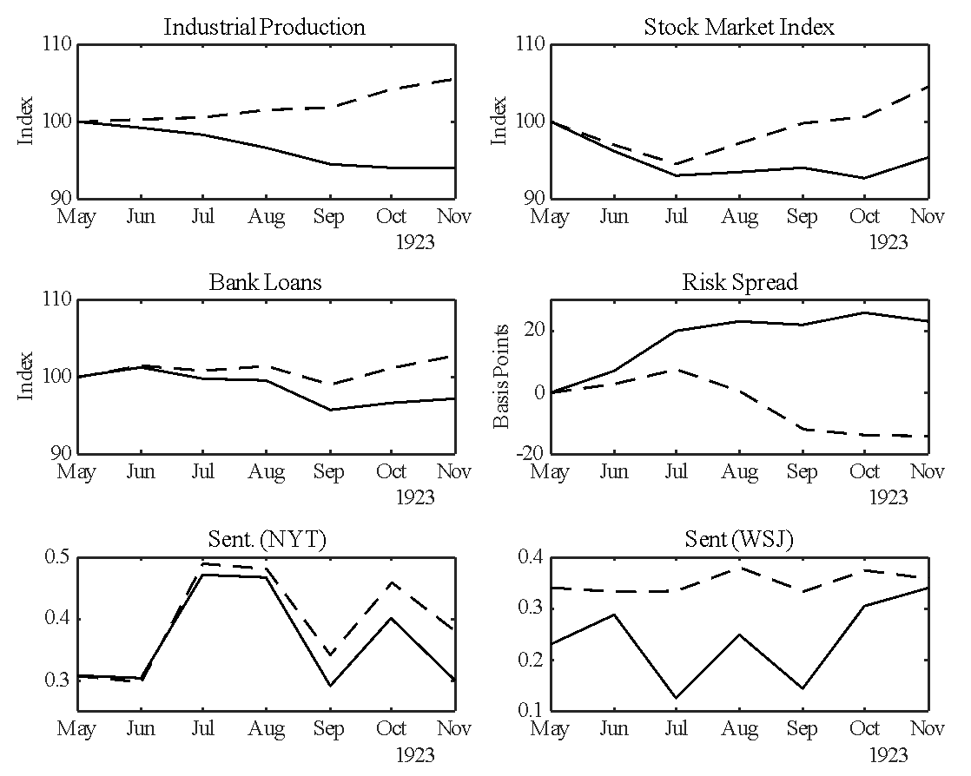

* Industrial production, the stock market, bank loans, and prices are normalized to equal 100 for the first date of each subperiod. The credit risk spread is measured in deviations (in basis points) from the value at the first date of each subperiod. The solid line is the actual data while the dashed line is the counterfactual series with the business-sentiment shock removed.

historical decompositions reported in Figure 8 all show that the negative sentiment shocks had a significant and negative effect on the economy.

These sentiment shocks relate very clearly to conditions in Europe. A characteristic piece in the WSJ, the highest “avoidance” rated piece in July 1923, the month of the greatest negative shock, was a report on the return to the U.S. of Oscar W. Underwood, Democratic Senator from Alabama, and two times a serious contender for the Presidency, who spent four months in Europe observing economic and political conditions: ‘most. like myself, have failed to realize how exhausted by war are many of the nations of Europe, both as to governmental finance and private endeavour. There is a hectic business development along certain lines, but it more largely comes from the money of the profiteer. … Stability of government is almost as *uncertain* as stability of finance. In one country it may be a near revolution that *threatens*, in another a change of ministry, but in either event the government working under such conditions is generally weak, and drifting from day to day without effective policy for the future, instead of moving forward to a goal that can be won by political courage with a definite policy.’ In addition, Underwood then complained that American policy was unhelpful: ‘We seem to be just observing and drifting.’[39] The case is not that the European misery was hurting America directly, but that it was dragging down business-sentiment.

The year 1926, in which growth was generally sustained and resilient, provides some interesting examples of how sentiment shocks affect economic outcomes. Starting in May 1926 and ending in August 1926, there is a surge in our business-sentiment index, culminating in a large positive business-sentiment shock in both July and August of 1926. However, in September 1926 there is an almost equally as large negative business-sentiment shock that lasts for two months, as can be seen in Figure 4.

The impact of the large swings in business-sentiment can be seen in the historical decompositions depicted in Figure 9. The impact of the positive business-sentiment shock in July and August is profound. In fact, had it not been for the business-sentiment shock in July and August, business-sentiment would have fallen. The same is observed for industrial production. The actual industrial production series continues its upward trend from August to

**Figure 9: Historical Decomposition for February 1926 to April 1927.\***

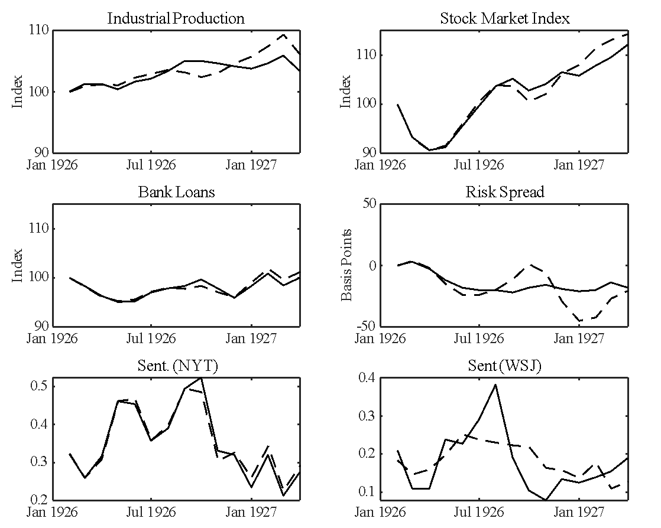

* Industrial production, the stock market, bank loans, and prices are normalized to equal 100 for the first date of each subperiod. The credit risk spread is measured in deviations (in basis points) from the value at the first date of each subperiod. The solid line is the actual data while the dashed line is the counterfactual series with the business-sentiment shock removed.

September, whereas the red counterfactual series shows industrial production declining during this period. Had it not been for the positive business-sentiment shock in August it appears that industrial production should have fallen. The gap between the actual industrial production and the counterfactual industrial production is maximized in October and is equal to three percent. At the same time, the stock market index is three percent higher than the counterfactual series and the bank loans is about one percent higher than the counterfactual value. The credit risk spread is also impacted by the business-sentiment shock in August. The actual credit risk spread is flat throughout the latter part of 1926 whereas the counterfactual credit risk spread series is nineteen and a half basis points higher than the actual spread.

The model predicts that, had it not been for the large positive business-sentiment shock in August, the economy would have had a sharp negative correction. In September, there is a sharp negative business-sentiment shock and this shock has the opposite effect on the variables of the model. Actual industrial production falls whereas the counterfactual series would have risen. By the end of 1926, the impact of the two, opposing business-sentiment shocks, have cancelled each other out.

This is an interesting period, as the impact of the business-sentiment shock appears to be sharp but short-lived. In the summer (June through August), there was a general level of anxiety about events in Europe, especially the currency problems in Belgium and France, but this is more than made up by positive news. The positive news is dominated by stories about railroads and crops, i.e. about the events driving the US domestic economy. During this period, there are many articles containing a high number of approach words that refer to record crop yields in the upper plains and high profits for railroads, especially the Great-Northern railroad. Also during this time there are articles extolling the soundness and competitiveness of the US economy. There is also a notably high degree of triumphalism.

An ecstatic article on the way foreign countries perceived the 150th anniversary of the Declaration of Independence, for instance, commented on ‘the *amazing* progress that has been made by the United States’ and details of the ‘*incredible* total’ of American wealth: ‘Articles are appearing in the British press describing the money glut in the United States-the vast hoard of more than half the gold of the world. The American government has asurplus of $350,000,000, says the daily press, while the British government has a deficit of at least $100,000,000.’ [40] The story with the highest approach rating starts with a celebration of United States Steel’s ‘*brilliant* performance.’[41] However, there is no one unifying theme in this triumphalism suggesting that the run up of business-sentiment during the middle of 1926 reflects a surge in sentiment rather than being the result of any specific news.

In September, 1926 there followed an equally sizeable negative business-sentiment shock, with worries about US trade performance and competitiveness, as exports to Canada and Germany produced gold outflows from the US.[42] Interestingly, the article that is top in avoidance terms concerned allegations of market manipulation through the press – the *Wall Street Journal* and the Dow Jones ticker. C. W. Barron, the president of Dow Jones, assured the readers of his newspaper that he had never had occasion to sack any reporter for ‘faithlessness.’ [43] There is also discussion of bad weather in Texas and disease and pestilence in the cotton crop. This period provides an example of a short sharp bout of enthusiasm followed by what appears to be an overreaction the other way. The impact on industrial production is short and sharp as well. The overall impact is about four percent with a short increase in when the counterfactual series suggests industrial production should have gone the other way.

Then there are two large negative sentiment shocks at the same time fundamentals would suggest an increase in industrial production was likely. Actual industrial production fell when the counterfactual industrial production series, where the sentiment shocks are set to zero, was rising. We also see the stock market index rising slower than what would have been predicted without the sentiment shocks and we see that the credit risk spread would have been substantially lower had it not been for the negative business-sentiment shocks in September and October.

The turn to a strong negative business-sentiment shock in September and October 1926 well illustrates the way in which it is not specific news, but rather general doubts, often about market integrity, that pulled down investor spirits. Some of the shock came simply from the technical operation of the market and the constraints on credit it imposed. Thus at the end of September there was heavy calling of loans, and ‘stocks dragged through another day of *uncertainty* as a result of heavy requisitions for money in connection with October first settlements.’ There was in consequence ‘a heavy drain on credit available for speculative purposes.’ It led, considerable selling of stocks carried on margin.[44]

The more interesting articles, and ones that score highest in negative sentiment, looked at accusations that the market was being rigged. On this issue, the WSJ was generally defensive, and argued that the charges were ill-founded; but it is plausible that just the discussion of the issue sowed seeds of doubt. Thus, for instance the highest-ranking article in avoidance in September 1926 was an interview with B.C. (Bertie Charles) Forbes, the founder of *Forbes Magazine*, over the handling in WSJ of an interview with JP Morgan partner Thomas Cochran, and claims that the newspaper had tried to manipulate stock in the financial interest of its writers or staff. Forbes gave a forceful defense, but perhaps protested too much: ‘I have trained the Dow-Jones staff over many years; and if a single member of it was faithless to his trust, or gave any subscriber an advantage over any other subscriber, or in any way used his information for private personal gain, he would be shunned by his associates ever before he would be by me decapitated. I am happy to say that I do not recall ever having to discharge a reporter in any city for faithlessness to his trust as a financial journalist.’[45] The second highest in avoidance terms in September was also an article about accusations of market manipulation, this time by the oil industry after the Attorney General of Texas brought a suit against the Marland Oil Co. [46]

The same debate was at the top of the negative articles in October 1926 that delivered yet a new sentiment shock. ‘Corporate publicity, as a question affecting the investor in securities, looms largely in the public eye today. This is due to a great extent to the articles by Professor William Z. Ripley who has been attacking such corporations as *fail* [sic] to give their stockholders and the investing public at large a full account of their activities and financial standing.’ Again, the WSJ attempted a defense of corporations against the charges of rigging: ‘The work of the stock exchange making for fuller information for stockholders has not won the praise it deserves; in fact, the exchange often has been for its *failure* to insist on such publicity. These criticisms have been due for the most part to the fact that few people understand the limitations under which the exchange naturally operates, or are aware of the efforts it has made and is still making.’[47] There were similar discussions of accusations that the major houses were manipulating the bond market, and again the WSJ was defensive: ‘some of the agitation has no relation whatever to the question of helpfulness to the corporation but is rather a poorly disguised attempt to handicap larger banking houses, which by years of active counsel and work have acquired the designation of bankers for this or that company, with the pretence also of aiding the smaller houses.’ [48]

The period leading up to the October 1929 crash is of particular interest. From April to August of 1928 there are a run of moderately sized positive sentiment shocks. Then starting in February 1929 through July 1929 there are a run of large negative sentiment shocks with the largest negative sentiment-shock occurring in May 1929.

Finally, the foreign themes appeared again, with articles that defended the status quo against doubts or pessimism scoring high. The WSJ thus relayed a report of a prominent banker, Henry M. Robinson, President of First National Bank of Los Angeles, denying that the reparations settlement was unsustainable, producing an article whose ostensible message was upbeat or comforting. ‘It is rather surprising that bankers and economists in the United States should be expressing opinions to the effect that there must be a revision of the Dawes Plan, when the Agent General’s report gives them nothing on which to base their assertions.’[49] Just the discussion of uncertainties was sufficient to engender market nervousness.

The historical decomposition for the period from April 1928 to December 1928 can be found in Figure 10. The run of positive business- sentiment in the middle of 1928 can be seen to have impacted industrial production, the stock market, bank loans, and the credit risk spread considerably. By December 1928, the accumulated impact of the positive sentiment shocks amount to a difference of nine percent for industrial production, six percent for the stock market index, four and a half percent for bank loans, and twenty-nine basis points for the credit risk spread. Had it not been for the positive sentiment in the middle of 1928, industrial production would have been flat while the credit risk spread would have risen sharply.

**Figure 10: Historical Decomposition for April 1928 to December 1928.\***

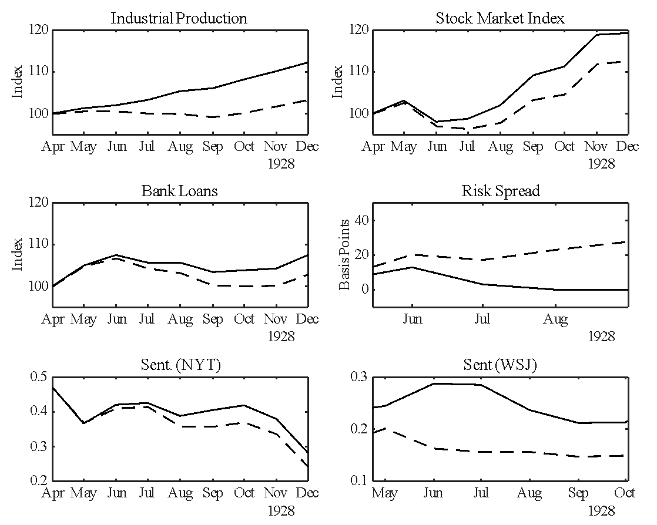

* Industrial production, the stock market, bank loans, and prices are normalized to equal 100 for the first date of each subperiod. The credit risk spread is measured in deviations (in basis points) from the value at the first date of each subperiod. The solid line is the actual data while the dashed line is the counterfactual series with the business-sentiment shock removed.

As shown in Figure 4, there are large negative business-sentiment shocks in the first half of 1929 with the largest negative shocks occurring in

February, March, and May of 1929. The historical decomposition for this period can be found in Figure 11. It can be seen that the run of negative business-sentiment shocks in early 1929 had the effect of dampening industrial production. By September 1929, industrial output was three percent lower than the counterfactual series. The overall shape of the actual and counterfactual series were the same but had it not been for the negative business-sentiment shocks, industrial production would have been lower. The stock market and

**Figure 11: Historical Decomposition for January 1929 to December 1929.\***

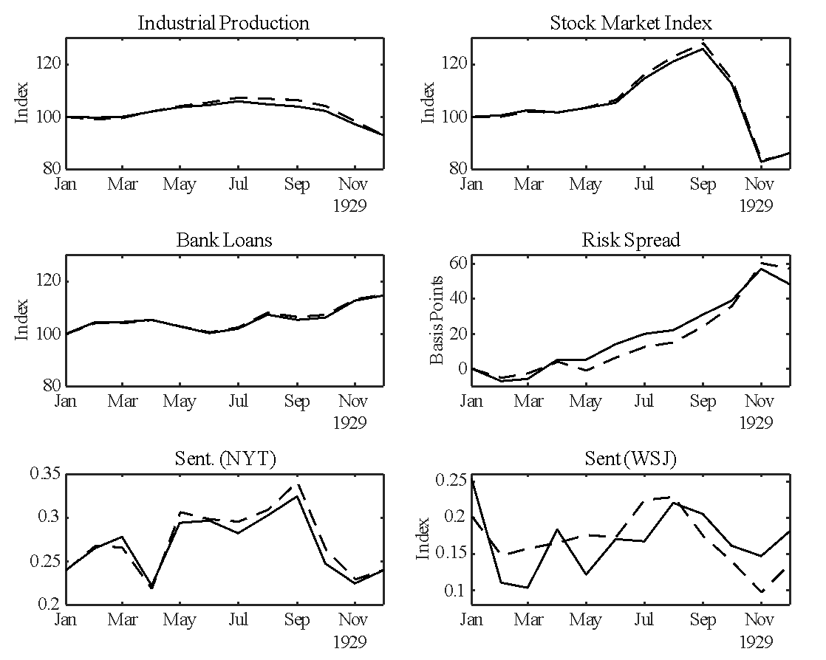

* Industrial production, the stock market, bank loans, and prices are normalized to equal 100 for the first date of each subperiod. The credit risk spread is measured in deviations (in basis points) from the value at the first date of each subperiod. The solid line is the actual data while the dashed line is the counterfactual series with the business-sentiment shock removed.

bank loans were also lower by two and a half percent and one percent respectively. The credit risk spread was higher by seven basis points compared to the counterfactual. The impact of the negative business-sentiment shocks was to steadily raise the cost of bond financing for Baa-rated firms.

With one exception, in February 1929, the lead-up to the dramatic stock market events is punctuated less by worries about bad or dangerous developments than by a cooling of enthusiasm, a diminution of the grounds for any euphoria. There was a shortage of any general optimistic vision. In February 1929, there was a surge of avoidance terms, mostly associated with the Federal Reserve’s restriction of broker loans. The daily “Abreast of the Market” market gossip and news column of February 11 explained that: “Sentiment generally continues pessimistic. There is a feeling that the latest warning of the Federal Reserve Board has attracted more attention than those of the past month and as a result, a general tendency to clean house is noted, particularly among those outsiders who have been outspokenly optimistic right along. Conservative observers plan to continue to favor taking profits whenever opportunities are presented, because they feel that before the market reaches a level where good buying will be encountered stocks can be repurchased at more reasonable figures.”[50] Writers were highly critical of the Federal Reserve’s crackdown on broker’s loans and there was commentary during this period that this would affect business’ access to credit, as money would be diverted to the stock market from commercial loans.

The newspaper reported on a National City Bank report’s “alarm” at the ‘extraordinary growth of unregulated non-bank loans being made for speculative purposes, not because the size of brokers’ loans is of itself dangerous, but because non-bank lenders feels little responsibility towards the money market, may withdraw their funds at a moment’s notice, and thus place upon banks the responsibility of maintaining the money market on an even keel.’[51] There were complaints about the “smug silence” of the New York Fed.[52] Other worries included difficulties for railroad mergers, such as objections to a merger of the Chesapeake & Ohio with the Baltimore & Ohio.[53]

For the rest of the year leading up to the October crash, however, there is not so much of a surge in avoidance terms, as an absence of approach terms, a lack of reasons to be enthusiastic about the economy or stock market. After October 1929, there is a long period of prevalence of avoidance terms, unsurprisingly given the worsening state of economic news.

From 1930, news was generally negative, but so of course was the reality that was being reported. Industrial production fell twenty percent in 1930 and a further twenty percent in 1931. The stock market fared even worse. The online companion to this paper shows the effect of business-sentiment during this period. While there are some impacts, the impacts are relatively small compared to the overall changes in the variables of interest. The only period where business-sentiment appears to make a sizeable impact is towards the end of 1933 where a run of negative business-sentiment affected industrial production and the stock market. This can be seen in Figure 12. During this period, industrial production rose by fifty percent and the stock market doubled. The impact of the run of negative business shocks in the later part of 1933, lowered industrial production by ten percent and lowered the stock market index by seven and a half percent. Bank loans are down by five percent and the credit risk spread is higher by twenty-five basis points in October of 1933.

These shocks appear much more clearly in the reporting and news interpretation of the WSJ than in the NYT, and reflect a worry about the political direction of the Roosevelt administration and the New Deal. Thus, the top-ranking “avoidance” article in July 1933 is simply a report of the “bombshell” message that Roosevelt deployed to break up the sputtering London World Economic Conference.[54] Other articles worry about the effect of the new labor codes on wage costs and profitability in the energy industries;[55] or about the way in which the administration was relying on a policy of depreciating the dollar: ‘as the practical difficulties of industrial and agricultural control develop, this tendency to cling to and emphasize currency management will become more marked.’[56] The measurement of business-sentiment then reflects a real drag on the economic recovery process that was central to the objectives of the new administration.

It should be noted that there were many important news events during the 1930’s, such as Britain leaving the gold standard, that do not show up in the identified business-sentiment shocks. This lends credibility to our assertion that we have filtered out news shocks from the identified business-sentiment shock.

**Figure 12:** Historical Decomposition for July 1932 to December 1933.*

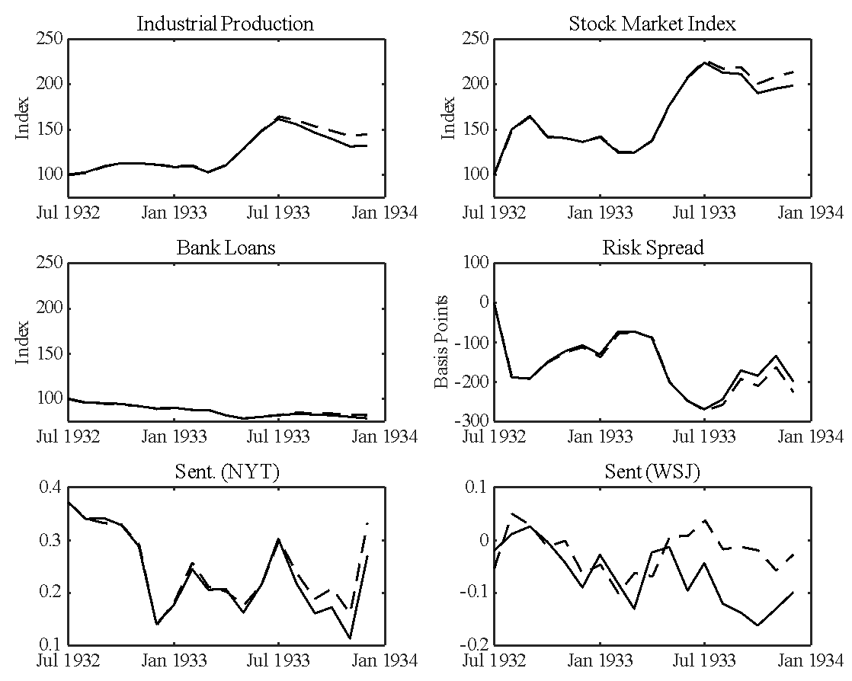

* Industrial production, the stock market, bank loans, and prices are normalized to equal 100 for the first date of each subperiod. The credit risk spread is measured in deviations (in basis points) from the value at the first date of each subperiod. The solid line is the actual data while the dashed line is the counterfactual series with the business-sentiment shock removed.

# Summary and Conclusions

According to several historical accounts, the credit and business cycles of the 1920’s and the Great Depression were influenced by sentiment, but these accounts struggle to measure the precise impact. This paper uses novel techniques and new data sources to investigate the scale and timing of the impact of these sentiments on the macro economy, in a dynamic setting, and thus to precisely specify how sentiment moved the economy at critical moments.

We hypothesise that newspaper articles of the time contain information related to the state of emotions or confidence of economic agents as well as information about the fundamentals of the economy. We use over 250,000 digitized articles from the WSJ to algorithmically derive a monthly business-sentiment index based on emotion related words. The emotion component is constructed to be orthogonal to the fundamental shocks to the real economy and credit markets through the use of a vector error correction model. We interpret the business-sentiment shocks as capturing the change in economic agents’ perceptions over time.

We show the identified business-sentiment shocks had economically significant effects on industrial production, the S&P 500 stock market index, bank loans, and credit spreads during some important periods of our sample, implying a distinct role for business-sentiment in the credit and business cycles of the 1920’s and the Great Depression.

In some periods, such as in 1921 and 1926, changes in agents’ perceptions are hard to reconcile with any specific events in the news. In these cases, foreign and domestic news were creating mood music, rather than specific information, with rhapsodizing about the “greatest prosperity the world has ever known” alternating with gloom, frequently spurred by Europe’s intractable political problems, but also by reflections on the organization and structure of American business.

We contribute to the literature, in a number of ways. Firstly, while the focus of attention in prior studies has been the stock market, inflation expectations, or uncertainty, we investigate the major components of the macroeconomy including the financial side, in a dynamic setting. Second, our method employs digitized data for historical time periods using very large textual databases, establishing further these emerging techniques for use in historical finance and macroeconomics. We also show that our sentiment index contains different information to existing state of the art sentiment lexicons and provide a method of sentiment analysis that can be applied to other historical databases. Lastly, by using data at the monthly frequency, we are able to provide a clearer understanding of the nature and timing of business-sentiment shocks and the intensity and timing of the reactions of major subcomponents of the economy. This allows for much improved identification of when and how these business-sentiments behaved and how they transmitted across the economy.

# References

Baker, S. R., Bloom, N., Davis, S. J. (2016). ‘Measuring Economic Policy Uncertainty’ *Quarterly Journal of Economics*, 131(4) 1593-1636 <https://doi.org/10.1093/qje/qjw024>

Bandelj, N. (2009) ‘Emotions in economic action and interaction’. *Theory and Society*, 38(4): 347–36. <https://doi.org/10.1007/s11186-009-9088-2>

Berezin, M. (2005) Emotions and the Economy. In Smelser, N. and Swedberg, R. (eds) The Handbook of Economic Sociology (2nd edition). New York and Princeton: Russell Sage Foundation and Princeton University Press, pp. 109 131. <https://doi.org/10.1515/9781400835584.109>

Bernanke, B. (1983) ‘Nonmonetary Effects of the Financial Crisis in the Propagation of the Great Depression’ *The American Economic Review* 73,(3) 257-276 <https://doi.org/10.3386/w1054>

Bernanke, B. (2004). *Essays on the Great Depression* Princeton: Princeton University Press.

Binder, C., (2016). ‘Estimation of historical inflation expectations,’ *Explorations in Economic History*, 61, pp.1-31.

Binder, J.R., Conant, L.L., Humphries, C.J., Fernandino, L., Simons, S.B., Aguilar, M., and Desai, R.H. (2016). ‘Toward a brain-based componential semantic representation.’ *Cognitive Neuropsychology*, 33(3-4). pp. 130-174.

Borowiecki, K. J. (2017): “How Are You, My Dearest Mozart? Well-Being and Creativity of Three Famous Composers Based on Their Letters,” *Review of Economics and Statistics*, 99, 591–605.

Bruner, J. (1990). *Acts of meaning*. Cambridge, Mass.: Harvard Univ. Press. <https://doi.org/10.1017/s0033291700030555>

Calomiris, C. W. and Mamaysky, H., (2019). "How News and Its Context Drive Risk and Returns Around the World," *Journal of Financial Economics*, 133(2), Pages 299—336. https://doi.org/10.1016/j.jfineco.2018.11.009

Cecchetti, S. G., (1992). “Prices during the Great Depression: Was the deflation of 1930-1932 really unanticipated?” *The American Economic Review*, 82(1): 141 – 156.

Choi, H. and Varian, H., (2012). ‘Predicting the present with Google Trends’. *Economic Record*, *88*(s1), pp.2-9 <https://doi.org/10.1111/j.1475-4932.2012.00809.x>

Chong, K. and Tuckett, D. (2015). ‘Constructing conviction through action and narrative: how money managers mange uncertainty and the consequence for financial market functioning,’ *Socio-Economic Review*, 13(2), Pages 309 – 330.

Cowles, A. and associates, (1938) *Common Stock Indexes, 1871 – 1937*, Cowles Commission for Research in Economics, Monograph 3, Principia Press Inc. , Bloomington, Indiana.

Daniel, V. and Steege, L., 2020. Inflation expectations and the recovery from the Great Depression in Germany. *Explorations in Economic History*, 75, p.101305.

Damasio, A. (1999). *The feeling of what happens*. New York: Harcourt Brace. <https://doi.org/10.26439/persona2000.n003.1708>

De Long, J. and Shleifer, A. (1991). ‘The stock market bubble of 1929: evidence from closed-end mutual funds’, *The Journal of Economic History*, 51(03), pp.675-700. <https://doi.org/10.1017/s0022050700039619>

Dominguez, K. and Shapiro, M. (2013). ‘Forecasting the Recovery from the Great Recession: Is This Time Different?’ *American Economic Review*, 103(3), pp.147-152. <https://doi.org/10.1257/aer.103.3.147>

Fisher, I. (1932). *Booms and Depressions. Some first principles*. New York: Adelphi.

Galbraith, J.K. (1955). *The Great Crash, 1929* Boston: Houghton Mifflin

Garcia, D. (2013) ‘Sentiment during Recessions’ *The Journal of Finance*, 68(3), pp.1267-1300 https://doi.org/10.1111/jofi.12027

Graham, B. and Dodd, D. (1934). *Security analysis*. [New York]: McGraw-Hill.

Haddow, A, Hare, C, Hooley, J and Shakir, T (2013) ‘Macroeconomic uncertainty; what is it, how can we measure it and why does it matter?’ *Bank of England Quarterly Bulletin*, Vol. 53, No. 2, pages 100-109.

<https://www.bankofengland.co.uk/quarterly-bulletin/2013/q2/macroeconomic-uncertainty-what-is-it-how-can-we-measure-it-and-why-does-it-matter> [accessed 11 October 2017]

Hall, P. (1992). *The Bootstrap and Edgeworth Expansion*, New York: Springer-Verlag.

Hanna, A. J., J. D. Turner, and C. B. Walker (2020): “News Media and Investor Sentiment during Bull and Bear Markets,” *European Journal of Finance*, 26, 1377–195.

Hills, T. T., E. Proto, D. Sgroi, and C. I. Seresinhe (2019): “Historical Analysis of National Subjective Wellbeing Using Millions of Digitized Books,” *Nature Human Behaviour*, 3, 1271–75.

Jalil, A. and Rua, G., (2016). Inflation expectations and recovery in spring 1933. *Explorations in Economic History*, 62, pp.26-50.

Johansen, S. (1995). *Likelihood-based Inference in Cointegrated Vector Autoregressive Models*, Oxford: Oxford University Press.

<https://doi.org/10.1093/0198774508.001.0001>

Johnson, S.G.B, Bilovich, A. and Tuckett, D. (2021). ‘Conviction Narrative Theory: A theory of choice under radical uncertainty,’

https://doi.org/10.31234/osf.io/urc96

Keynes, J.M. (1936). *The General Theory of Employment, Interest, and Money*. Palgrave Macmillan.

Lennard, J. (2020): “Uncertainty and the Great Slump,” *Economic History Review*, 73, 844–67.

Loughran, T. and McDonald, B., (2011). ‘When is a Liability not a Liability? Textual Analysis, Dictionaries, and 10-Ks,’ *Journal of Finance,* 66(1), 36—65.

Manela, A. and Moreira, A., (2017). ‘News implied volatility and disaster concerns’, [*Journal of Financial Economics*](https://ideas.repec.org/s/eee/jfinec.html), 123(1), pages 137-162. [https://doi.org/10.1016/j.jfineco.2016.01.032](https://doi.org/10.1016/j.jfineco.2016.01.032%C2%A0)

Mankiw, N. G. and Miron, J. A., (1985). ‘The Changing Behavior of the Term Structure of Interest Rates,’ NBER Working Paper No 1669, NBER, Cambridge, MA.

Mathy, G. (2020): “How Much Did Uncertainty Shocks Matter in the Great Depression?” *Cliometrica*, 14, 283–323.

Mathy, G. amd Ziebarth, N. (2017). “How much does Political Uncertainty Matter? The Case of Louisiana under Huey Long.” *The Journal of Economic History*, 77(1): 90 – 126.

Püttmann, L. (2018). ‘Patterns of Panic: Financial Crisis Language in Historical Newspapers (April 27, 2018). SSRN: http://dx.doi.org/10.2139/ssrn.3156287

Ramey, V. and Shapiro, M. (1999). ‘Displaced Capital’. *SSRN Electronic Journal*. <https://doi.org/10.2139/ssrn.138980>

Rappoport, P. and White, E.N., (1993). ‘[Was There a Bubble in the 1929 Stock Market?](https://ideas.repec.org/a/cup/jechis/v53y1993i03p549-574_01.html)’, [*The Journal of Economic History*](https://ideas.repec.org/s/cup/jechis.html), Cambridge University Press, vol. 53(03), pages 549-574 <https://doi.org/10.1017/s0022050700013486>

Romer, C.D. (1990) ‘The Great Crash and the Onset of the Great Depression’ *The Quarterly Journal of Economics*, 105 (3) 597-624. https://doi.org/10.2307/2937892

Romer, C. D. and Romer, D.H. (2010) ‘The Macroeconomic Effects of Tax Changes: Estimates Based on a New Measure of Fiscal Shocks*.’ American Economic Review*, 100 (3), 763-801 <https://doi.org/10.1257/aer.100.3.763>

Rosenberg, Jerry M. (1982) *Inside the WSJ: The Power and the History of Dow Jones and Company and America’s most influential Newspaper,* Macmillan, ISBN 9780026048606.

Shiller, R. (1981). ‘Do Stock Prices Move Too Much to be justified by Subsequent Changes in Dividends?’ *The American Economic Review,* *71*(3), 421-436.

(2000). *Irrational Exuberance,* Princeton University Press. <https://doi.org/10.1108/jes.2001.28.6.446.1>

Tetlock, P.C. (2007). ‘Giving Content to Investor Sentiment: The Role of Media in the Stock Market’. *The Journal of Finance*, 62(3): pp. 1139–1168 <https://doi.org/10.1111/j.1540-6261.2007.01232.x>

Tuckett, D. (2011). *Minding the Markets: An Emotional Finance View of Financial Instability*. Palgrave Macmillan. <https://doi.org/10.1057/9780230307827>

Tuckett, D. Smith, R.E. and Nyman, R. (2014) ‘Tracking phantastic objects: A computer algorithmic investigation of narrative evolution in unstructured data sources, *Social Networks*, Volume 38, Pages 121-133, ISSN 0378-8733, Available at SSRN: <https://ssrn.com/abstract=2405447> or [http://dx.doi.org/10.2139/ssrn.2405447](https://dx.doi.org/10.2139/ssrn.2405447)

Tuckett, D. and Nikolic, M. (2017). The role of conviction and narrative in decision-making under radical uncertainty. *Theory & Psychology*, 27(4), pp.501-523. <https://doi.org/10.1177/0959354317713158>

Turton, J., Kabiri, A., Tuckett, D., Smith, R.E., and Vinson, D.P. (2021). ‘Differentiating approach and avoidance from traditional notions of sentiment in economic contexts,’ Working paper. *arXiv:2112.02607 [cs.CL].*

White, E.H (1990). ‘The Stock Market Boom and Crash of 1929 Revisited’ *Journal of Economic Perspectives*, 4(2), pp. 67-83. <https://doi.org/10.1257/jep.4.2.67>

**Appendix (Note: Not for dissemination until publication)**

**Table 2: Approach Words**

|  |  |  |  |
| --- | --- | --- | --- |
|  |  |  |  |
|  |  |  |  |
|  |  |  |  |
|  |  |  |  |
|  |  |  |  |
|  |  |  |  |
|  |  |  |  |
|  |  |  |  |
|  |  |  |  |
|  |  |  |  |
|  |  |  |  |
|  |  |  |  |
|  |  |  |  |
|  |  |  |  |
|  |  |  |  |
|  |  |  |  |
|  |  |  |  |
|  |  |  |  |
|  |  |  |  |
|  |  |  |  |
|  |  |  |  |
|  |  |  |  |
|  |  |  |  |
|  |  |  |  |
|  |  |  |  |
|  |  |  |  |
|  |  |  |  |
|  |  |  |  |
|  |  |  |  |
|  |  |  |  |
|  |  |  |  |
|  |  |  |  |
|  |  |  |  |
|  |  |  |  |
|  |  |  |  |
|  |  |  |  |
|  |  |  |  |
|  |  |  |  |
|  |  |  |  |
|  |  |  |  |

**Table 3: Avoidance Words**

***Online Appendix for*** *“***The Role of Sentiment in the Economy: 1920 to 1934”**

**A.1 Construction of Sentiment Index**

The WSJ dataset consists of digitized items. These items are made up of articles, notices, and other reports. Figure 1A reports the total number of items for each month and is broken down into a number of major categories. Before constructing the sentiment index, display advertisements, classified advertisements, legal notices, and theatre reviews are removed. These items are identified by searching for items containing these phrases in their title. Note that items in the dataset are not tagged so all searching and filtering is done via text search.

**Figure A.1: Breakdown of Items in WSJ Dataset**

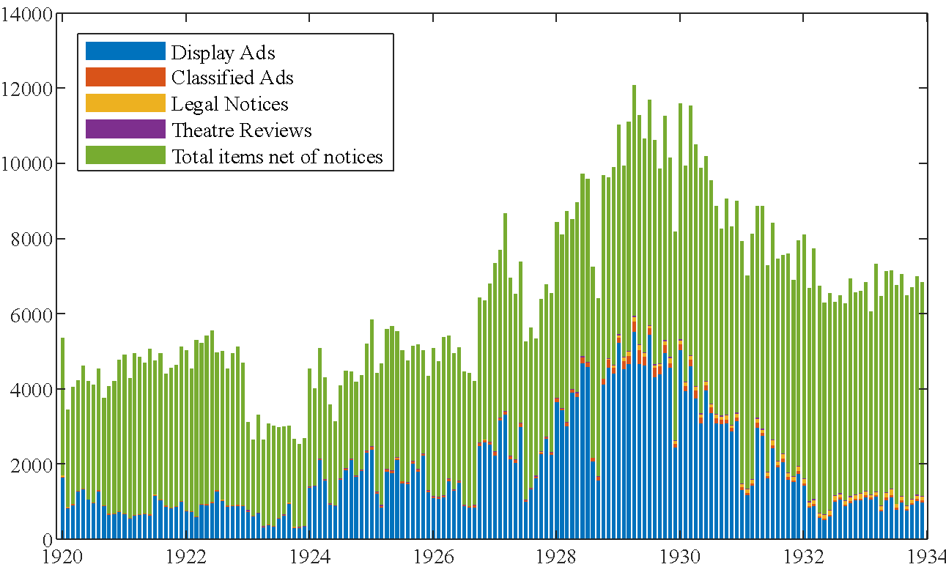

These notices (display ads, classified ads, legal notices, and theatre reviews) are removed leaving the numbers of items reported in Figure A.2. The items net of notices is broken down into items that contain at least one sentiment word and those that do not contain any sentiment words. The number of items that contain at least one sentiment word ranges from a minimum of 620 in February of 1923 to a maximum of 1907 in April 1929. Figure A.3 reports the proportion of total items (net of notices) that have at least one sentiment word in them. The proportion of items that contain sentiment ranges from a minimum of 15.5% in February of 1932 to a maximum of 29.6% in October of 1921. From 1926 onwards the proportion of items containing sentiment is stable and has a mean of 20% and standard deviation of 1.6%.

**Figure A.2: Items in WSJ net of Notices**

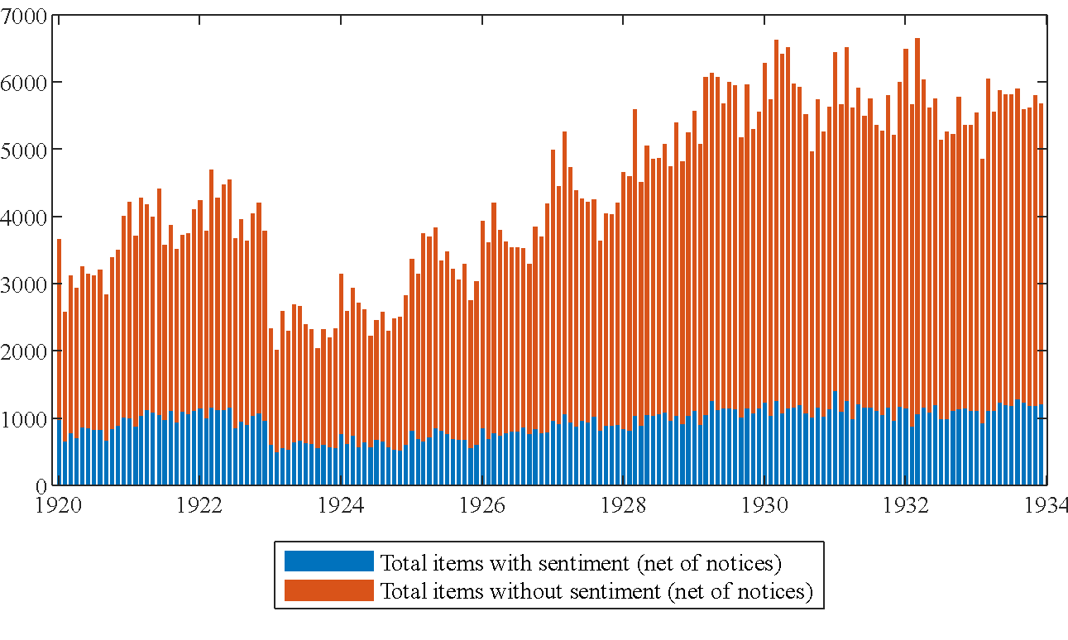

**Figure A.3: Items with Sentiment as a percentage of total items (net of notices)**

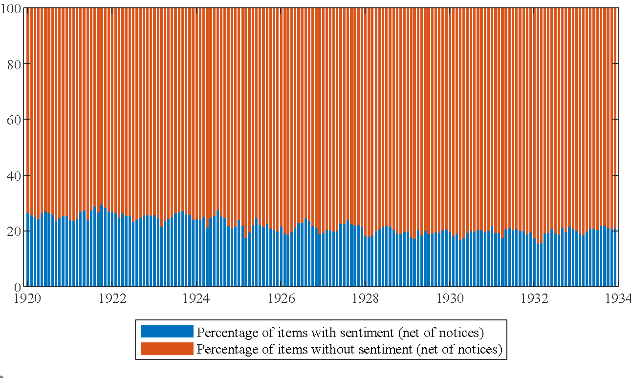

The sentiment index that we calculate is a count of sentiment words normalized by the total number of words for each month. Figure A.4 reports the proportion of words that are in items that contain sentiment. This proportion ranges from a minimum of 33.8% in February of 1932 to 61% in December of 1921. The items that make up the dataset (net of those notices we exclude) contain articles and other information based items. Examples of these are dividend notices, exchange rate reports, and bond price reports. These items do contain some words but are mostly numbers. The items that include at least one sentiment word account for a higher proportion of the total words in the dataset than items. This is because the items that typically contain sentiment words are articles and therefore are generally longer than the items that do not contain sentiment words.

The items that do not contain are not excluded from the construction of the index as they contain words and some comment on the state of the markets.

**Figure A.4: Proportion of words in items with sentiment (net of notices)**

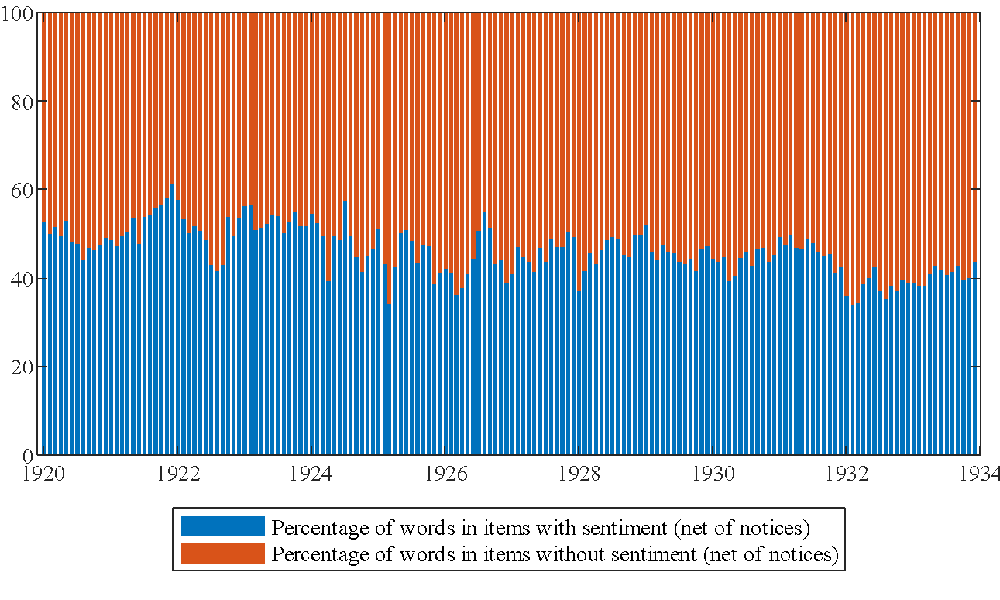

**A.2 Econometric Results**

In this section of the appendix, the full econometric results are reported for the vector error correction model used in our paper. The data used are depicted in Figure A1.

**Figure A5: Data Used in Analysis**

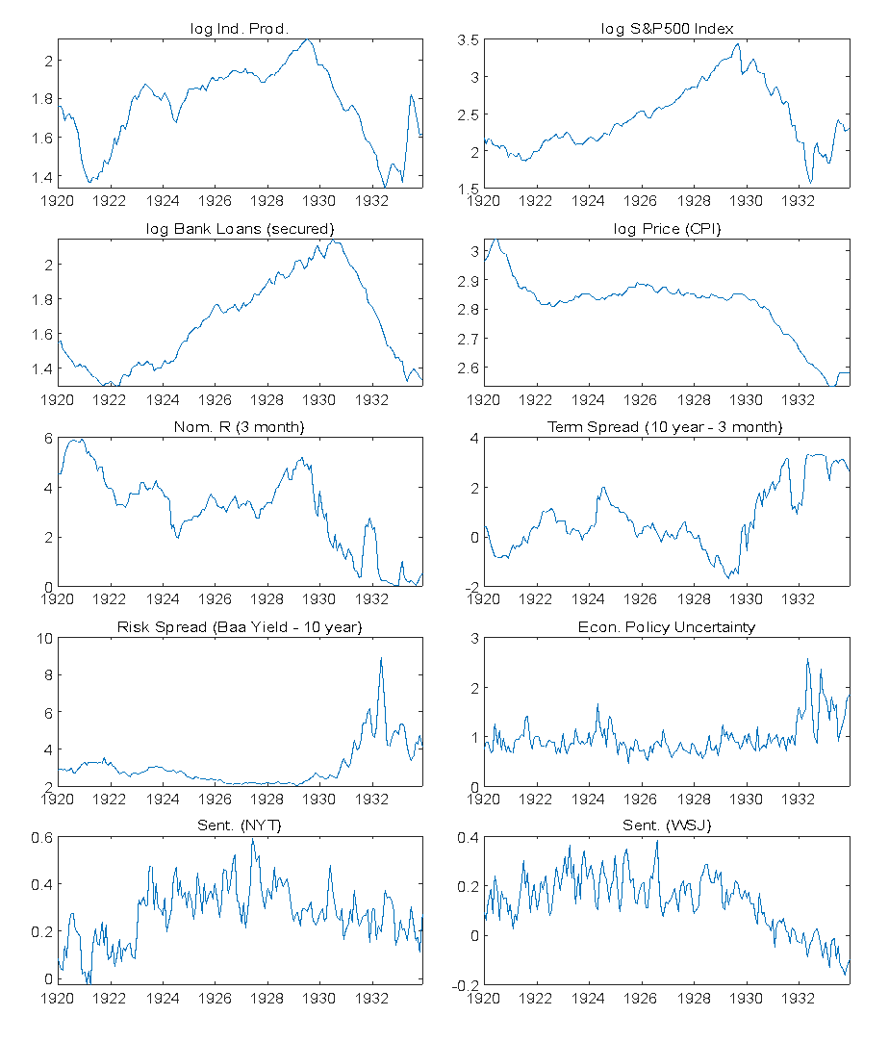

All time series depicted in Figure A1 contain a unit root. Information criteria suggest that the Johansen cointegration test should be performed with one lag. The results of the cointegration tests are found in Table A1. The results suggest there are four cointegrating relationships.

**Table A1: Cointegration Test Results (Rank Test)**

|  |  |  |  |  |
| --- | --- | --- | --- | --- |
| **Hypothesized No. of Cointegrating relationships in H0** | **Eigenvalue** | **Test Statistic** | **5% Critical Value** | **p-value** |
| None * | 0.456385 | 101.1793 | 64.50472 | 0.0000 |
| At most 1 * | 0.355122 | 72.82333 | 58.43354 | 0.0011 |
| At most 2 * | 0.287085 | 56.17316 | 52.36261 | 0.0194 |
| At most 3 * | 0.244979 | 46.64761 | 46.23142 | 0.0451 |
| At most 4 | 0.194511 | 35.90674 | 40.07757 | 0.1370 |
| At most 5 | 0.142279 | 25.47705 | 33.87687 | 0.3535 |
| At most 6 | 0.111175 | 19.56392 | 27.58434 | 0.3721 |
| At most 7 | 0.044873 | 7.621159 | 21.13162 | 0.9254 |
| At most 8 | 0.032139 | 5.422768 | 14.26460 | 0.6878 |
| At most 9 | 0.004521 | 0.752194 | 3.841465 | 0.3858 |

Table A2 reports the information criteria results used to determine the lag length used in the estimated model. Both information criteria suggest that the vector error correction model should be estimated with one lag.

**Table A2: Lag Length Determination for VEC model with 4 CI Relationships**

|  |  |  |
| --- | --- | --- |
| **Lags** | **BIC** | **AIC** |
| 1 | -26.03* | -30.01* |
| 2 | -23.70 | -29.58 |
| 3 | -21.61 | -29.39 |
| 4 | -19.84 | -29.52 |

The vector error correction model was estimated with four cointegrating relationships and one lag using likelihood methods. All cointegrating relationships include a constant to allow for trends in the data. The estimation results are as follows.

**Table A3: Estimated Cointegrating Relationships**

|  |  |  |  |  |
| --- | --- | --- | --- | --- |
|  | Dependent Variables | | | |
| Variables Included |  |  |  |  |
| Constant | 3.467 | 6.224 | 3.481 | 2.499 |
|  | -0.418  (0.051) | -0.935  (0.393) | -0.453  (0.291) | 0.150  (0.027) |
|  | -0.457 (0.060) | -0.959  (0.455) | -0.409  (0.336) | 0.144  (0.031) |
|  | 0.057  (0.035) | -1.631  (0.270) | -1.201  (0.199) | -0.153  (0.018) |
|  | -0.228  (0.101) | 4.935  (0.771) | 3.353  (0.570) | 0.115  (0.053) |
|  | -1.017  (0.242) | -2.734  (1.846) | -0.518  (1.364) | 0.474  (0.127) |
|  | 1.778  (0.312) | 5.277  (2.372) | 3.086  (1.752) | -0.210  (0.163) |

**Table A4: Estimates of short-run parameters of model.**

|  |  |  |  |  |  |  |  |  |  |  |
| --- | --- | --- | --- | --- | --- | --- | --- | --- | --- | --- |
|  | Dependent Variables | | | | | | | | | |
|  |  |  |  |  |  |  |  |  |  |  |
|  | -0.064 | 0.003 | -0.033 | 0.003 | 0.089 | -0.090 | -0.259 | -0.561 | 0.015 | 0.151 |
|  | (0.016) | (0.041) | (0.011) | (0.005) | (0.218) | (0.218) | (0.214) | (0.136) | (0.048) | (0.043) |
|  | -0.007 | -0.025 | 0.065 | 0.006 | 0.261 | -0.241 | -0.847 | 0.070 | -0.075 | -0.021 |
|  | (0.018) | (0.044) | (0.012) | (0.005) | (0.236) | (0.236) | (0.232) | (0.147) | (0.052) | (0.048) |
|  | 0.006 | 0.010 | -0.106 | -0.011 | -0.413 | 0.381 | 1.485 | 0.074 | 0.086 | 0.044 |
|  | (0.021) | (0.068) | (0.019) | (0.008) | (0.363) | (0.362) | (0.357) | (0.227) | (0.080) | (0.071) |
|  | -0.024 | 0.059 | 0.159 | 0.016 | 1.220 | -1.152 | -5.455 | -1.625 | 0.260 | -0.138 |
|  | (0.062) | (0.157) | (0.044) | (0.019) | (0.837) | (0.836) | (0.824) | (0.523) | (0.186) | (0.165) |
|  | 0.351 | 0.087 | 0.096 | 0.059 | -0.181 | 0.255 | -1.935 | -0.261 | 0.193 | 0.071 |
|  | (0.069) | (0.176) | (0.049) | (0.021) | (0.937) | (0.936) | (0.922) | (0.586) | (0.208) | (0.184) |
|  | 0.104 | -0.009 | -0.013 | -0.002 | 0.542 | -0.569 | 0.492 | -0.553 | 0.154 | -0.030 |
|  | (0.039) | (0.101) | (0.028) | (0.012) | (0.537) | (0.537) | (0.529) | (0.336) | (0.119) | (0.109) |
|  | -0.103 | -0.237 | 0.087 | -0.033 | 0.928 | -0.973 | 0.879 | -0.364 | 0.381 | -0.406 |
|  | (0.105) | (0.266) | (0.074) | (0.033) | (1.416) | (1.414) | (1.393) | (0.885) | (0.315) | (0.279) |
|  | 0.201 | -0.106 | 0.112 | 0.302 | 0.637 | -0.783 | 5.965 | 3.951 | 0.818 | -0.519 |
|  | (0.252) | (0.640) | (0.179) | (0.079) | (3.407) | (3.403) | (3.352) | (2.130) | (0.759) | (0.671) |
|  | -0.006 | 0.129 | 0.050 | -0.003 | 1.705 | -0.832 | 0.524 | -1.013 | 0.230 | -0.321 |
|  | (0.091) | (0.231) | (0.064) | (0.028) | (1.233) | (1.232) | (1.213) | (0.771) | (0.274) | (0.243) |
|  | -0.013 | 0.107 | 0.052 | -0.006 | 1.584 | -0.717 | 0.719 | -0.944 | 0.216 | -0.329 |
|  | (0.092) | (0.234) | (0.065) | (0.029) | (1.246) | (1.245) | (1.226) | (0.779) | (0.277) | (0.245) |
|  | -0.009 | -0.088 | -0.002 | -0.000 | -0.020 | 0.022 | 0.569 | 0.181 | -0.003 | -0.008 |
|  | (0.006) | (0.017) | (0.004) | (0.0021) | (0.093) | (0.093) | (0.091) | (0.058) | (0.020) | (0.018) |
|  | 0.010 | -0.015 | -0.009 | -0.002 | 0.066 | -0.072 | -0.040 | -0.080 | 0.001 | 0.016 |
|  | (0.009) | (0.024) | (0.006) | (0.003) | (0.130) | (0.130) | (0.128) | (0.081) | (0.029) | (0.025) |
|  | 0.041 | 0.021 | -0.009 | -0.005 | -0.069 | 0.065 | -0.396 | -0.288 | -0.096 | -0.031 |
|  | (0.027) | (0.069) | (0.019) | (0.008) | (0.369) | (0.369) | (0.363) | (0.231) | (0.082) | (0.072) |
|  | -0.016 | -0.028 | -0.048 | 0.003 | 0.122 | -0.137 | 0.428 | -0.516 | -0.218 | -0.107 |
|  | (0.032) | (0.082) | (0.023) | (0.010) | (0.441) | (0.441) | (0.434) | (0.276) | (0.098) | (0.087) |
| *Constant* | -0.000 | 0.003 | -0.000 | -0.002 | -0.002 | 0.000 | 0.017 | 0.000 | 0.006 | -0.006 |
|  | (0.002) | (0.005) | (0.001) | (0.000) | (0.029) | (0.029) | (0.029) | (0.018) | (0.006) | (0.005) |
|  | 0.506 | 0.344 | 0.476 | 0.320 | 0.068 | 0.050 | 0.358 | 0.420 | 0.198 | 0.205 |
|  | 0.460 | 0.283 | 0.427 | 0.257 | -0.017 | -0.037 | 0.298 | 0.366 | 0.123 | 0.132 |
| *Notes*: lower case variables are in logarithms. | | | | | | | | | | |

**A.1 Forecast Error Variance Decompositions**

**Table A5: Variance Decompositions**

|  |  |  |  |  |  |  |  |  |  |  |
| --- | --- | --- | --- | --- | --- | --- | --- | --- | --- | --- |
| Variance Decomposition of | | | | | | | | | | |
| Period | *ip* | *sp500* | *loans* | *p* |  |  |  | *EPU* |  |  |
| 1 | 100.00 | 0.00 | 0.00 | 0.00 | 0.00 | 0.00 | 0.00 | 0.00 | 0.00 | 0.00 |
| 2 | 92.59 | 4.33 | 0.01 | 0.10 | 0.42 | 0.00 | 0.65 | 0.05 | 0.00 | 1.85 |
| 3 | 84.25 | 7.39 | 0.02 | 0.07 | 1.06 | 0.05 | 2.29 | 0.07 | 0.13 | 4.67 |
| 4 | 77.94 | 9.04 | 0.03 | 0.05 | 1.47 | 0.16 | 3.40 | 0.07 | 0.31 | 7.54 |
| 5 | 73.57 | 9.91 | 0.03 | 0.05 | 1.65 | 0.36 | 3.88 | 0.05 | 0.48 | 10.00 |
| 10 | 63.33 | 10.48 | 0.09 | 0.27 | 1.81 | 2.65 | 4.75 | 0.17 | 1.02 | 15.43 |
| 15 | 58.75 | 9.53 | 0.37 | 0.56 | 1.95 | 5.21 | 5.34 | 0.44 | 1.55 | 16.31 |
| 20 | 55.85 | 8.55 | 0.68 | 0.82 | 2.10 | 7.01 | 5.64 | 0.76 | 2.08 | 16.49 |
|  |  |  |  |  |  |  |  |  |  |  |
| Variance Decomposition of | | | | | | | | | | |
| Period | *ip* | *sp500* | *loans* | *p* |  |  |  | *EPU* |  |  |
| 1 | 11.80 | 88.20 | 0.00 | 0.00 | 0.00 | 0.00 | 0.00 | 0.00 | 0.00 | 0.00 |
| 2 | 14.55 | 76.95 | 0.02 | 0.01 | 0.42 | 0.11 | 6.46 | 1.21 | 0.10 | 0.17 |
| 3 | 17.13 | 69.61 | 0.17 | 0.02 | 0.61 | 0.26 | 8.06 | 3.28 | 0.35 | 0.51 |
| 4 | 18.45 | 66.58 | 0.43 | 0.02 | 0.51 | 0.41 | 7.21 | 4.62 | 0.66 | 1.12 |
| 5 | 18.76 | 65.35 | 0.66 | 0.05 | 0.40 | 0.60 | 6.19 | 5.34 | 0.89 | 1.76 |
| 10 | 17.46 | 63.61 | 0.75 | 0.14 | 0.20 | 2.62 | 4.97 | 6.82 | 1.09 | 2.35 |
| 15 | 16.45 | 62.12 | 0.58 | 0.14 | 0.13 | 4.63 | 5.03 | 7.35 | 1.21 | 2.36 |
| 20 | 15.67 | 61.06 | 0.46 | 0.13 | 0.10 | 6.25 | 5.16 | 7.52 | 1.34 | 2.32 |
|  |  |  |  |  |  |  |  |  |  |  |
| Variance Decomposition of | | | | | | | | | | |
| Period | *ip* | *sp500* | *loans* | *p* |  |  |  | *EPU* |  |  |
| 1 | 4.48 | 2.31 | 93.22 | 0.00 | 0.00 | 0.00 | 0.00 | 0.00 | 0.00 | 0.00 |
| 2 | 2.44 | 1.19 | 94.02 | 0.68 | 0.98 | 0.08 | 0.06 | 0.00 | 0.09 | 0.46 |
| 3 | 1.93 | 4.08 | 84.09 | 2.05 | 2.17 | 0.16 | 0.04 | 0.63 | 0.94 | 3.92 |
| 4 | 2.45 | 9.26 | 69.66 | 3.38 | 3.04 | 0.12 | 0.13 | 2.29 | 2.21 | 7.47 |
| 5 | 3.18 | 14.49 | 55.86 | 4.38 | 3.61 | 0.10 | 0.37 | 4.35 | 3.58 | 10.07 |
| 10 | 4.91 | 27.41 | 21.66 | 6.31 | 4.65 | 1.78 | 1.69 | 11.46 | 7.45 | 12.68 |
| 15 | 4.88 | 29.66 | 12.75 | 6.61 | 4.89 | 4.72 | 2.47 | 14.08 | 8.21 | 11.73 |
| 20 | 4.51 | 29.64 | 9.72 | 6.54 | 4.96 | 7.51 | 2.97 | 15.03 | 8.21 | 10.92 |
|  |  |  |  |  |  |  |  |  |  |  |
| Variance Decomposition of | | | | | | | | | | |
| Period | *ip* | *sp500* | *loans* | *p* |  |  |  | *EPU* |  |  |
| 1 | 0.18 | 0.08 | 0.85 | 98.89 | 0.00 | 0.00 | 0.00 | 0.00 | 0.00 | 0.00 |
| 2 | 3.43 | 0.41 | 1.94 | 93.72 | 0.25 | 0.01 | 0.03 | 0.18 | 0.02 | 0.01 |
| 3 | 6.80 | 1.33 | 2.57 | 87.59 | 0.40 | 0.04 | 0.12 | 1.01 | 0.11 | 0.03 |
| 4 | 9.29 | 2.30 | 2.98 | 82.42 | 0.46 | 0.11 | 0.27 | 1.93 | 0.17 | 0.08 |
| 5 | 10.98 | 3.21 | 3.24 | 78.32 | 0.46 | 0.20 | 0.43 | 2.76 | 0.21 | 0.19 |
| 10 | 13.47 | 6.14 | 3.59 | 67.85 | 0.30 | 1.14 | 0.95 | 5.28 | 0.46 | 0.82 |
| 15 | 13.44 | 7.50 | 3.35 | 63.40 | 0.19 | 2.55 | 1.36 | 6.49 | 0.64 | 1.08 |
| 20 | 13.09 | 8.11 | 3.07 | 61.00 | 0.14 | 3.90 | 1.66 | 7.12 | 0.72 | 1.19 |
|  |  |  |  |  |  |  |  |  |  |  |
| Variance Decomposition of | | | | | | | | | | |
| Period | *ip* | *sp500* | *loans* | *p* |  |  |  | *EPU* |  |  |
| 1 | 1.20 | 0.22 | 1.24 | 0.86 | 96.48 | 0.00 | 0.00 | 0.00 | 0.00 | 0.00 |
| 2 | 1.53 | 1.16 | 1.13 | 1.36 | 94.35 | 0.15 | 0.27 | 0.02 | 0.00 | 0.02 |
| 3 | 1.82 | 1.64 | 1.47 | 1.97 | 91.96 | 0.47 | 0.64 | 0.02 | 0.00 | 0.02 |
| 4 | 2.14 | 2.01 | 1.91 | 2.56 | 89.33 | 0.89 | 1.11 | 0.02 | 0.01 | 0.02 |
| 5 | 2.45 | 2.29 | 2.38 | 3.13 | 86.75 | 1.35 | 1.57 | 0.05 | 0.03 | 0.02 |
| 10 | 3.96 | 3.45 | 4.17 | 4.98 | 76.76 | 3.50 | 2.60 | 0.35 | 0.23 | 0.01 |
| 15 | 5.15 | 4.59 | 5.29 | 5.89 | 70.29 | 4.80 | 2.76 | 0.73 | 0.46 | 0.03 |
| 20 | 5.92 | 5.54 | 5.99 | 6.45 | 66.15 | 5.41 | 2.74 | 1.07 | 0.66 | 0.06 |
|  |  |  |  |  |  |  |  |  |  |  |
| Variance Decomposition of | | | | | | | | | | |
| Period | *ip* | *sp500* | *loans* | *p* |  |  |  | *EPU* |  |  |
| 1 | 1.14 | 0.21 | 1.11 | 0.83 | 96.60 | 0.10 | 0.00 | 0.00 | 0.00 | 0.00 |
| 2 | 1.39 | 1.18 | 0.93 | 1.34 | 94.82 | 0.05 | 0.25 | 0.03 | 0.00 | 0.02 |
| 3 | 1.60 | 1.68 | 1.15 | 1.96 | 92.99 | 0.05 | 0.54 | 0.02 | 0.00 | 0.02 |
| 4 | 1.84 | 2.06 | 1.44 | 2.56 | 91.03 | 0.10 | 0.92 | 0.04 | 0.01 | 0.02 |
| 5 | 2.06 | 2.33 | 1.76 | 3.13 | 89.15 | 0.18 | 1.29 | 0.07 | 0.02 | 0.01 |
| 10 | 3.18 | 3.39 | 2.94 | 5.07 | 82.13 | 0.60 | 2.13 | 0.39 | 0.16 | 0.01 |
| 15 | 4.06 | 4.38 | 3.67 | 6.03 | 77.66 | 0.86 | 2.25 | 0.76 | 0.32 | 0.01 |
| 20 | 4.62 | 5.16 | 4.12 | 6.61 | 74.76 | 0.96 | 2.24 | 1.06 | 0.45 | 0.02 |
|  |  |  |  |  |  |  |  |  |  |  |
| Variance Decomposition of | | | | | | | | | | |
| Period | *ip* | *sp500* | *loans* | *p* |  |  |  | *EPU* |  |  |
| 1 | 5.95 | 21.43 | 0.80 | 0.04 | 0.02 | 1.20 | 70.57 | 0.00 | 0.00 | 0.00 |
| 2 | 12.85 | 22.95 | 0.31 | 0.09 | 0.20 | 1.59 | 60.83 | 0.87 | 0.15 | 0.17 |
| 3 | 17.61 | 25.79 | 0.69 | 0.13 | 0.15 | 1.97 | 50.04 | 1.58 | 0.86 | 1.19 |
| 4 | 19.54 | 27.29 | 1.53 | 0.66 | 0.59 | 2.53 | 41.77 | 1.78 | 1.72 | 2.58 |
| 5 | 19.84 | 27.67 | 2.27 | 1.47 | 1.36 | 3.44 | 36.42 | 1.79 | 2.36 | 3.38 |
| 10 | 18.81 | 25.50 | 2.62 | 3.80 | 3.29 | 10.82 | 26.73 | 1.71 | 4.09 | 2.63 |
| 15 | 17.92 | 22.81 | 2.22 | 4.39 | 3.78 | 16.46 | 22.88 | 1.50 | 6.04 | 2.01 |
| 20 | 17.03 | 20.70 | 1.90 | 4.53 | 4.00 | 20.39 | 20.82 | 1.26 | 7.74 | 1.63 |
|  |  |  |  |  |  |  |  |  |  |  |
| Variance Decomposition of | | | | | | | | | | |
| Period | *ip* | *sp500* | *loans* | *p* |  |  |  | *EPU* |  |  |
| 1 | 0.44 | 0.38 | 0.15 | 0.00 | 0.24 | 0.68 | 2.70 | 95.41 | 0.00 | 0.00 |
| 2 | 3.44 | 7.14 | 0.59 | 0.58 | 0.56 | 0.76 | 8.00 | 77.74 | 0.01 | 1.17 |
| 3 | 7.78 | 8.44 | 0.66 | 0.62 | 0.51 | 0.69 | 9.56 | 69.15 | 1.50 | 1.09 |
| 4 | 11.01 | 8.50 | 1.06 | 0.63 | 0.65 | 0.65 | 8.81 | 63.76 | 3.48 | 1.45 |
| 5 | 12.73 | 8.12 | 1.58 | 0.93 | 1.12 | 0.61 | 8.25 | 59.71 | 5.22 | 1.75 |
| 10 | 18.64 | 7.17 | 1.99 | 1.89 | 2.25 | 1.78 | 8.08 | 47.51 | 9.06 | 1.63 |
| 15 | 22.30 | 7.06 | 1.81 | 2.21 | 2.77 | 4.74 | 8.84 | 37.52 | 10.95 | 1.81 |
| 20 | 23.62 | 6.87 | 1.55 | 2.35 | 3.17 | 8.38 | 9.58 | 30.61 | 12.02 | 1.86 |
|  |  |  |  |  |  |  |  |  |  |  |
| Variance Decomposition of | | | | | | | | | | |
| Period | *ip* | *sp500* | *loans* | *p* |  |  |  | *EPU* |  |  |
| 1 | 0.32 | 0.01 | 0.76 | 3.18 | 0.05 | 0.23 | 0.01 | 2.41 | 93.04 | 0.00 |
| 2 | 0.29 | 0.01 | 1.37 | 5.73 | 0.45 | 0.25 | 0.50 | 6.12 | 85.15 | 0.13 |
| 3 | 0.31 | 0.11 | 1.57 | 8.31 | 0.57 | 0.44 | 1.42 | 7.55 | 78.80 | 0.92 |
| 4 | 0.26 | 0.42 | 1.59 | 9.77 | 0.63 | 0.54 | 2.51 | 8.33 | 73.74 | 2.22 |
| 5 | 0.26 | 0.91 | 1.72 | 10.42 | 0.73 | 0.55 | 3.19 | 8.47 | 70.54 | 3.21 |
| 10 | 0.99 | 3.67 | 3.93 | 9.61 | 1.76 | 0.38 | 3.22 | 7.21 | 64.31 | 4.91 |
| 15 | 1.96 | 6.48 | 5.76 | 8.40 | 2.52 | 0.31 | 3.39 | 5.78 | 59.99 | 5.40 |
| 20 | 2.74 | 8.91 | 7.01 | 7.49 | 3.09 | 0.32 | 3.63 | 4.74 | 56.65 | 5.42 |
|  |  |  |  |  |  |  |  |  |  |  |
| Variance Decomposition of | | | | | | | | | | |
| Period | *ip* | *sp500* | *loans* | *p* |  |  |  | *EPU* |  |  |
| 1 | 1.91 | 5.03 | 4.86 | 0.14 | 0.02 | 1.89 | 0.45 | 0.65 | 6.63 | 78.42 |
| 2 | 3.61 | 4.82 | 3.70 | 0.15 | 0.04 | 1.40 | 1.14 | 0.61 | 11.54 | 72.98 |
| 3 | 4.73 | 4.56 | 3.69 | 0.13 | 0.07 | 1.15 | 1.42 | 0.65 | 15.81 | 67.80 |
| 4 | 6.01 | 4.25 | 3.92 | 0.12 | 0.10 | 1.00 | 1.51 | 0.69 | 18.49 | 63.91 |
| 5 | 7.40 | 3.92 | 4.12 | 0.15 | 0.12 | 0.91 | 1.45 | 0.75 | 20.14 | 61.04 |
| 10 | 12.11 | 2.74 | 4.76 | 0.33 | 0.32 | 1.08 | 1.01 | 0.74 | 23.10 | 53.80 |
| 15 | 14.40 | 2.32 | 5.26 | 0.31 | 0.66 | 2.03 | 0.79 | 0.58 | 23.72 | 49.92 |
| 20 | 15.75 | 2.16 | 5.44 | 0.28 | 0.96 | 3.36 | 0.68 | 0.48 | 23.75 | 47.15 |

The following figures depict the impulse response function for each identified shock on all variables.

**A.2 Impulse Response Functions**

**Figure A6: Impulse Response of Industrial Production Shock**

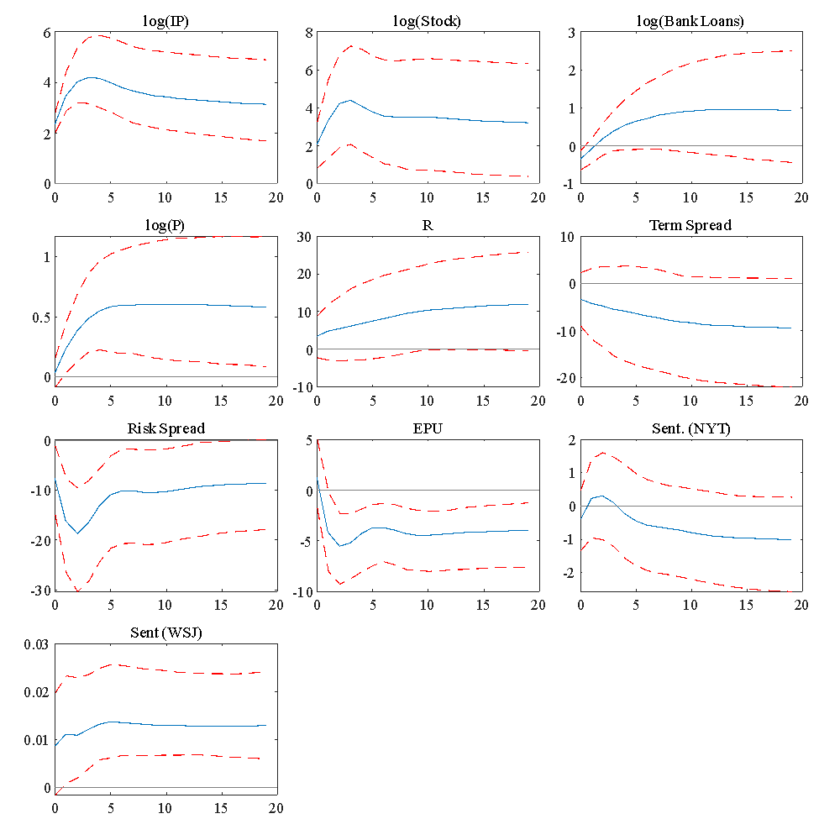

* The solid lines represent the mean impulse response of the selected variables to a one standard deviation shock to the business-sentiment shock. The business sentiment shock was obtained from ordering the WSJ sentiment series last in a ten variable vector error correction model. The dashed lines represent a 95% bootstrapped confidence interval using 1000 bootstrap replications using the method of Hall.

**Figure A7: Impulse Response of S&P 500 Stock Index Shock**

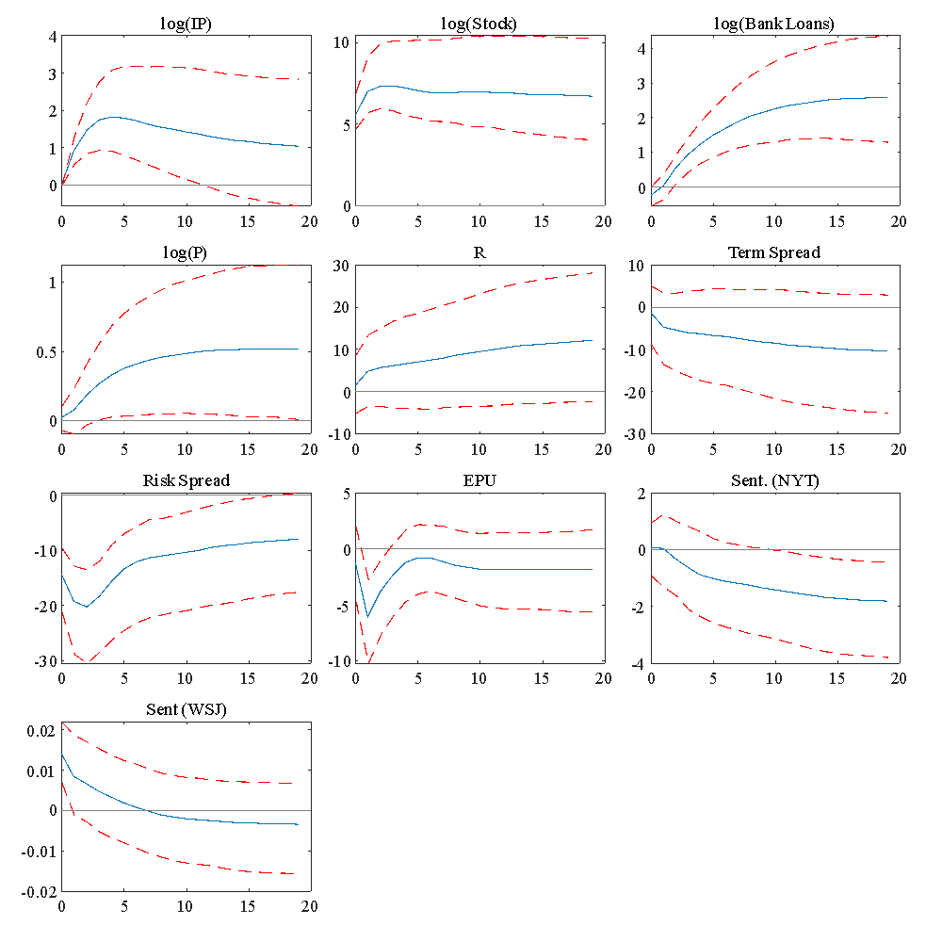

* The solid lines represent the mean impulse response of the selected variables to a one standard deviation shock to the business-sentiment shock. The business sentiment shock was obtained from ordering the WSJ sentiment series last in a ten variable vector error correction model. The dashed lines represent a 95% bootstrapped confidence interval using 1000 bootstrap replications using the method of Hall.

**Figure A8: Impulse Response Function of Loans Shock**

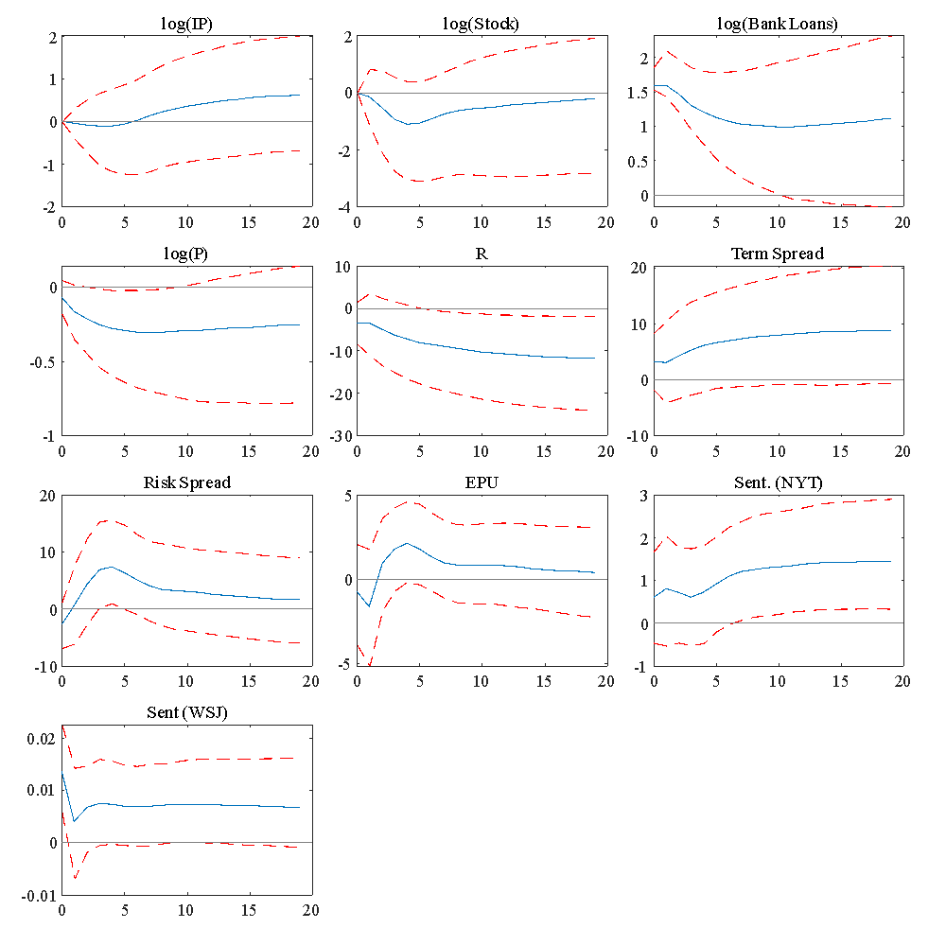

* The solid lines represent the mean impulse response of the selected variables to a one standard deviation shock to the business-sentiment shock. The business sentiment shock was obtained from ordering the WSJ sentiment series last in a ten variable vector error correction model. The dashed lines represent a 95% bootstrapped confidence interval using 1000 bootstrap replications using the method of Hall.

**Figure A9: Impulse Response Function of Price Shock**

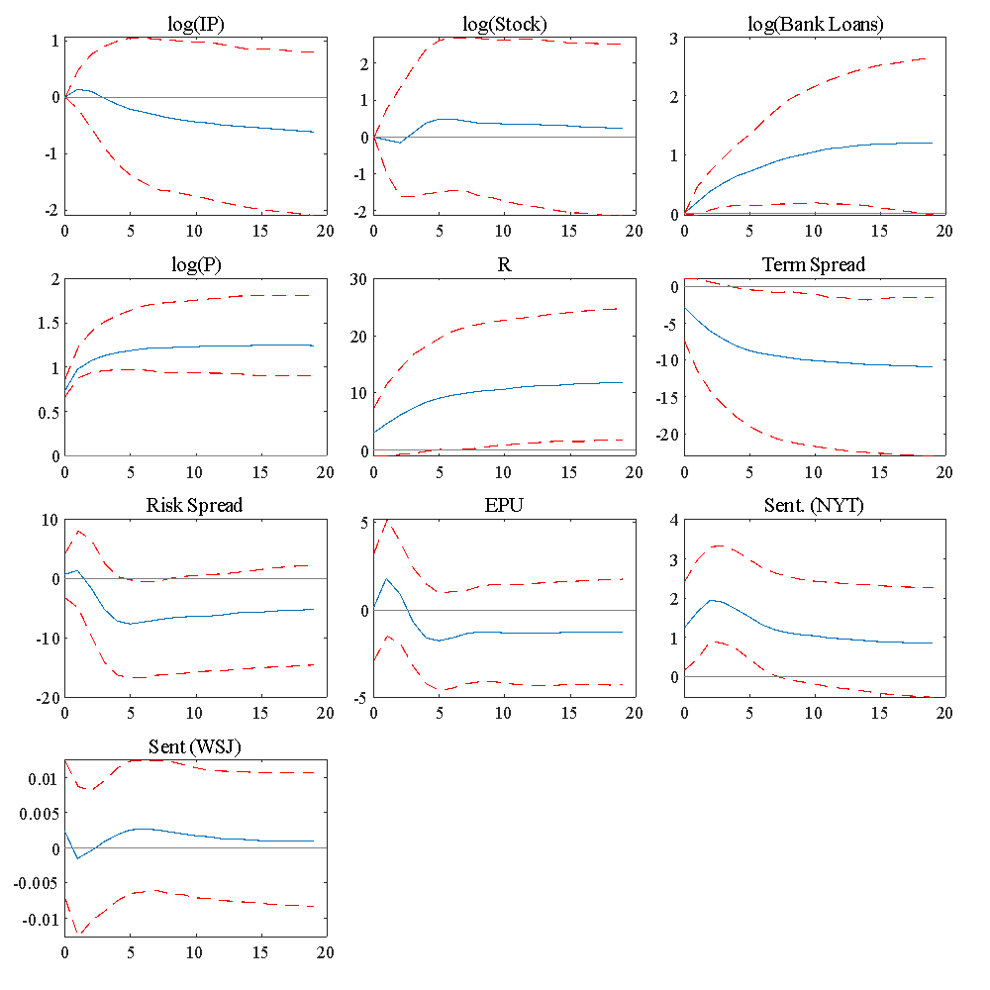

* The solid lines represent the mean impulse response of the selected variables to a one standard deviation shock to the business-sentiment shock. The business sentiment shock was obtained from ordering the WSJ sentiment series last in a ten variable vector error correction model. The dashed lines represent a 95% bootstrapped confidence interval using 1000 bootstrap replications using the method of Hall.

**Figure A10: Impulse Response Function of a Short Term Interest Rate Shock**

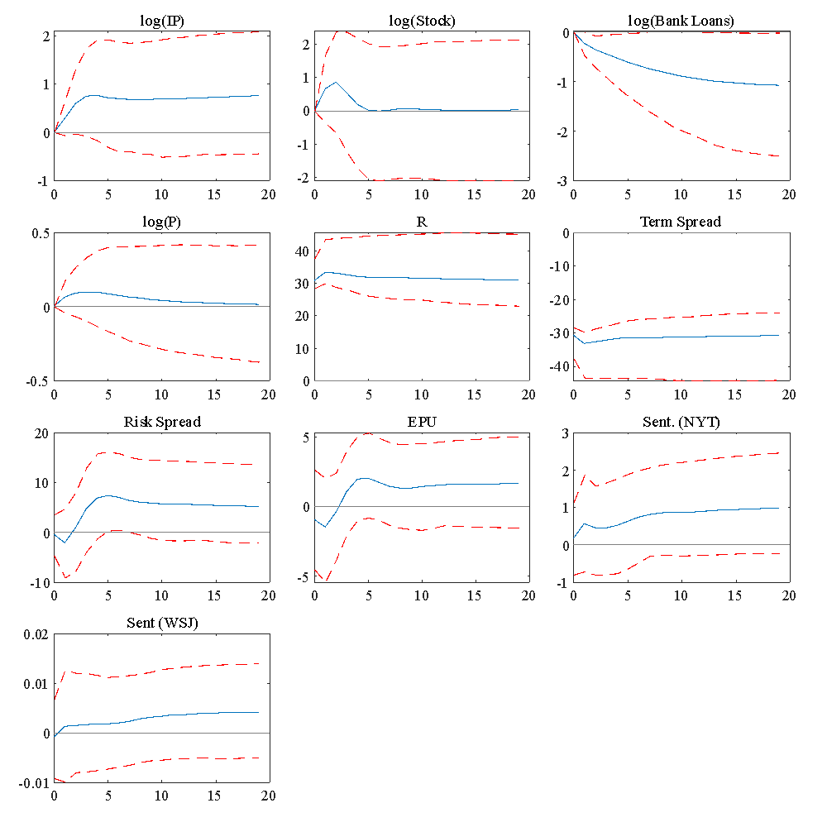

* The solid lines represent the mean impulse response of the selected variables to a one standard deviation shock to the business-sentiment shock. The business sentiment shock was obtained from ordering the WSJ sentiment series last in a ten variable vector error correction model. The dashed lines represent a 95% bootstrapped confidence interval using 1000 bootstrap replications using the method of Hall.

**Figure A11: Impulse Response Function of a Term Spread Shock**

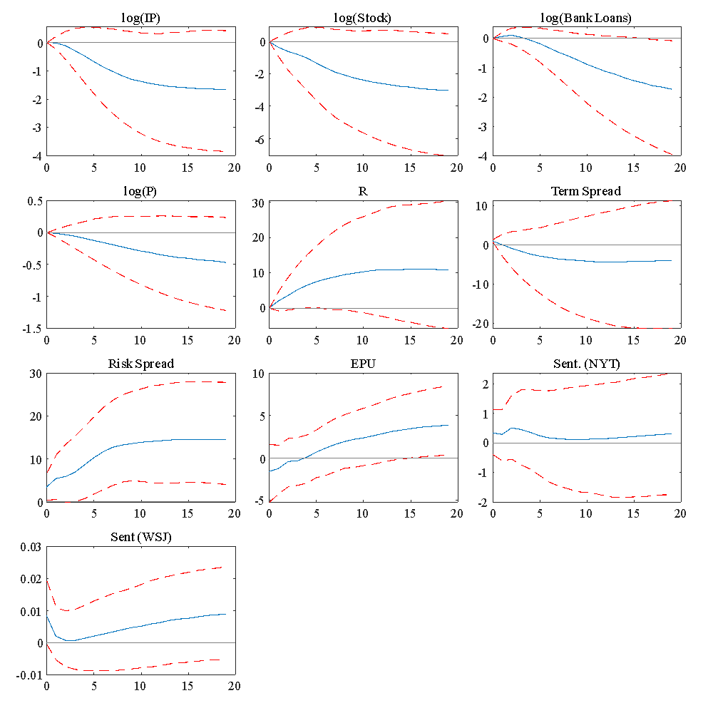

* The solid lines represent the mean impulse response of the selected variables to a one standard deviation shock to the business-sentiment shock. The business sentiment shock was obtained from ordering the WSJ sentiment series last in a ten variable vector error correction model. The dashed lines represent a 95% bootstrapped confidence interval using 1000 bootstrap replications using the method of Hall.

**Figure A12: Impulse Response of a Risk Spread Shock**

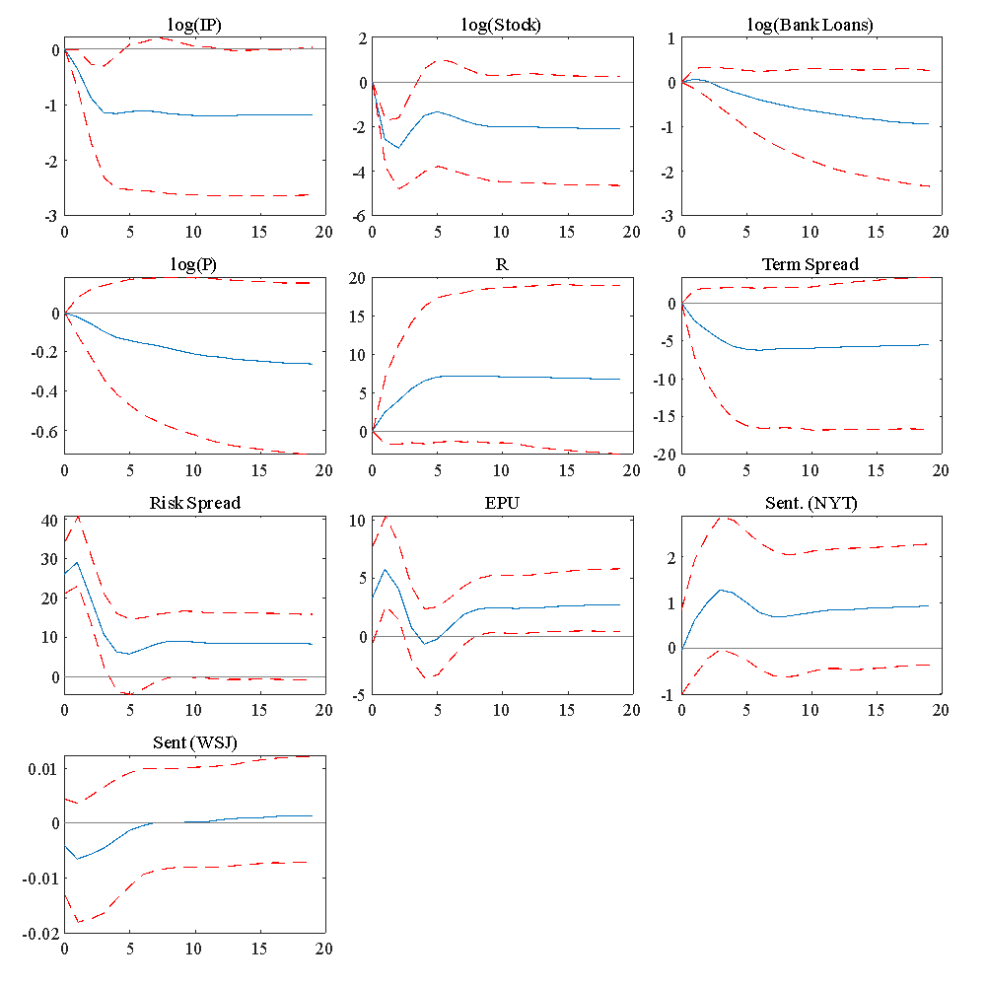

* The solid lines represent the mean impulse response of the selected variables to a one standard deviation shock to the business-sentiment shock. The business sentiment shock was obtained from ordering the WSJ sentiment series last in a ten variable vector error correction model. The dashed lines represent a 95% bootstrapped confidence interval using 1000 bootstrap replications using the method of Hall.

**Figure A13: Impulse Response Function of an EPU Shock**

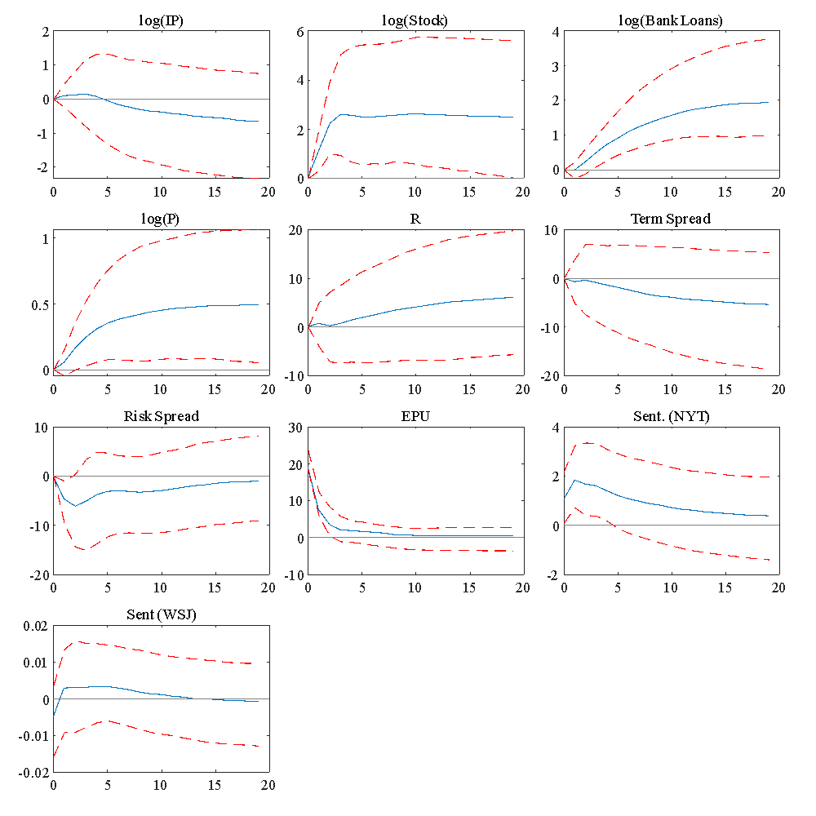

* The solid lines represent the mean impulse response of the selected variables to a one standard deviation shock to the business-sentiment shock. The business sentiment shock was obtained from ordering the WSJ sentiment series last in a ten variable vector error correction model. The dashed lines represent a 95% bootstrapped confidence interval using 1000 bootstrap replications using the method of Hall.

**Figure A14: Impulse Response Function of a Sentiment (NYT) Shock**

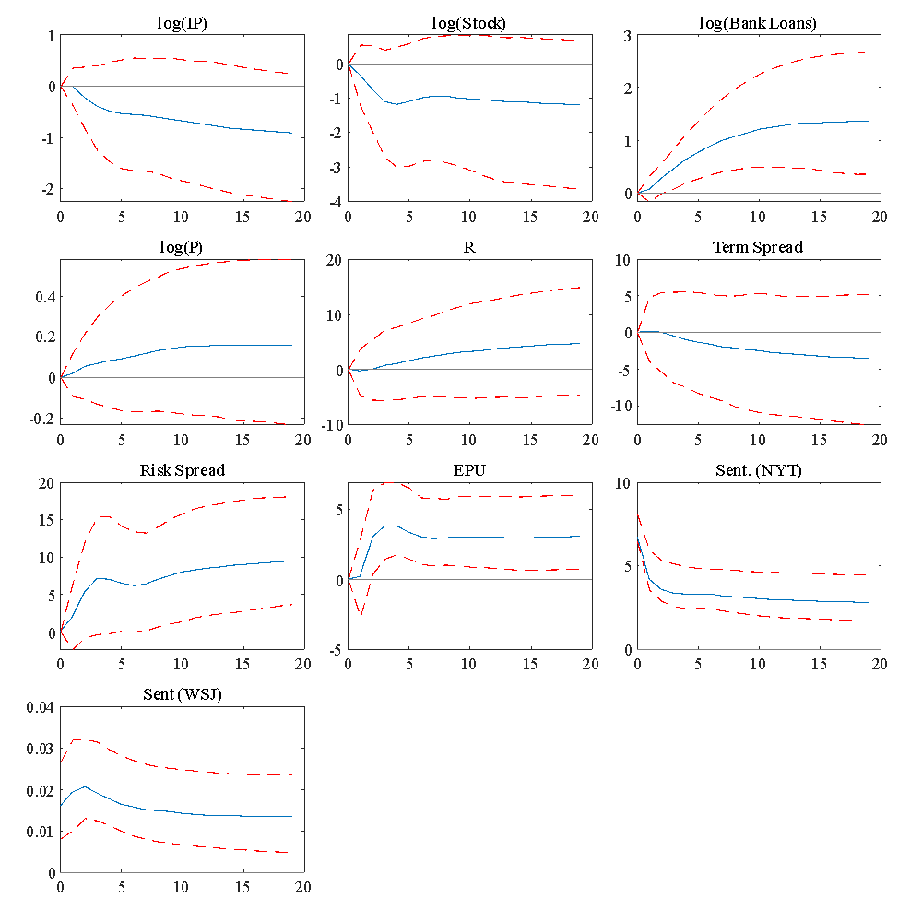

* The solid lines represent the mean impulse response of the selected variables to a one standard deviation shock to the business-sentiment shock. The business sentiment shock was obtained from ordering the WSJ sentiment series last in a ten variable vector error correction model. The dashed lines represent a 95% bootstrapped confidence interval using 1000 bootstrap replications using the method of Hall.

**Figure A15: Impulse Response Function of a Business-Sentiment Shock**

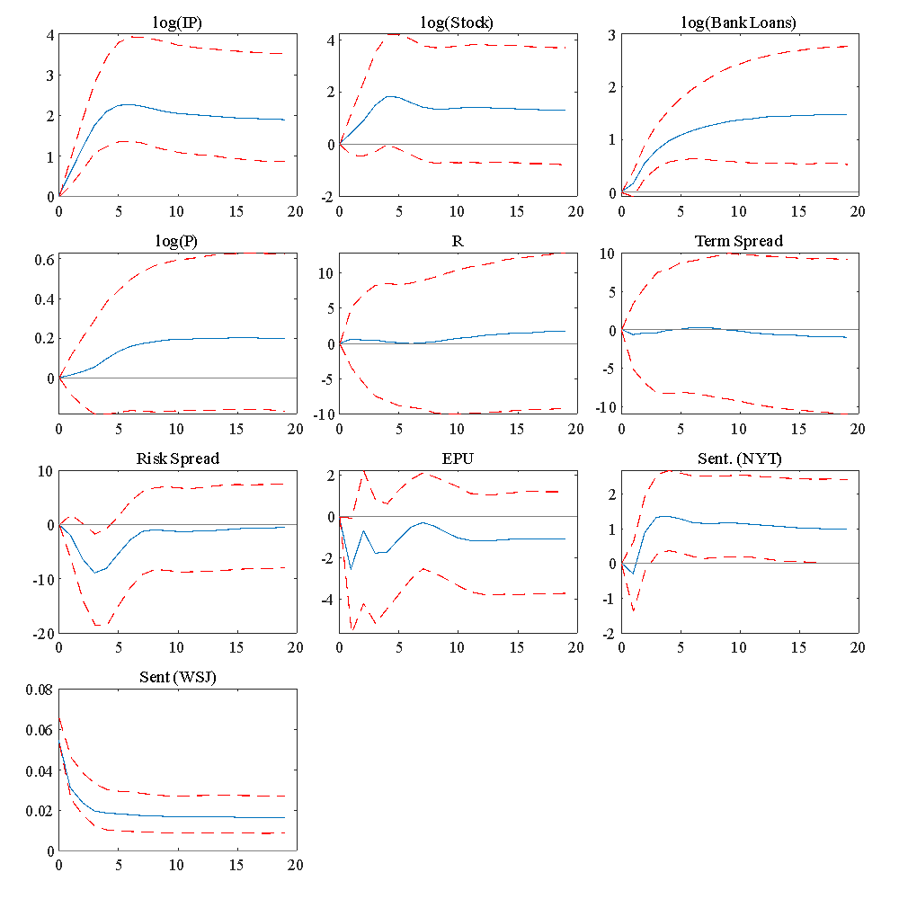

* The solid lines represent the mean impulse response of the selected variables to a one standard deviation shock to the business-sentiment shock. The business sentiment shock was obtained from ordering the WSJ sentiment series last in a ten variable vector error correction model. The dashed lines represent a 95% bootstrapped confidence interval using 1000 bootstrap replications using the method of Hall.

Next we report historical decompositions for a number of interesting periods.

**A.3 Historical Decompositions**

**Figure A16: Historical decomposition for July 1920 to May 1921**

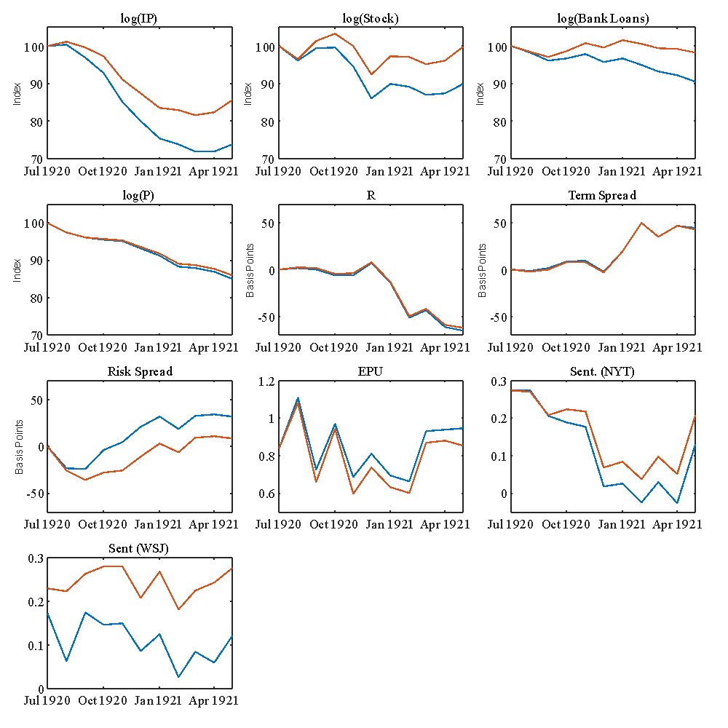

*Industrial production, the stock market, bank loans, and prices are normalized to equal 100 for the first date of each subperiod. The credit risk spread is measured in deviations (in basis points) from the value at the first date of each subperiod. The blue line is the actual data while the red line is the counterfactual series with the business-sentiment shock removed.

**Figure A17: Historical decomposition for June 1921 to March 1922**

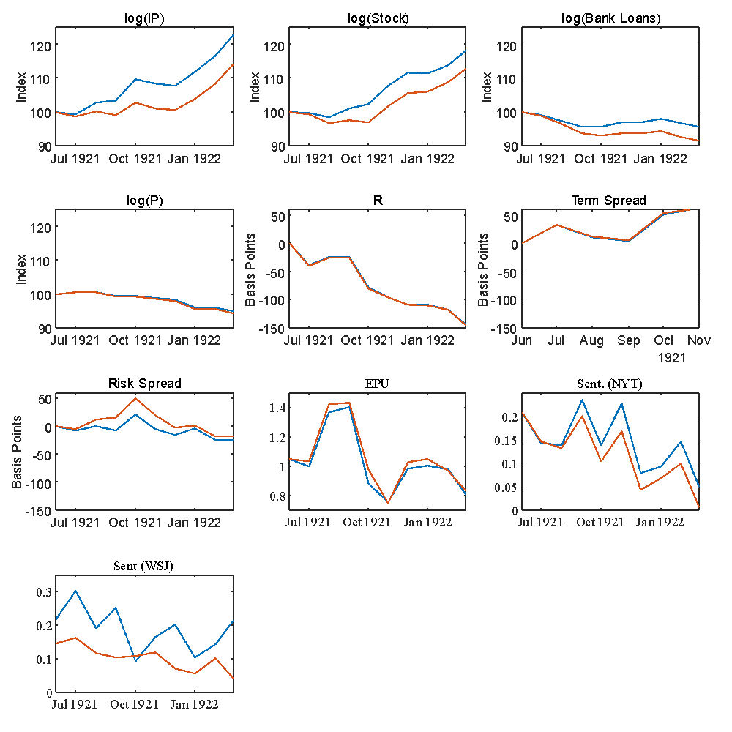

*Industrial production, the stock market, bank loans, and prices are normalized to equal 100 for the first date of each subperiod. The credit risk spread is measured in deviations (in basis points) from the value at the first date of each subperiod. The blue line is the actual data while the red line is the counterfactual series with the business-sentiment shock removed.

**Figure A18: Historical decomposition for May 1923 to November 1923**

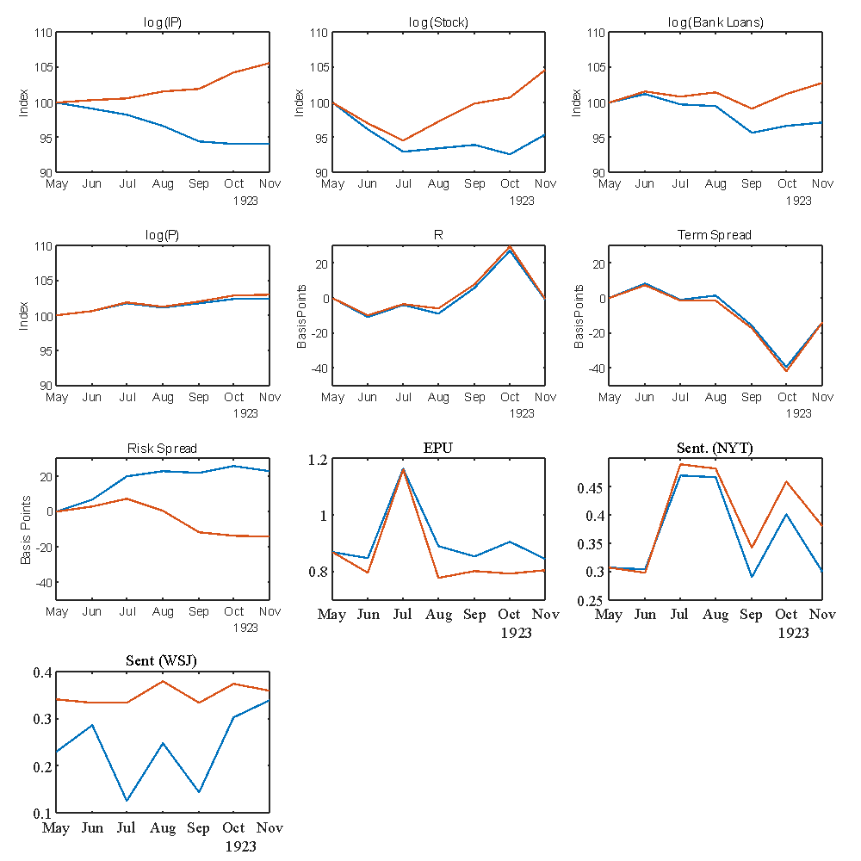

*Industrial production, the stock market, bank loans, and prices are normalized to equal 100 for the first date of each subperiod. The credit risk spread is measured in deviations (in basis points) from the value at the first date of each subperiod. The blue line is the actual data while the red line is the counterfactual series with the business-sentiment shock removed.

**Figure A19: Historical decomposition for May 1926 to April 1927**

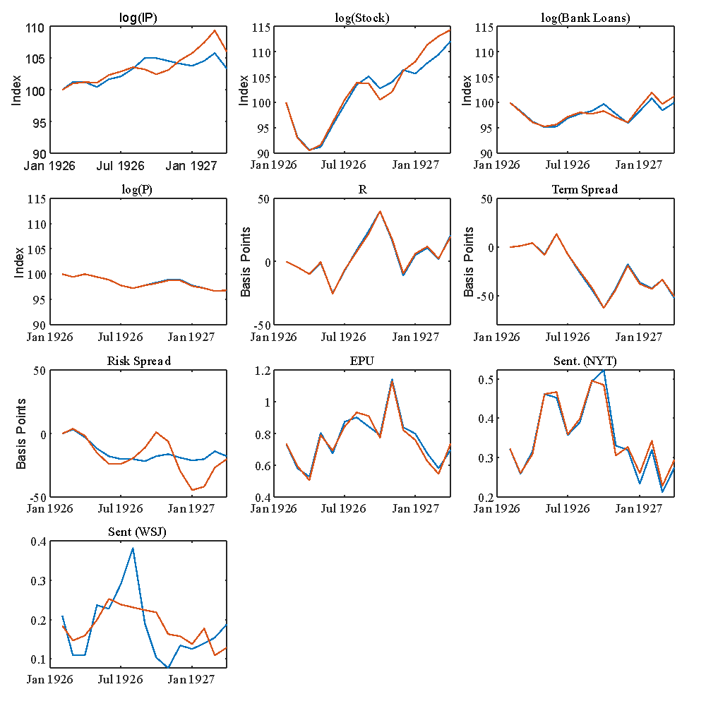

*Industrial production, the stock market, bank loans, and prices are normalized to equal 100 for the first date of each subperiod. The credit risk spread is measured in deviations (in basis points) from the value at the first date of each subperiod. The blue line is the actual data while the red line is the counterfactual series with the business-sentiment shock removed.

**Figure A20: Historical decomposition for April 1928 to December 1928**

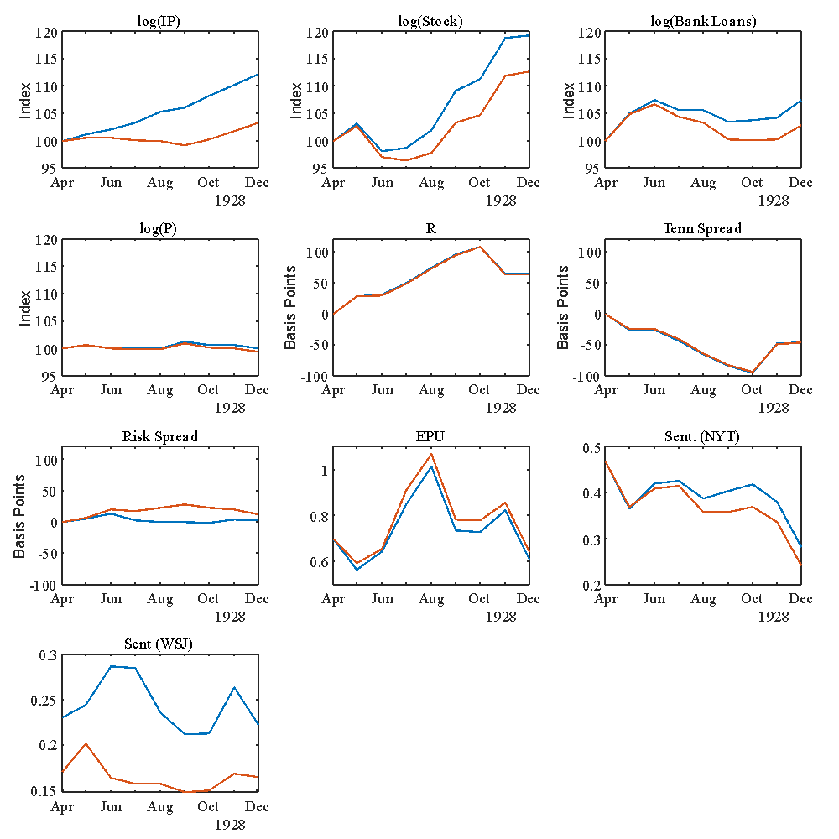

*Industrial production, the stock market, bank loans, and prices are normalized to equal 100 for the first date of each subperiod. The credit risk spread is measured in deviations (in basis points) from the value at the first date of each subperiod. The blue line is the actual data while the red line is the counterfactual series with the business-sentiment shock removed.

**Figure A21: Historical decomposition for January 1929 to December 1929**

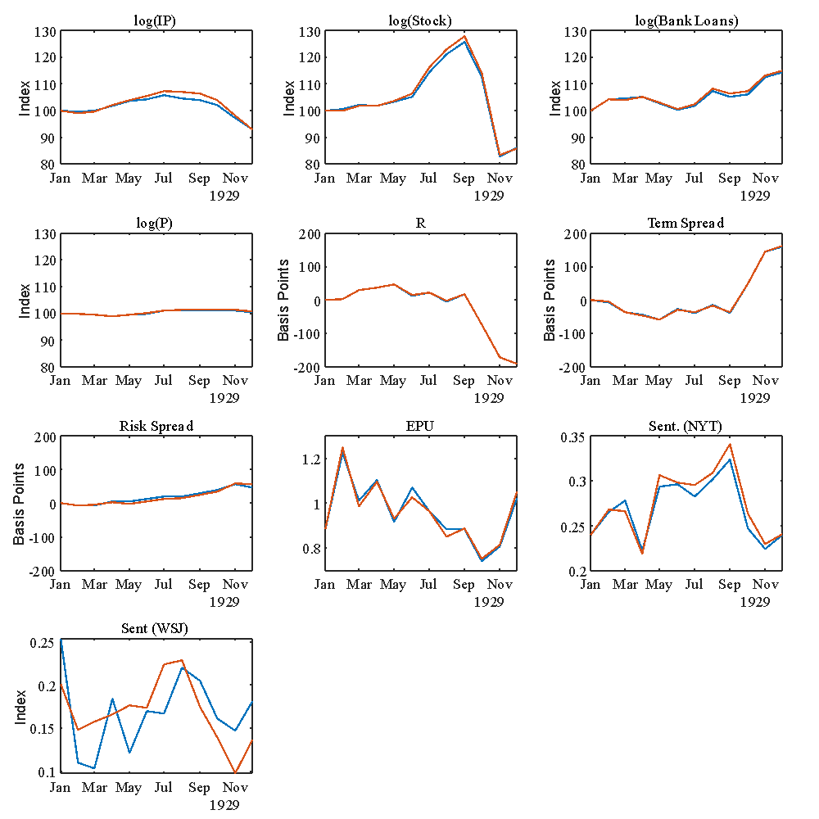

*Industrial production, the stock market, bank loans, and prices are normalized to equal 100 for the first date of each subperiod. The credit risk spread is measured in deviations (in basis points) from the value at the first date of each subperiod. The blue line is the actual data while the red line is the counterfactual series with the business-sentiment shock removed.

**Figure A22: Historical decomposition for April 1930 to December 1930**

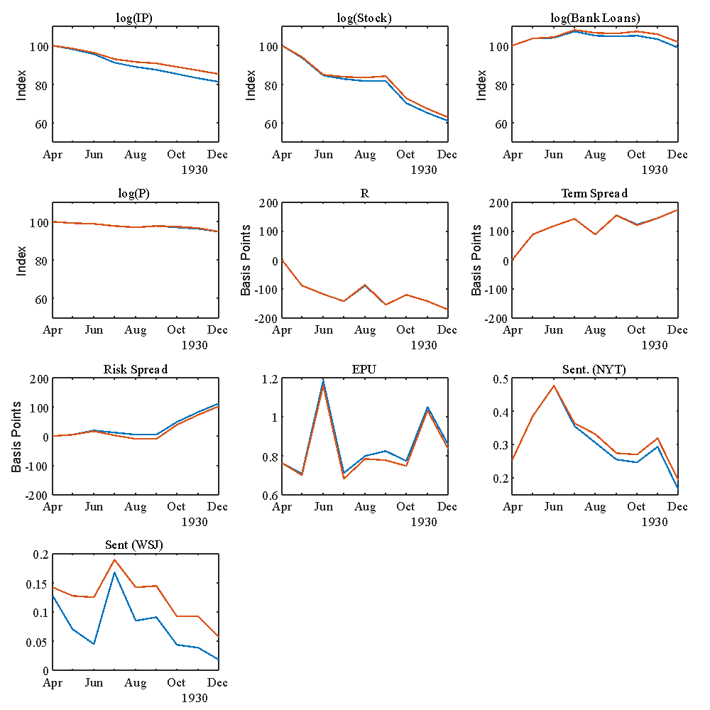

*Industrial production, the stock market, bank loans, and prices are normalized to equal 100 for the first date of each subperiod. The credit risk spread is measured in deviations (in basis points) from the value at the first date of each subperiod. The blue line is the actual data while the red line is the counterfactual series with the business-sentiment shock removed.

**Figure A23: Historical decomposition for January 1931 to December 1931**

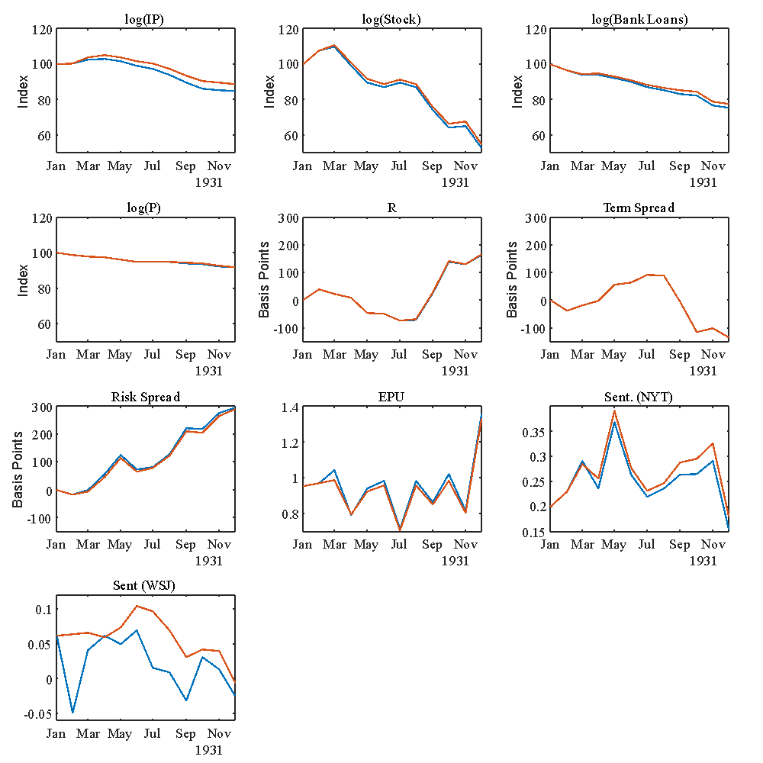

*Industrial production, the stock market, bank loans, and prices are normalized to equal 100 for the first date of each subperiod. The credit risk spread is measured in deviations (in basis points) from the value at the first date of each subperiod. The blue line is the actual data while the red line is the counterfactual series with the business-sentiment shock removed.

**Figure A24: Historical decomposition for July 1932 to December 1933**

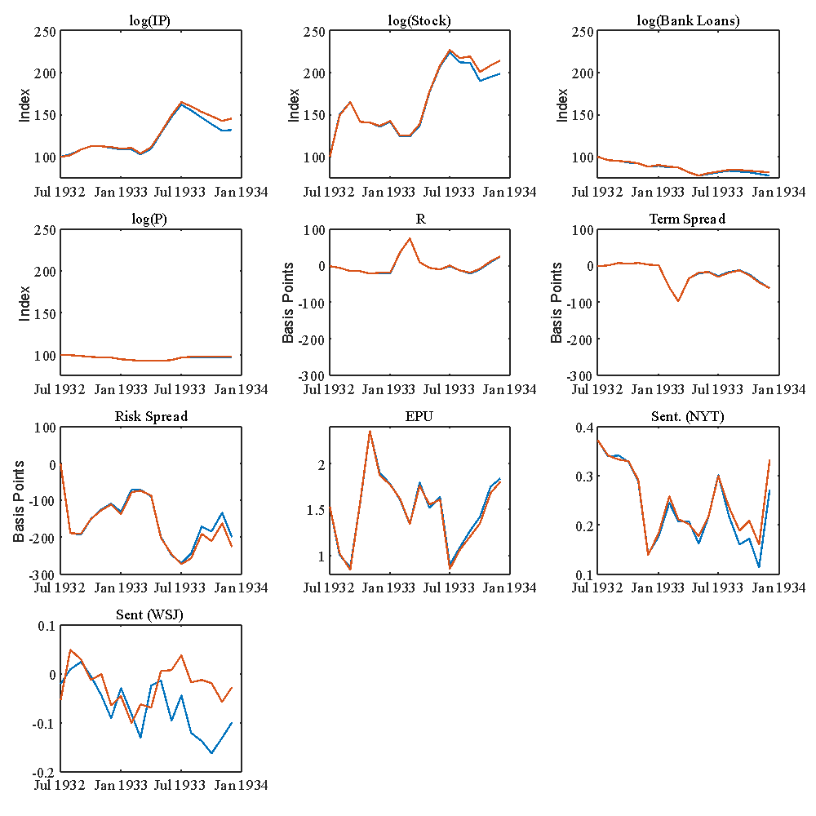

*Industrial production, the stock market, bank loans, and prices are normalized to equal 100 for the first date of each subperiod. The credit risk spread is measured in deviations (in basis points) from the value at the first date of each subperiod. The blue line is the actual data while the red line is the counterfactual series with the business-sentiment shock removed.

**A.4 Robustness Checks**

In what follows, we report the forecast error variance decompositions for alternative specifications.

The first alternative model is a model with bank loans replaced by M2. The impact of the WSJ derived business-sentiment shock on industrial production, the stock market and M2 are similar in quantity to the original specification.

**Table A6: FEVD for Model with M2 replacing Bank Loans of a shock to Sentiment**

|  |  |  |  |  |  |  |  |  |  |  |
| --- | --- | --- | --- | --- | --- | --- | --- | --- | --- | --- |
| Period | *ip* | *sp500* | *M2* | *p* |  |  |  | *EPU* |  |  |
| 1 | 0.00 | 0.00 | 0.00 | 0.00 | 0.00 | 0.00 | 0.00 | 0.00 | 0.00 | 80.76 |
| 2 | 1.54 | 0.12 | 1.03 | 0.12 | 0.12 | 0.13 | 0.32 | 0.87 | 0.07 | 74.38 |
| 3 | 3.56 | 0.39 | 2.36 | 0.56 | 0.31 | 0.29 | 2.08 | 0.76 | 1.22 | 68.16 |
| 4 | 5.60 | 1.07 | 4.08 | 1.26 | 0.53 | 0.49 | 4.71 | 0.84 | 2.98 | 63.03 |
| 5 | 7.30 | 1.82 | 5.70 | 2.16 | 0.80 | 0.72 | 6.80 | 0.97 | 4.41 | 59.14 |
| 10 | 10.12 | 2.62 | 10.72 | 6.02 | 2.72 | 2.38 | 7.42 | 0.78 | 7.41 | 48.68 |
| 15 | 9.47 | 2.39 | 12.20 | 7.56 | 4.77 | 4.15 | 6.07 | 0.62 | 8.59 | 42.41 |
| 20 | 8.65 | 2.14 | 12.46 | 8.07 | 6.23 | 5.40 | 5.04 | 0.51 | 9.01 | 38.22 |
| Notes: Numbers reported are in percentages. Lowercase variables are in logarithms. | | | | | | | | | | |

The next robustness check is to check whether there is different information in the RSS (approach/avoidance) based sentiment series compared to the sentiment series constructed using the lexicon of Laughran and McDonald. We do this first by replacing the two RSS based sentiment series with the alternative LM based sentiment series on the VECM.

**Table A7: FEVD of a shock to Sentiment for Model with LM replacing RSS**

|  |  |  |  |  |  |  |  |  |  |  |
| --- | --- | --- | --- | --- | --- | --- | --- | --- | --- | --- |
| Period | *ip* | *sp500* | *loans* | *p* |  |  |  | *EPU* | *SNYT(LM)* | *SWSJ(LM)* |
| 1 | 0.00 | 0.00 | 0.00 | 0.00 | 0.00 | 0.00 | 0.00 | 0.00 | 0.00 | 68.51 |
| 2 | 0.28 | 0.02 | 1.78 | 0.08 | 0.27 | 0.24 | 0.12 | 1.45 | 1.25 | 62.61 |
| 3 | 0.45 | 0.01 | 7.02 | 0.34 | 0.45 | 0.38 | 0.95 | 3.65 | 2.74 | 59.92 |
| 4 | 0.46 | 0.04 | 12.80 | 0.68 | 0.56 | 0.47 | 2.14 | 5.93 | 4.10 | 58.04 |
| 5 | 0.40 | 0.07 | 17.19 | 1.02 | 0.61 | 0.51 | 3.24 | 7.62 | 5.08 | 57.32 |
| 10 | 0.19 | 0.05 | 23.92 | 2.26 | 0.47 | 0.38 | 5.35 | 9.16 | 7.60 | 58.14 |
| 15 | 0.13 | 0.04 | 24.72 | 3.05 | 0.31 | 0.25 | 6.10 | 8.46 | 8.91 | 58.36 |
| 20 | 0.13 | 0.03 | 24.73 | 3.54 | 0.22 | 0.18 | 6.79 | 7.78 | 9.63 | 57.89 |
| Notes: Numbers reported are in percentages. Lowercase variables are in logarithms. | | | | | | | | | | |

Table A7 reports the FEVD of a shock to WSJ derived sentiment (using the LM lexicon). Compared to the FEVD of a shock to WSJ derived sentiment (using our approach/avoidance lexicon), the sentiment shock derived using LM does not have any power in explaining variation in output or the stock market. It does explain more of the variation in bank loans and the risk spread. Our interpretation is that the sentiment derived from the approach/avoidance lexicon has a different information content to the one derived from LM.

The next robustness check is to include the WSJ-derived LM sentiment in the same model as the WSJ-derived sentiment using the approach/avoidance lexicon. We order the LM based sentiment series first. If the two series have the same information content the approach/avoidance variable should not explain any of the variation in the variables included in the model.

Table A8 reports the FEVD for a shock to WSJ-derived sentiment using the approach/avoidance lexicon; this time with the WSJ-derived sentiment using the LM lexicon. The first thing to note is the WSJ-derived sentiment using the LM lexicon does not change the impact that the A/A-based sentiment series has on industrial production and the stock market. Similar to what we saw in Table A7, the LM-based sentiment series has an impact on bank loans. Table A9 reports the FEVD of a shock to the LM-Based sentiment series (derived from the WSJ). It is apparent that the LM-based sentiment series (obtained from the WSJ) has a bigger impact on bank loans and prices, a similar impact on the risk spread (albeit with a delay), but a smaller impact on industrial production and the stock market than the A/A-based sentiment series.

Importantly, the LM-based sentiment series explains at most 26% of the observed variation in the A/A-based sentiment series. There is clearly some information in both series that are similar but there is clearly a large amount of information in the A/A-based sentiment series that is orthogonal to the LM-based series.

**Table A8: FEVD of a shock to A/A-Based Sentiment for Model with WSJ based sentiment (LM and A/A)**

|  |  |  |  |  |  |  |  |  |  |  |
| --- | --- | --- | --- | --- | --- | --- | --- | --- | --- | --- |
| Period | *ip* | *sp500* | *loans* | *p* |  |  |  | *EPU* | *SWSJ(LM)* | *SWSJ(A/A)* |
| 1 | 0.00 | 0.00 | 0.00 | 0.00 | 0.00 | 0.00 | 0.00 | 0.00 | 0.00 | 69.00 |
| 2 | 1.07 | 0.04 | 0.06 | 0.01 | 0.10 | 0.09 | 0.27 | 3.66 | 0.01 | 60.96 |
| 3 | 2.73 | 0.20 | 1.43 | 0.10 | 0.08 | 0.07 | 1.93 | 4.17 | 0.11 | 58.03 |
| 4 | 4.69 | 0.61 | 2.52 | 0.22 | 0.07 | 0.06 | 4.12 | 5.77 | 0.21 | 55.61 |
| 5 | 6.74 | 1.09 | 3.21 | 0.27 | 0.05 | 0.05 | 5.59 | 6.81 | 0.20 | 53.69 |
| 10 | 13.61 | 1.47 | 3.13 | 0.28 | 0.09 | 0.13 | 5.10 | 7.02 | 0.16 | 47.64 |
| 15 | 16.43 | 1.43 | 2.32 | 0.30 | 0.11 | 0.19 | 4.33 | 7.15 | 0.15 | 44.67 |
| 20 | 18.20 | 1.40 | 1.87 | 0.32 | 0.12 | 0.22 | 3.90 | 7.02 | 0.13 | 42.82 |
| Notes: Numbers reported are in percentages. Lowercase variables are in logarithms. | | | | | | | | | | |

**Table A9: FEVD of a shock to LM-based Sentiment for Model with WSJ based sentiment (LM and A/A)**

|  |  |  |  |  |  |  |  |  |  |  |
| --- | --- | --- | --- | --- | --- | --- | --- | --- | --- | --- |
| Period | *ip* | *sp500* | *loans* | *p* |  |  |  | *EPU* | *SWSJ(LM)* | *SWSJ(A/A)* |
| 1 | 0.00 | 0.00 | 0.00 | 0.00 | 0.00 | 0.00 | 0.00 | 0.00 | 73.40 | 16.30 |
| 2 | 0.44 | 0.05 | 1.80 | 0.02 | 0.26 | 0.23 | 0.13 | 2.14 | 68.06 | 23.56 |
| 3 | 0.88 | 0.05 | 7.49 | 0.20 | 0.35 | 0.30 | 0.66 | 3.98 | 67.74 | 25.33 |
| 4 | 1.19 | 0.05 | 14.71 | 0.42 | 0.43 | 0.37 | 1.21 | 6.23 | 67.98 | 26.22 |
| 5 | 1.41 | 0.06 | 20.55 | 0.64 | 0.48 | 0.41 | 1.71 | 7.63 | 68.68 | 26.32 |
| 10 | 1.85 | 0.22 | 31.27 | 1.78 | 0.41 | 0.36 | 3.83 | 9.82 | 70.84 | 24.20 |
| 15 | 1.66 | 0.29 | 32.40 | 2.60 | 0.26 | 0.24 | 5.34 | 9.46 | 71.03 | 21.94 |
| 20 | 1.41 | 0.32 | 32.26 | 3.10 | 0.20 | 0.18 | 6.48 | 8.89 | 70.48 | 20.20 |
| Notes: Numbers reported are in percentages. Lowercase variables are in logarithms. | | | | | | | | | | |

Finally, Garcia (2013) (see references in main paper), constructed a LM-based sentiment series for the NYT based on two important financial columns. The next results reports what happens when we replace our A/A-based sentiment derived from the NYT with Garcia’s series. The addition of Garcia’s financial-centric NYT sentiment index (using the LM lexicon) does not significantly change the impact of our A/A-based sentiment index. The FEVD for the A/A-based sentiment index derived from the WSJ is shown in Table A10. Except for the stock market, the results are qualitatively similar to the results reported in the main paper. Our interpretation of these results are that the information contained in our A/A-based sentiment index that is derived from the WSJ is largely orthogonal to the financial information contained in the NYT.

**Table A10: FEVD of a shock to Sentiment for Model with Garcia and A/A-based WSJ sentiment**

|  |  |  |  |  |  |  |  |  |  |  |
| --- | --- | --- | --- | --- | --- | --- | --- | --- | --- | --- |
| Period | *ip* | *sp500* | *loans* | *p* |  |  |  | *EPU* | *SNYT(Garcia)* | *SWSJ(A/A)* |
| 1 | 0.00 | 0.00 | 0.00 | 0.00 | 0.00 | 0.00 | 0.00 | 0.00 | 0.00 | 78.83 |
| 2 | 0.86 | 0.04 | 1.00 | 0.02 | 0.05 | 0.05 | 0.09 | 1.58 | 1.16 | 77.03 |
| 3 | 1.95 | 0.02 | 5.24 | 0.02 | 0.05 | 0.05 | 0.68 | 1.37 | 3.38 | 75.07 |
| 4 | 3.26 | 0.10 | 9.25 | 0.02 | 0.07 | 0.07 | 1.49 | 1.22 | 5.55 | 73.43 |
| 5 | 4.48 | 0.21 | 12.52 | 0.04 | 0.09 | 0.08 | 2.00 | 1.14 | 7.24 | 71.97 |
| 10 | 7.59 | 0.30 | 17.84 | 0.49 | 0.18 | 0.14 | 1.65 | 2.33 | 12.85 | 67.11 |
| 15 | 7.92 | 0.27 | 17.93 | 0.90 | 0.39 | 0.30 | 1.34 | 2.46 | 15.89 | 64.36 |
| 20 | 7.79 | 0.24 | 17.42 | 1.13 | 0.61 | 0.46 | 1.27 | 2.43 | 17.52 | 62.11 |
| Notes: Numbers reported are in percentages. Lowercase variables are in logarithms. | | | | | | | | | | |

14-Feb-2022

Dear Harold

I hope that this finds you well.

I write to you with respect to Manuscript ID EcHR-21-08-0096-OA.R2, which you submitted to The Economic History Review.

I have read through your response to the minor comments of the referees and I have decided that these have all been addressed. It is, therefore, a great pleasure to accept your manuscript entitled "The Role of Sentiment in the Economy: 1920 to 1934" in its current form for publication in The Economic History Review.

I only have one suggestion which you can take or leave. Your title might be better as "The Role of Sentiment in the U.S. Economy: 1920 to 1934". I think that this better reflects the subject matter of your paper.

FOR QUANTITATIVE PAPERS, IF SUBMITTED AFTER 1 JAN 2020: This acceptance is conditional on your provision and deposit of a replication package, as set out in Part C of our Notes for Contributors, unless you are prevented from producing a package because of privacy or contractual constraints. Please upload this package to the First Look section of our submission system (details below), along with information about its deposit at an external repository.

OR, IF SUBMITTED BEFORE 1 JAN 2020: We are encouraging authors to supply replication packages for papers. This is only required for papers submitted after the 1 January 2020, but we would urge you to do so for your paper, in order to meet the best standards in social science. Details are set out in Part C of our Notes for Contributors. If you are able, upload this package to the First Look section of our submission system(details below), along with information about its deposit at an external repository.

The final version of your article cannot be published until the publisher has received the appropriate signed license agreement. Within the next few days the corresponding author will receive an email from Wiley’s Author Services system which will ask them to log in and will present them with the appropriate license for completion.

Please take time to familiarise yourself with the Author Promotion Toolkit and Article Sharing Policy that details how you can share your work: <https://authorservices.wiley.com/author-resources/Journal-Authors/Promotion/index.html>

If you have not already done so, please ensure that you have submitted the .xls files for all figures appearing in your submission produced using Excel (including both the figures and the underlying data). In addition, please check to make sure you have included full page extents for articles and essays cited in your list of references. I have attached our house-style document here for your guidance. Once you have made your changes, please upload your amended files via the First Look facility in ScholarOne Manuscripts.

Thank you for your fine contribution. On behalf of the Editors of The Economic History Review, we look forward to your continued contributions to the Journal.

Sincerely

John

Professor John Turner

Editor, The Economic History Review

[j.turner@qub.ac.uk](mailto:j.turner@qub.ac.uk)

Wiley offers authors the option to make their article available to non-subscribers on Wiley Online Library through their OnlineOpen service. This service is also suitable for authors whose funding agency requires grantees to archive the final version of their article. With OnlineOpen, the author, the author's funding agency, or the author's institution pays a fee to ensure that the article is made available to non-subscribers upon publication via Wiley Online Library, as well as deposited in the funding agency's preferred archive. For the full list of terms and conditions, see <http://wileyonlinelibrary.com/onlineopen#OnlineOpen_Terms>. Any authors wishing to send their paper OnlineOpen will be required to complete the payment form available from our website at: <https://authorservices.wiley.com/bauthor/onlineopen_order.asp>.

P.S. – You can help your research get the attention it deserves! Wiley Editing Services offers professional video abstract and infographic creation to help you promote your research at [www.wileyauthors.com/eeo/promotion](http://www.wileyauthors.com/eeo/promotion). And, check out Wiley’s free Promotion Guide for best-practice recommendations for promoting your work at [www.wileyauthors.com/eeo/guide](http://www.wileyauthors.com/eeo/guide)

1. * Kabiri: University of Buckingham, Financial Markets Group (FMG), London School of Economics and Political Science, and Centre for the Study of Decision-Making Uncertainty, UCL. Hunter St, Buckingham MK18 1EG, UK, email ali.kabiri@buckingham.ac.uk. James: Princeton University, Princeton, NJ 08544, USA, hjames@princeton.edu. Landon-Lane: Rutgers University, 75 Hamilton St, New Brunswick, NJ 08901, USA, john.landonlane@rutgers.edu. Tuckett: Centre for the Study of Decision-Making Uncertainty, UCL, Gower St, London WC1E 6BT, UK, [d.tuckett@ucl.ac.uk](mailto:d.tuckett@ucl.ac.uk). Nyman: Centre for the Study of Decision-Making Uncertainty, UCL, Gower St, London WC1E 6BT, UK, r.nyman@cs.ucl.ac.uk. The authors would like to thank Charles Goodhart for valuable advice and suggestions and Jacob Turton for research assistance. Any errors are our own.
2. Bernanke, *Essays*, p. 5
3. See, for example, Graham and Dodd, *Security Analysis*, Fisher, *Booms,* and Keynes, *General Theory*
4. Graham and Dodd, *Security Analysis*
5. Fisher, *Booms*, p. 33.
6. Keynes, *General Theory*, p. 317.
7. “Banking Opinion Shows Confidence: Northwest, Clear to the Pacific Coast, Cheered by Fine Crops, Feels Sure of Good Times,” *Wall Street Journal*, January 10, 1925.
8. See, for example, Tetlock, “Giving content to investor sentiment’, Loughran and McDonald, ‘When is Liability not a Liability?’, and Püttmann, ‘Patterns of Panic: Financial Crisis Language in Historical Newspapers.’
9. See, for example, Ramey and Shapiro, ‘Displaced capital’; Romer and Romer, ‘The macroeconomic effects of tax changes’; Dominguez and Shapiro, ‘Forecasting the Recovery from the Great Recession’; Choi and Varian, ‘Predicting the present with Google Trends’; Haddow et. al. ‘Macroeconomic uncertainty; what is it, how can we measure it and why does it matter?’
10. Manela and Moreira, ‘News implied volatility and disaster concerns’. Garcia, ‘Sentiment during recessions’ Baker et. al. ‘Measuring economic policy uncertainty’.
11. See, for example Binder, ‘Estimation of historical inflation expectations’; Daniel and ter Steege,’Inflation expectations and the recovery from the Great Depression in Germany’; Jalil and Rua, ‘Inflation expectations and recovery in spring 1933’.
12. See for example, Romer, ‘The Great Crash’; Lennard, ‘Uncertainty and the Great Slump’; Mathy and Ziebarth, ‘How much does political uncertainty matter?’; Mathy, ‘How Much Did Uncertainty Shocks Matter in the Great Depression?’
13. Borowiecki, ‘How Are You, My Dearest Mozart? Well-Being and Creativity of Three Famous Composers Based on Their Letters’; Hills et al., ‘Historical Analysis of National Subjective Wellbeing Using Millions of Digitized Books’; Hanna et al., ‘News Media and Investor Sentiment during Bull and Bear Markets’
14. De Long and Shleifer, ‘The stock market bubble of 1929’; White, ‘The stock market boom and crash of 1929 revisited’ and Rappaport and White, ‘Was there a bubble in the 1929 stock market?’.
15. Shiller, ‘Do Stock Prices Move Too Much to be justified by Subsequent Changes in Dividends?’ and *Irrational Exuburance*.
16. Tuckett and Nikolic, ‘The role of conviction and narrative in decision-making under radical uncertainty’.
17. Rosenberg, *Inside the WSJ*, p 46.
18. Loughran and McDonald, ‘When is a liability not a liability? Textual Analysis, Dictionaries, and 10-Ks.’ Harvard-IV and Lasswell http://www.wjh.harvard.edu/~inquirer/homecat.htm
19. Tuckett and Nikolic, ‘The role of conviction and narrative in decision-making under radical uncertainty,’ and Chong and Tuckett, ‘Constructing conviction thought action and narrative’
20. Johnson, Bilovich, and Tuckett, ‘Conviction Narrative Theory: A theory of choice under radical uncertainty.’
21. Binder et. al., ‘Toward a brain-based componential semantic representation.’ Turton et. al., ‘Differentiating approach and avoidance from traditional notions of sentiment in economic contexts.’
22. See appendix for full list of words
23. Tuckett et. al. ‘Tracking phantastic objects: A computer algorithmic investigation of narrative evolution in unstructured data sources.’
24. See, for example, Tuckett, *Minding the Markets*, Tuckett and Nikolic, ‘The role of conviction in decision-making under radical uncertainty’, Bruner, *Acts of Meaning*, Berezin, ‘Emotions and the economy’, Damasio, *The feeling of what happens*, and Bandelj, ‘Emotions in economic action and interaction’.
25. Manela and Moreira, ‘News implied volatility and disaster concerns’.
26. Garcia, ‘Sentiment during recessions.’
27. Rosenberg, *Inside the WSJ*.
28. Loughran and McDonald, ‘When is a liability not a liability? Textual Analysis, Dictionaries, and 10-Ks’.
29. Calomiris and Mamaysky, ‘How news and its context drive risk and returns around the world’.
30. IP (http://fred.stlouisfed.org/series/INDPRO) ,

    Stock Market (http://www.econ.yale.edu/~shiller/data.htm - These data are based on Cowles (and others) *Common Stock Indexes, 1871 –1937* indexes of US stock prices for 59 industrial groups. The data was accessed first in 2017.)

    Bank Loans (https://fred.stlouisfed.org/series/M14074USM027NNBR),

    CPI (https://fred.stlouisfed.org/series/M04128USM350NNBR),

    3-month interest rate (Data used in Cecchetti, ‘Prices during the Great Depression: Was the deflation of 1930-1932 really unanticipated?’ Interest rate data from Mankiw and Miron, ‘The changing behaviour of the Term Structure of Interest rates.’)

    EPU (Baker et. al., ‘Measuring economic policy uncertainty’.)
31. Bernanke, ‘Nonmonetary Effects of the Financial Crisis in the Propagation of the Great Depression’
32. “Circulation. Gains in December,” New York Times. Jan 24, 1929: 21.
33. Johansen, *Likelihood-based inference in cointegrated vector autoregressive models*.
34. Hall, *The bootstrap and Edgeworth expansion*.
35. “Comptroller Williams Criticises Money Rates,” Wall Street Journal, 31 July 1920: 1 (number 1 in avoidance in July 1920).
36. “Coal May Go Back To Government Control,” Wall Street Journal 12 July 1920: 9 (number 3 in avoidance terms in July 1920).
37. “Western Bank Doubts If Prices Decline Much Wall Street Journal,” Aug 13, 1920: 10 (number 1 in avoidance in August 1920).
38. Schwab Says We Won War Shall We Win The Peace?, WSJ, April 29, 1921 (number 1 in Approach, April 1921).
39. Underwood Says Europe is Worse, WSJ, July 6, 1923 (number 1 in avoidance, July 1923).
40. “Herbert N. Casson, America's Progress Astounds Britain: Publication of Facts on Wealth of United States Amaze People of Older Nation,” Wall Street Journal, 19 July 1926: 10 (number 4 in approach, July 1926).
41. “Market Comment: Buying Grows in Volume Big Investment Demand,” Wall Street Journal; Jul 1, 1926: 16 (number 1 in Approach, July 1926).
42. “Gold Flowing In Both Ways: Exports Going to Canada and Germany,” Wall Street, 09 Sep 1926: 8.
43. “U.S. Steel--General Motors: B.C. Forbes Tells ‘Inside Story’ of Now Famous Articles by Dow, Jones & Co.” *Wall Street Journal*, 01 Sep 1926: 11 (number 1 in avoidance in September 1926).
44. Market Comment, WSJ, September 30, 1926.
45. U.S. Steel - General Motors, WSJ, September 1, 1926, number 1 in avoidance September 1926.
46. Texas Suit May Not Embarrass Marland, WSJ, September 27, 1926, number 2 in avoidance September 1926.
47. Stock Exchange's Publicity Effort, WSJ, October 4, 1926, number 1 in avoidance, October 1926.
48. Bonds and Bond Men, WSJ, October 8, 1926, number 6 in avoidance, October 1926.
49. Says Germany Can Meet Reparations, WSJ, October 23, 1926, number 2 in avoidance, October 1926.
50. “Abreast of the Market: A Daily Column of Comment,” Wall Street Journal; Feb 11, 1929: 16.
51. “ ‘Others’ Loans Create Alarm: City Bank Stresses Danger of Potential ...,” Wall Street Journal; Feb 4, 1929:
52. “No Place for Mysteries,”Wall Street Journal*;* Feb 19, 1929: 1.
53. “Merger Plans of Trunk Lines: C. & O. and B. & O. Unification ... ,from the Wall Street Journal Washington Bureau,” Wall Street Journal; Feb 21, 1929: 1.
54. Roosevelt Sees, WSJ, July 28, 1933 (number 1 in Avoidance, July 1933).
55. Oil, Coal Codes Raise Questions of Labor Costs, WSJ, July 15 1933 (number 3 in Avoidance, July 1933).
56. Currency Alone May Rule Trade, WSJ, July 8, 1933 (number 13 in Avoidance, July 1933).