CUBAN IMMIGRANTS IN THE UNITED STATES: WHAT DETERMINES THEIR EARNINGS DISTRIBUTION?[1]

**ALEIDA COBAS-VALDÉS**[2]

**ANA FERNÁNDEZ-SAINZ**[3]

**STEPHEN WILKINSON**[4]

ABSTRACT

In this paper the conditional earnings distribution of Cuban immigrants in the U.S. using OLS and Quantile Regression is analyzed. The data used in the study come from the 2011 American Community Survey (ACS) in the U.S. provided by IPUMS (2011). The results show that increments in earnings associated with different socioeconomic characteristics such as: sex, marital status, ethnicity, proficiency in English and education vary across the whole earnings distribution.

Keywords: Cuban migration; Earnings distribution; Cuban workers in U.S; Socioeconomic characteristics; Quantile Regression.

JEL Codes: C13, J1, J3.

INTRODUCTION

In terms of education level, Cuban immigrants positively self-select in their migration decision to move the U.S., that is, the people with the highest levels of education are those who tend to migrate. In general, migrants have more years of study than the mean of distribution of years of study of workers in Cuba (Cobas and Fernández, 2014) and therefore they are workers with extensive skills in their source country. In addition, when considering legal migration, there is a tendency for the U.S. government to grant visas to both younger and better qualified individuals.

Since it is the most highly skilled people who migrate, it is undoubtedly of interest to analyze the whole distribution of earnings and quantify the effect of socioeconomics variables in different location of the distribution of earnings.

Although most of the population of Cuban origin in the U.S. have arrived within the past 25 years. The United States has been the main destination for migrants from Cuba, and other Latin American countries. The U.S. Census for 2012 reveals that 52.4 million people (16.95% of the entire population) in the United States are of Hispanic origin (U.S. Census Bureau, 2012); 1.12 million of them, i.e. 3% of the foreigners living in the U.S. were born in Cuba (Motel and Patten, 2012).

It is well known that an important proportion of the labor force in the U.S. is made up of immigrants. In 2012, 6% of U.S. workers comprised people of Latin ethnicity (U.S. Bureau of Labor Statistics, 2013), Cubans made up 5%, making them the third biggest group of Hispanic immigrants in the U.S.

Upon arrival in the U.S., immigrants can be expected to be at an earnings disadvantage with respect to natives because they lack certain skills and information that natives have (Friedberg, 1992). Over time, they may increase their income when they improve their English and adapt to the specific skill sets of the country.

Moreover, the migration of higher educated individuals has a negative impact on countries of birth since most educational investment on migrants is lost (Aupetit and Gérard, 2009). In terms of benefits to the host country, migration increases its production capacity and technological capabilities, and from an economic point of view entails no significant costs in terms of social services, which would be required if the majority of those who migrated had less education (Cuecuecha, 2005).

This paper describes the earnings of Cuban immigrants in the U.S. using Ordinary Least Square (OLS) and Quantile Regression (QR). Quantile Regression is a method for estimating the relationship between a response variable and a set of explanatory variables for the whole conditional probability distribution of the response variable.The explanatory variables considered are those that are considered as most important in the relevant literature: years of education, age on arrival in the U.S., potential job experience, sex, marital status, ethnicity, citizenship status and proficiency in English.

OLS enables the effect of the explanatory variables on the mean of the response variable to be calculated, while QR enables the conditional distribution of earnings on the explanatory variables at different locations of the distribution to be described, and thus offers a comprehensive overview of the link between the response variable and the explanatory variables. The applications of QR range from the field of education (Rangvid, 2007) to biostatistics (Terry et al., 2007) and economics (Chamarbagwala, 2010).

Some papers, using cross-section regression, have tended to confuse the true assimilation of immigrants in the U.S. labor market. Chiswick (1978) found that the wage of Cubans immigrants in the U.S. who arrived in 1965-1969 increased by about 37% within the first 10 years after immigration. This could lead to the conclusion that the earnings of immigrants grow rapidly and this rapid growth enables immigrants to overtake the earnings of native workers within 10-15 years of immigration. Borjas (1985) compared different cohorts, at the same points of their U.S. life cycle, using cross-section models within immigrant cohorts, and found that for the same period, 1965-1969, the earnings of Cuban immigrants decreased by about 25%.

Some recent studies about earnings distribution of Latin immigrants in the U.S. reveal considerable disadvantages with respect to native-born people. Chiswick et al. (2008) find that immigrants from non-English speaking countries have mean hourly earnings of around 12% less than those of native born workers in the U.S.; Elliott and Lindley (2008) concludes that differences in human capital endowment and socioeconomic characteristics explain some of the lack of earnings assimilation; Hunt (2012) concludes that non-English-speaking immigrants earn less than their native counterparts. Borjas (2015) finds that Cuban immigrants who arrived in the United States between 1995 and 1999 experienced a wage decrease of 4.4 % in their first 10 years in the U.S.

The contribution of this article is twofold. First, it utilises OLS and QR methods to estimate the effects of different socioeconomic characteristics on the conditional probability distribution of the earnings of Cuban immigrants in the U.S. to analyze the distribution of earnings of Cuban immigrants in the U.S. and quantify the effect of this socioeconomic variables. Secondly, it illustrates the differences in the impact of these characteristics between higher and lower income workers. Taking into account that a QR model proposes different regression lines for the different quantiles of the earnings distribution, the contribution of the socioeconomics characteristics on different levels of earnings can be compared.

The paper is structured as follows: Section 1 reviews the presence of Cubans in the U.S., Section 2 describes the methodology used, Section 3 presents the results of our estimation and Section 4 sets out the main conclusions.

1. CUBANS IN THE U.S.

Although most of the population of Cuban origin in the U.S. have arrived within the past 50 years, the Cuban presence in the country has a long history. Between 1871 and 1958 some 221,000 Cubans migrated to the U.S., mainly to Florida, the most proximate state to the island (Pérez, 1986). However, this figure is dwarfed by the approximately 1.25 million Cubans who have migrated to United States since 1959. This exodus has also been mainly to Florida, particularly Miami, where approximately three out of every five Cubans in the U.S. reside (Pérez 2001, p. 91). Unlike most ethnic groups in other cities, overrepresented in only a few sectors of the economy, the presence of Cubans has been widespread in the Miami economy (Portes and Shafer, 2007).

There have been five distinct periods of Cuban migration: The first was from 1959-1962, when around 200,000 Cubans migrated generally from the upper classes; the second period lasted from 1965-1973, when the U.S. conducted “freedom flights” and 260,500 applicants were permitted to leave the country in airlifts sponsored by the U.S.

The third wave came in 1980-1981, known as the Mariel boatlift period when some 125,000 Cubans migrated, including those from lower socioeconomic classes. Then came the so-called *Balseros Crisis* of 1994, when Cuba announced it would not restrain Cubans from leaving the country by raft or sea vessels and, consequently, over 40,000 *balseros* successfully migrated to the U.S. (Pérez 2001, p. 93).

The final period, from 1995 to the present, has been characterized by a steady outflow of some 20-30,000 Cubans migrating legally every year to the U.S. under accords reached following the *Balseros Crisis*. In addition, there has been a smaller, but unquantifiable number of Cubans migrating illegally[5].

Thus around 1.5 million Cubans have immigrated to the United States since the 19th Century, settling predominately in Miami. They dominate the political scene in South Florida and have more recently become a leading demographic in political elections in the twenty-first century. Their success in the United States is partly due to the favorable treatment that Cubans receive as a consequence of The Cuban Adjustment Act, U.S. legislation passed during the Cold War to assist Cubans fleeing from communism (Pew Research Center, 2015), and partly due to factors inherent in their distinct demographic characteristics.

Until the end of the 1990s, Cubans were the oldest, wealthiest and most educated Latino immigrants in the United States. In 2000, the median age of Cubans was 41.3 years, more than ten years older than the next eldest who were Central and South Americans, averaging 29.9 years of age. Furthermore, 24.8 percent of Cubans held a bachelor’s degree compared with 18.0 percent of Central and South Americans. (Pérez 2001, p. 115). One in four Cubans 25 and older is a college graduate, more than double the rate of other Hispanics.

The number of Cubans who have arrived in the USA has suffered a significant rise since Presidents Barack Obama and Raul Castro announced the renewal of diplomatic relations with a 78% increase in the number of illegal Cuban migrants entering the U.S., reportedly the largest wave of migration since the 1990s (Pew Research Center, 2015).

According to US Custom and Border Protection (2016) 46.635 Cubans have entered the USA via ports of entry during the first 10 months of fiscal year 2016. In full fiscal year 2015, 43.159 Cubans arrived in the USA in contrast with year 2011 when 7.759 Cubans entered.

Cuban Americans are more educated than other Latinos, and native-born Cubans show higher rates of college graduation than non-Hispanic whites. (Suarez-Orozco and Páez, 2002). Since the turn of the century, the trend has been for younger (aged 20-40) and more highly qualified professional Cubans to migrate (Hernández and Foladori 2014, p. 32).

1. **METHODOLOGY**

Many of the issues that social researchers are currently analyzing, are related to the values of variables of interest located at the tails of the distribution of the variable of interest. The Quantile Regression (QR) method proposed in this paper measures the effect of the explanatory variables at various points of the (log) hourly earnings distribution. The difference at various quantiles provides significant information about the effects of the covariates considered on the hourly earnings spread. A linear quantile regression model (Koenker and Basset, 1978) links the conditional quantiles of the response variable to the covariates linearly.

With this method it is possible to study the conditional distribution of the (log) hourly earnings over the different socioeconomic variables at different locations and thus provide an overview of the links between (log) hourly earnings and the socioeconomic variables selected for the study.

As pointed out in Machado and Mata (2005) the estimated Quantile Regression coefficients can be interpreted as rates of return of labor market skills at different points of the conditional wage distribution. In general, the parameter estimated in linear quantile regression models have the same interpretation as those in any other linear regression model but now defined for a specified quantile (Koenker, 2005).

A robust OLS estimation on Equation (1) employing the heteroskedasticity robust HC4 estimator of (Cribari-Neto, 2004) was initially carried out. This estimator improves sample performance when the term of error is independent but heteroskedastic, especially in the presence of influential observations (Zeileis, 2004).

|  |  |
| --- | --- |
| $$w_{i}=x_{i}^{'}β+ε_{i} i=1, …., n$$ | [1] |

where $w_{i}$ is the logarithm of gross hourly earnings for individual i, using total pre-tax wage and salary income (expressed in contemporary dollars), i.e, money received as an employee for the previous year as the measure of earnings; $x_{i}$ is a vector of socioeconomics characteristics of Cuban immigrants in the U.S. including an intercept, $ε_{i}$ is the error term and $β∈R^{m}$ is a vector of unknown parameters.

Next, the proposed model in Equation (1) under the conditional Quantile Regression (QR) is estimated. For any t v (0,1) a linear quantile regression model can be written as

|  |  |
| --- | --- |
| $$w_{i}= x_{i}^{'} β_{τi}+ε_{τi}$$ | [2] |

The quantile function $Q_{wi}\left(τ | x_{i}\right)$ of the response variable $w_{i }$ conditional on covariate vector $x_{i }$ at a given quantile parameter $τ$ is given by

|  |  |
| --- | --- |
|  | [3] |

No specific assumptions are made for the error term, apart from $ε_{τi }$ and $ε_{τj }$ being independent for $i≠j$ and to consider that the distribution function at 0 is $τ$. The estimation of regression quantiles coefficients, ${ β}_{τ}$, can differ across the different -quantiles, so the marginal effect of a particular explanatory variable may not be homogeneous across the quantiles.

Since all continuous explanatory variables are centered at their median value, we use the centercept concept (Wainer, 2000) which has a more meaningful interpretation than the usual intercept because it provides the value of the (log) hourly earnings for the median individual.

1. **EMPIRICAL RESULTS**

The data used in this paper come from the random sample of 1% of the 2011 American Community Survey (ACS) provided by Integrated Public Use Microdata Series (IPUMS, 2011). This sample includes only individuals who entered the U.S. at the age of 17 years or over. This approach is intended to exclude people who completed their education in U.S (Lowell et al., 2008).

In addition, only individuals who entered the U.S. when less than 50 years old are considered, since the assumption is that the group aged between 16 and 49 years consists of those most likely to migrate for economic reasons (Bertoli et al., 2013). Only individuals in work and those aged between 25-64 at the time of the survey are considered.

The sample consists of 19.079 observations. Table 1 gives a summary of the variables considered in the estimation models for Cubans immigrants in the U.S. As can be seen, 43% of the people in the sample are women, 63% are married, 45% are nationalized in the U.S., 53% speak English well or very well and approximately 3% are black. 50 % of Cubans in the U.S. were 30 years old or more at the time of their entry into the U.S., have 12 or more years of education and earn $8.33 per hour or more. On average they have 27 years of potential experience.

|  |  |  |  |
| --- | --- | --- | --- |
| Table 1. Statistics of covariates: Mean and Standard Deviation. | | | |
| Variable | Description | Mean | Standard Deviation |
| Woman | Dummy variable: 1 if woman | 0.4264 | 0.4946 |
|  |  |  |  |
| Black | Dummy variable: 1 if black | 0.0309 | 0.1730 |
|  |  |  |  |
| Married | Dummy variable: 1 if married | 0.6283 | 0.4833 |
|  |  |  |  |
| AmericanCitizen | Dummy variable: 1 if an american citizen | 0.4461 | 0.4971 |
|  |  |  |  |
| EnglishProficiency | Dummy variable: 1 if proficiency in English | 0.5314 | 0.4990 |
|  |  |  |  |
| AgeImm | Age of the individual (in years) at time of migration | 29.81 | 8.2119 |
|  |  |  |  |
| YearsEducation | Years of Education of the individual | 12.46 | 2.9781 |
|  |  |  |  |
| Experience | Potential Experience of the individual[6] | 27.43 | 11.5426 |
|  |  |  |  |
| Log Hourly Earnings | Response Variable | 2.6219 | 0.7724 |
| Source: Author’s own elaboration based on the 2011 American Community Survey (ACS) in the U.S. provided by IPUMS(2011). | | | |

Figure 1 and 2 show where individuals work depending on their level of education. We considered whether individuals in Cuba and in the U.S. held jobs with a professional category in line with their education level. A comparison of the occupation of Cubans in Cuba and Cubans in the United States reveals that a higher percentage of Cubans in U .S. with 13 or more years of education work in jobs that require lower skills than they actually possess.

Figure 1. Job Category in Cuba.



Source: Author’s own elaboration based on the Population and Housing Census of Cuba 2002 provided by IPUMS-International (2011).

Figure 2. Job Category in the U.S.

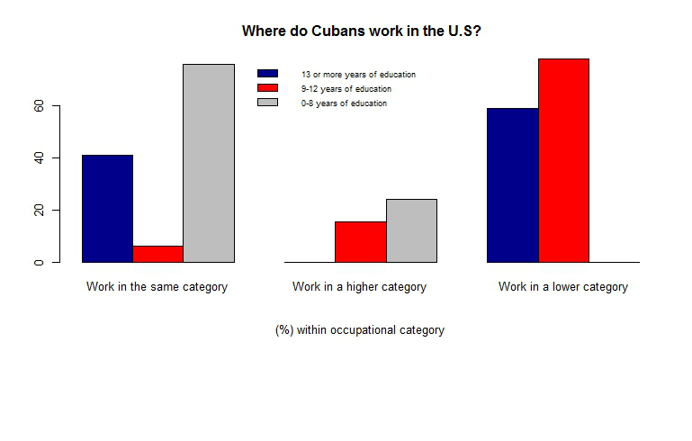

Source: Author’s own elaboration based on the 2011 American Community Survey (ACS) in the U.S. provided by IPUMS (2011).

Figure 3 presents a histogram and box plot of (log) hourly earnings for Cuban immigrants. The histogram of (log) hourly earnings gives a good picture of the presence of positive skewness, the mean of (log) hourly earnings is 2.6219 ($13.762), higher than the federal minimum wage ($7.25 per hour in 2011)[7].

Figure 3. Histogram and Box Plot of (log) Hourly Earnings.

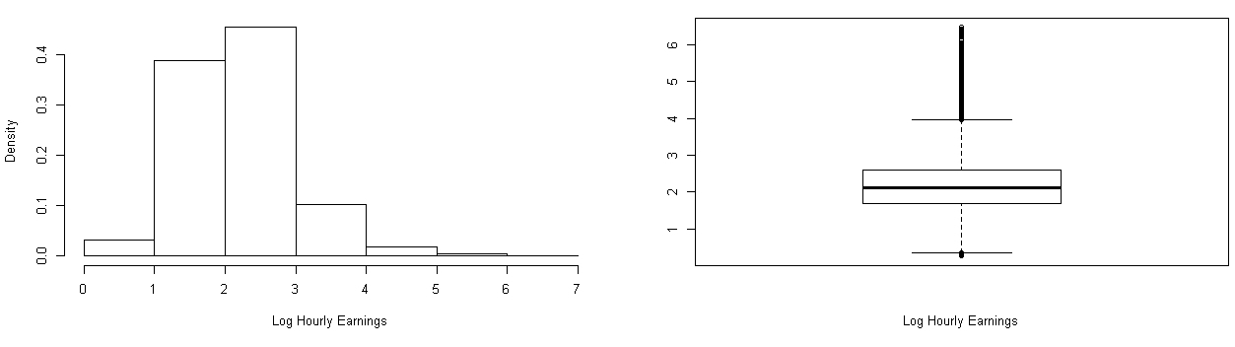

Source: Author’s own elaboration based on the 2011 American Community Survey (ACS) in the U.S. provided by IPUMS (2011).

Nearly 60% of Cubans in the United States who have 13 or more years of education take jobs with low skill requirements and 78% of those with 9-12 years of education work as skilled workers (Cobas and Fernández, 2014). Many Cubans begin their working life in U.S. in jobs with skill levels much lower than and very different from those that they held in Cuba (Cattan, 1993).

Table 2 contains the sample correlations between the explanatory variables. As can be seen, there are significant correlations between Proficiency in English and Citizenship Status (r = 0.3387), that is, Cubans with greater Proficiency in English are more likely to be citizens. Age on arrival in the U.S. and proficiency in English are negatively associated (r = - 0.3611); this means that younger individuals seem to be the most predisposed to learn English. Those with higher education levels appear to have less professional experience (r = -0.2925) but to be more willing to learn English (r = 0.2916).

|  |  |  |  |  |  |  |  |  |  |  |  |  |  |  |  |  |  |
| --- | --- | --- | --- | --- | --- | --- | --- | --- | --- | --- | --- | --- | --- | --- | --- | --- | --- |
| Table 2. Sample correlation of variables | | | | | | | | | | | | | | | | | |
|  | Woman | | Black | | Married | | American  Citizen | | English  Proficiency | | AgeImm | | Years of Education | | Experience | |
| Woman | | 1.000 | | -0.020 | | -0.0353 | | 0.1118 | | 0.0198 | | -0.0945 | | 0.0443 | | 0.0324 | |
|  | |  | |  | |  | |  | |  | |  | |  | |  | |
| Black | |  | | 1.000 | | -0.0483 | | -0.0401 | | -0.0073 | | 0.0311 | | -0.0278 | | -0.0111 | |
|  | |  | |  | |  | |  | |  | |  | |  | |  | |
| Married | |  | |  | | 1.000 | | 0.0622 | | -0.0145 | | 0.0439 | | 0.0121 * | | 0.0638 | |
|  | |  | |  | |  | |  | |  | |  | |  | |  | |
| American  Citizen | |  | |  | |  | | 1.000 | | 0.3387 | | -0.2659 | | 0.1208 | | 0.4033 | |
|  | |  | |  | |  | |  | |  | |  | |  | |  | |
| English  Proficiency | |  | |  | |  | |  | | 1.000 | | -0.3611 | | 0.2916 | | -0.0115 | |
|  | |  | |  | |  | |  | |  | |  | |  | |  | |
| AgeImm | |  | |  | |  | |  | |  | | 1.000 | | -0.0404 | | 0.2292 | |
|  | |  | |  | |  | |  | |  | |  | |  | |  | |
| Years of Education | |  | |  | |  | |  | |  | |  | | 1.000 | | -0.2925 | |
|  | |  | |  | |  | |  | |  | |  | |  | |  | |
| Experience | |  | |  | |  | |  | |  | |  | |  | | 1.000 | |

Note: All correlations are significant at the 1% significance level. **\*** means significant only at the 10% significance level.

As can be seen in the first column of Table 3, in the OLS estimation there is only one non-significant explanatory variable (Black) to explain the (log) hourly earnings, at the $significance level of 5\%$. The remaining explanatory variables are statistically significant. In particular, note that being married, being a naturalized American, speaking English well or very well, years of education and potential job experience show a positive link to (log) hourly earnings, while being a woman and age on entry in the U.S. show a negative link to the response variable.

|  |  |  |  |  |  |  |
| --- | --- | --- | --- | --- | --- | --- |
| Table 3. OLS and Linear Quantile Regression. | | | | | | |
| Dependent variable: Log Hourly Earnings | | | | | | |
|  | OLS | 10% | 25% | 50% | 75% | 90% |
| Centercept | 2.1266  (0.0134)*** | 1.3763  (0.0180)*** | 1.6915  (0.0143)*** | 2.0707  (0.0142)*** | 2.4683  (0.0184)*** | 2.9478  (0.0298)*** |
| IsWoman | -0.2839  (0.0108)*** | -0.2626  (0.0141)*** | -0.3128  (0.0109)*** | -0.3256  (0.0109)*** | -0.2889  (0.0144)*** | -0.2355  (0.0230)*** |
| IsBlack | -0.0377  (0.0323) | -0.0646  (0.0266)** | -0.0992  (0.0344)** | -0.0344  (0.0354) | -0.0310  (0.0326) | 0.0946  (0.0824) |
| IsMarried | 0.0654  (0.0108)*** | 0.0709  (0.0143)*** | 0.0710  (0.0114)*** | 0.0683  (0.0109)*** | 0.0688  (0.0145)*** | 0.0547  (0.0226)** |
| IsAmericanCitizen | 0.0884  (0.0133)*** | 0.1029  (0.0194)*** | 0.1111  (0.0141)*** | 0.0898  (0.0135)*** | 0.0871  (0.0171)*** | 0.0024  (0.0288) |
| EnglishProficiency | 0.1564  (0.0118)*** | 0.0992  (0.0162)*** | 0.1514  (0.0123)*** | 0.1577  (0.0121)*** | 0.1432  (0.0157)*** | 0.1824  (0.0260)*** |
| AgeImm | -0.0110  (0.0008)*** | -0.0087  (0.0011)*** | -0.0113  (0.0008)*** | -0.0121  (0.0008)*** | -0.0114  (0.0010)*** | -0.0119  (0.0017)*** |
| Years of Education | 0.0623  (0.0023)*** | 0.0425  (0.0030)*** | 0.0525  (0.0023)*** | 0.0653  (0.0024)*** | 0.0727  (0.0029)*** | 0.0751  (0.0049)*** |
| Experience | 0.0046  (0.0006)*** | 0.0009  (0.0009) | 0.0038  (0.0006)*** | 0.0053  (0.0006)*** | 0.0054  (0.0008)*** | 0.0075  (0.0013)*** |
| Years of Education Sqd. | 0.0051  (0.0003)*** | 0.0029  (0.0004)*** | 0.0041  (0.0003)*** | 0.0054  (0.0004)*** | 0.0063  (0.0004)*** | 0.0064  (0.0008)*** |
| Experience Sqd. | -0.0003  (0.00004)*** | -0.0003  (0.00005)*** | -0.0003  (0.00004)*** | -0.0003  (0.00004)*** | -0.0003  (0.00006)*** | -0.0002  (0.00009)** |
| Significance Codes.**\*\*\*** 0.001 **\*\*** 0.05 **\*** 0.10. Standard Errors in parentheses. | | | | | | |

The estimate of the return to years of education on the mean earnings is lower than expected, equal to 6.23%. An additional year of potential job experience is shown to increase mean earnings by 0.46%. Being a woman decreases mean earnings by 28.39% which is the greatest decrease in mean earnings. The model explains approximately 15% of the variance in (log) hourly earnings.

Figure 4. Quantile Regression.

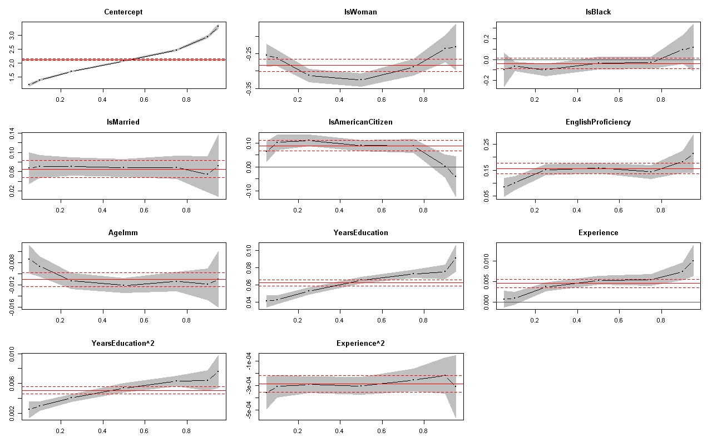

*Source: Author’s own elaboration based on the results of QR estimation.*

Figure 4 shows the Quantile Regression results and Table 3 presents the Quantile regression estimations for five values of τ-quantiles : 0.10, 0.25, 0.50, 0.75 and 0.90. Increments in earnings associated with the different socioeconomic characteristics vary across the earnings distribution[8]2. Being a woman causes a decrease in wages in all quantiles of the distribution, the decrease is highest from the 25th percentile to the 75th percentile. On average, women in the United States are paid just 77 cents for every dollar paid to men. For Latinas, the gap is larger. Latinas in the United States are paid, on average, just 54 cents for every dollar paid to white, non-Hispanic men (Fry and Taylor, 2013).

Being black is not a variable that explains the variability of (log) hourly earnings from the central part of the distribution to the upper part, since it is not a significant predictor in any percentile from the median at a significance level of 5%. For people who earn less it is a significant predictor and it causes decreases in earnings. Being married is a variable that produces a homogeneous effect on the different quantiles of the distribution. Being an American citizen has little effect on hourly earnings and only a minor effect in the upper quantiles.

The return to proficiency in English is higher for people who earn more. For the 90-th percentile it gives rise to an increase in hourly earnings of about 18% compared to around 10% for the 10-th percentile. The payoff for immigrants from learning the English language is likely to depend on the frequency with which they will use those skills in their everyday interactions (Lazear, 1999).

Borjas (2015) shows that more recent immigrants to the U.S are improving their English language skills at a far lower rate than earlier immigrants. Regarding age on entry in the U.S, being younger is more important in the upper quantiles of the distribution of earnings. The effect is negative for all quantiles and highest (in absolute terms) for the upper part of the distribution.

The age at which an individual migrates to the U.S is a potentially important determinant factor of how that immigrant will eventually do in the labour market (Friedberg, 1992). The return to potential experience is almost zero across the distribution of earnings of workers, but it is greater for people who earn more.

The number of years of education has a smaller impact on earnings in the lower quantiles (4.25% for 10th percentile and 5.25% for 25th percentile) than in the upper quantiles (7.27 % for the 75th percentile and 7.51% for the 90th percentile). With respect to the median value of the earnings distribution, an additional year of education causes an increase in hourly earnings of 6.53 %. This indicates that the effects of years of education are quite different across the different levels of hourly earnings.

The returns to education are higher at the top of the conditional earnings distribution but lower than expected. Martins and Pereira (2004) find that returns to education for male workers in U.S in 1995 were 3.9% for the 10th percentile and 7.9% for the 90th percentile. This means that the returns to education for Cuban workers now are similar to those for U.S workers 16 years ago.

One possible explanation for this situation is related to over-education. Workers are over-educated if the skills that they can bring to their jobs exceed the skills needed (Groot and Maassen, 2000). Lower earnings for over-educated workers increase the skill dispersion of pay by extending the lower tail of the wage distribution of the highly educated (Martin and Pereira, 2004). This might be because the types of job available to immigrants in the U.S, particularly to skilled workers, may not be as good as the jobs available in their own country, even though the pay may be better. Immigrants may also encounter difficulties in obtaining good jobs due to language barriers, less extensive network connections and lags in cultural adjustment (Bohon, 2005).

Another reason may be the fact that Cuban workers are not as highly valued in the U.S market now as they were years ago, due to increases in the emigration of highly skilled people. Skilled workers, earning relatively higher wages, have become relatively more abundant and, as a result, their relative wages have decreased (Machado and Mata, 2005).

1. CONCLUSIONS

This paper has analyzed the distribution of earnings of Cuban immigrants in the U.S in terms of certain observable characteristics: years of education, potential job experience, age at time of emigration, ethnicity, marital status, sex, citizenship status and proficiency in English. It uses the 2011 American Community Survey (ACS) of the U.S. provided by (IPUMS, 2011). Within the sample, only workers aged between 25 and 64 years who immigrated to the United States when they were between 17 and 49 years old are considered.

For the analysis, Ordinary Least Squares (OLS) estimation with standard errors calculated using the heteroskedasticity robust HC-4 estimator of Cribari and Neto (2004) was first employed and then Quantile Regression, a technique which allows us to characterize the whole distribution of earnings of Cuban immigrants in U.S was proposed.

When we use OLS estimation with heteroskedasticy-robust standard errors, all explanatory variables except the fact of being black prove to be significant at the 5% significance level. All other variables being constant, speaking English well or very well is the variable that produces the biggest increase in mean hourly earnings at about 15.64%; being a woman produces a decrease in mean hourly earnings of 28.39%; being married produces an increase of about 6.54%,; being a U.S citizen produces an increase of 8.84%; one more year of study increases expected hourly earnings by 6.23% and one year of potential experience increases expected hourly earnings by 0.46%.

However, the application of Quantile Regressions shows how the influence of the different variables considered on hourly earnings varies across the earnings distribution. With this type of estimation method differences between highly-skilled and low-skilled Cuban immigrants in the labour market can be detected.

The main conclusions of this article are the following: being a woman decreases hourly earnings at all points of the distribution, with the decrease being greater for individuals in the central part of the earnings distribution. The return to proficiency in English is greater for those people who earn more and the returns to education has a smaller impact on earnings in the lower quantiles and a greater impact at the top of the conditional earnings distribution but even then it is lower than expected. In particular, this article demonstrates how the return to education on earnings is less for Cuban born workers than expected.

REFERENCES

Aupetit, Sylvie Didou and Gérard, Etienne (2009). Fuga de cerebros, movilidad académica, redes científicas. En: Perspectivas latinoamericanas (primera ed.) México, DF: Centro de Investigación y de Estudios Avanzados del Instituto Politécnico Nacional.

Bertoli Simone; Fernández-Huertas, Jesús and Ortega, Francesc (2013). Crossing the Border: Self-Selection, Earnings and Individual Migration Decisions. En: Journal of Development Economics. Vol. 101, p. 75-91.

Bohon, Stephanie A. (2005). Occupational Attainment of Latino Immigrants in the United States. En: Geographical Review. Vol. 95, No. 2, p. 249-266.

Borjas, George J. (1985). Assimilation, Changes in Cohort Quality and the Earnings of Immigrants. En: Journal of Labor Economic. Vol.3, No.4, p. 463-489.

Borjas, George J. (2015). The Slowdown in the Economic Assimilation of Immigrants: Aging and Cohort Effects Revisited Again. En: Journal of Human Capital Vol.9, No 4, p. 483–517.

Cattan, Peter (1993). The diversity of Hispanics in the U.S. work force. En: Monthly Labor Review, Vol. 8, p. 3-15.

Chamarbagwala, Rubiana (2010). Economic liberalization and urban-rural inequality in India: a quantile regression analysis. En: Empirical Economics, Vol. 39, No. 2, p. 371-394.

Chiswick, Barry R. (1978). The effect of Americanization on the earnings of foreign-born men. En: The Journal of Political Economy, Vol.86, No 5, p. 897–921.

Chiswick, Barry R. and Miller, Paul W. (2008). How immigrants fare across the earnings distribution in Australia and the United States. En: Industrial and Labor Relations Review, Vol.61, No.3, p. 353-373.

Cobas Valdés, Aleida and Fernández Sainz, Ana (2014). Cuban migration to the United States and the Educational Self-Selection Problem. En: International Journal of Cuban Studies, Vol.6, No.1, 2014, p. 41-54.

Cribari-Neto, Francisco. (2004). Asymptotic Inference Under Heteroskedasticity of Unknown Form. En: Computational Statistics & Data Analysis, Vol. 45, No.2, p. 215-233.

Cuecuecha, Alfredo (2005). The Immigration of Educated Mexicans: The Role of Informal Social Insurance and Migration Costs. En: Canadian Economics Association. Available at http://economics.ca/2005/papers/0298.pdf.

Elliott, Robert and Lindley, Joanne (2008). Immigrant wage differentials, ethnicity and occupational segregation. En: Journal of the Royal Statistical Society: Series A (Statistics in Society), Vol. 171, No. 3, p. 645-671.

Friedberg, Rachel (1992). The Labor Market Assimilation of Immigrants in the United States: The Role of Age at Arrival. Working Paper. Brown University.

Fry, Richard and Taylor, Paul (2013). Hispanic high school graduates pass whites in rate of college enrollment. Washington DC: Pew Research Center.

Groot, Wim and Van Den Brink, Henriette, M. (2000). Overeducation in the labor market: a meta-analysis. En: Economics of Education Review, 19, p. 149-158.

Hernández, Judith and Foladori, Guillermo (2014). The Population Dynamic Challenge to Cuban Socialism. En: International Journal of Cuban Studies 6 (1), p. 25–40.

Hunt, Priscillia (2012). From the bottom to the top: a more complete picture of the immigrant-native wage gap in Britain. En: IZA Journal of Migration, Vol.1, No. 9, p. 1-18.

Integrated Public Use Microdata Series (IPUMS) (2011), Steven Ruggles, J.; Trent,A.; Genadek, K. ; Goeken R,; Schroeder M.B. and Sobek, M., Version 5.0 [Machine-readable database]. Minneapolis: University of Minnesota.

Integrated Public Use Microdata Series, International (IPUMS-International), 2011. Version 6.1 [Machine-readable database]. Minnesota Population Center. Minneapolis: University of Minnesota.

Koenker, Roger and Bassett, Gilbert (1978). Regression Quantiles. En: Econometrica, Vol. 46, No.1, p. 33-50.

Koenker, Roger (2005). Quantile Regression, Cambridge, U.K.: Cambridge University Press.

Lazear, Edward P. (1999). Culture and Language. En: Journal of Political Economy, 107, No. 6S, p. 95-125.

Lowell, B. Lindsay; Pederzini, Carla and Passel, Jeffrey (2008). The Demography of Mexico/U.S Migration. En: Mexico-U.S Migration Management: A Binational Approach. Maryland, Lexington Books. Agustín Escobar y Susan F. Martin, edits.

Machado, José A.F and Mata, José (2005). Counterfactual Decomposition of Changes in Wage Distribution Using Quantile Regression. En: Journal of Applied Econometrics, Vol. 20, No.4, p. 445-465.

Martins, Pedro S. and Pereira, Pedro T. (2004). Does education reduce wage inequality? Quantile regression evidence from 16 countries. En: Labour Economics No.11, p. 355-371.

Motel, Seth and Patten, Eileen (2012). Hispanic of Cuban Origin in the United States. En: Statistical Profile, Pew Hispanic Center, in <http://www.pewhispanic.org/files/2012/06/2010-Cuban-Factsheet.pdf>

Pérez, Alberto J. (2004) "Wet Foot, Dry Foot, No Foot: The RecurrinControversy Between Cubans, Haitians, and the United States Immigration Policy," Nova Law Review: Vol. 28.2 p. 436-465    
Available at: <http://nsuworks.nova.edu/nlr/vol28/iss2/16> accessed 09/09/2016

Pérez, Lisandro (1986). Cubans in the United States. En: The Annals of the American Academy of Political and Social Science, Vol. 487, p. 126–137.

Pérez, Lisandro (2001). Growing up Cuban in Miami. En: Ruben Rumbaut and Alejandro Portes, Ethnicities: Children of Immigrants in America. Los Angeles: University of California Press, pp. 91–126.

Pew Research Center, 2015. Cuban immigration to U.S surges as relations warm. En: FactTank. No. 10. http://www.pewresearch.org/fact-tank/2015/12/10/cuban-immigration-to-u-s-surges-as-relations-warm/ accessed 23/01/2016.

Portes, Alejandro and Shafer, Steven (2007). Revisiting the enclave hypothesis: Miami twenty-five years later. En: Research in the Sociology of Organizations 25, p. 157-190.

Rangvid, Beatrice S. (2007). School composition effects in Denmark: Quantile regression evidence from PISA 2000. En: Empirical Economics 33 (2), 359–388**.**

Suárez-Orozco, Marcelo and Páez, Mariela (2002). Latinos: Remaking America. Los Angeles, University of California Press.

Terry, Mary B.; Wei, Ying and Esserman, Denise (2007). Maternal, Birth and early-Life Influences on Adult Body Size in Women. En: American Journal of Epidemiology, Vol.166, No.1, pp. 5-13.

U.S Bureau of Labor Statistics. BLS Reports. (October 2013). “Labor Force Characteristics by Race and Ethnicity, 2012”.

U.S Census Bureau, (2012). Geographical Mobility/Migration Main. U.S Department of Commerce.

U.S Department of Labor. Wage and Hour Division (WHD). (2011) <http://www.dol.gov/whd/minimumwage.htm>.

Wainer, Howard (2000). The Centercept: An Estimable and Meaningful Regression Parameter. En: Psychological Science. Vol. 11, No. 5, p. 434-436.

Zeileis, Achim (2004). Econometric Computing with HC and HAC Covariance Matrix Estimators. En: Journal of Statistical Software, Vol. 11, No.10, p.1-17.

1. Research Article. This article is part of PhD Dissertation of Aleida Cobas Valdés in partial fulfillment of the requirements for the PhD degree in Economics. Financial support from the Econometrics Research Group, Basque Government grant IT-642-13 is gratefully acknowledged and for the participants in the 2nd CIdE Workshop for PhD students in Econometrics and Empirical Economics (WEEE).
2. Correspondence to: Aleida Cobas Valdés. Economist, University of Havana, Cuba. MSC. in Economics, University of Basque Country, Spain. Researcher at Institute of Public Economic. University of the Basque Country, UPV/EHU. Avenida Lehendakari Aguirre 81, 48015. Bilbao. Bizkaia, Spain. E-mail: [aleida.cobas@ehu.eus](mailto:aleida.cobas@ehu.eus)
3. Economist, University of Basque Country UPV/EHU, Spain. PhD in Economics, University of Basque Country UPV/EHU, Spain. Full Professor of Econometrics, Department of Econometrics and Statistics(Applied Economic III). University of the Basque Country UPV/EHU., Spain. E-mail: [ana.fernandez@ehu.eus](mailto:ana.fernandez@ehu.eus)
4. BA American Studies, Manchester University, U.K. PhD in Hispanic Studies. Queen Mary and Westfield College, University of London, U.K. Associate Lecturer, Department of Primary Care and Public Health Sciences King's College London School of Medicine  
   4th Floor, Capital House, 42 Weston Street LONDON, U.K. E-mail: s.wilkinson@cubastudies.org  
   
5. This illegal migration has been exacerbated by U.S. policy of admitting illegal migrants of Cuban origin who manage the enter U.S. territory. This so called ‘wet foot, dry foot’ policy incentivises illegal migration and has resulted in significant human trafficking through Central America and Mexico and is the cause of serious friction between migrants of Haitian origin, who do not benefit from the same policy. See for example Pérez, Alberto J. (2004).
6. Potential Experience of the individuals = Age-Years of Education-6
7. 1 U.S. Deparment of Labor, 2011.
8. 2 Tests on whether these coefficients differ significantly from one point in the distribution to another have been performed and the null hypothesis of equality of coefficients is rejected at the 5% significance level.